Ref. ME422 10th October 2022

Into the future with more precision – Micro-Epsilon Messtechnik opens new competence centre for micromechatronics
Precision sensor manufacturer Micro-Epsilon Messtechnik has opened a new production centre for micromechatronics at its headquarters in Ortenburg, Germany. Miniaturised mechatronic systems for semiconductor machine construction and aerospace applications are manufactured there. As a result, the growing demand for high-tech products from these key industries can continue to be met.

On an area of 36 x 36 m, the competence centre for micromechatronics offers optimal conditions for the demanding production of miniaturised mechatronic systems, including sensors and systems for the latest generation of semiconductor lithography machines, as well as sensors for use in aircraft and space applications. Micro-Epsilon sensors contribute to the highest accuracy in the production of future chip generations. In order to manufacture such high-tech sensors, a clean room is required that offers optimal environmental conditions. In addition to the high demands on cleanliness, humidity and temperature must also be kept constant.

Satellites and reflector telescopes
Sensor-actuator solutions for laser-based satellite communication are also manufactured in the new production centre. Fast tilting mirrors enable precise positioning of the laser beam to the nearest satellite at a distance of several hundred kilometres, thus enabling a global satellite-based Internet of the future.

Another application is high precision sensors for the world’s largest reflector telescope. The large-scale project comprises several thousand inductive position measuring systems. In the telescope, these sensors are used for the exact positioning of the 798 individual mirror segments.

“The new production area increases production capacity and enables us to produce sophisticated products with the highest quality and precision,” says Managing Director Dr. Thomas Wisspeintner. “The products are used in high-tech applications and make a significant contribution to more innovation and technological progress for the world of tomorrow. In this way, precise measurement in ongoing production can save material, reduce rejects while increasing quality and performance. More than 50 years of continuous investment in the development, production and support of innovative sensor and system solutions from Micro-Epsilon offer our customers more precision for their applications.”

The competence centre is also considered an important milestone for the sustainable safeguarding and expansion of the company’s business development and as a clear commitment to the Ortenburg location. The company focuses on the four business areas of industrial sensor technology, 3D sensor technology, micromechatronics, as well as measurement and inspection systems.

With the completion of the construction work, the company now has 3,800 additional square metres on three levels at its disposal. The investment in buildings, technology and equipment amounts to a total of 10 million euros. The company area at the Ortenburg site is thus growing to around 15,000 square metres. The competence centre for micromechatronics alone offers space for over 100 employees. Micro-Epsilon currently employs around 450 people in Ortenburg and has more than 1,400 employees worldwide at 24 locations within the Group.

For more information, please visit www.micro-epsilon.co.uk or call the Micro-Epsilon sales department on +44 (0)151 355 6070 or email mailto:info@micro-epsilon.co.uk

– ENDS – [686 words]

Photos and captions:
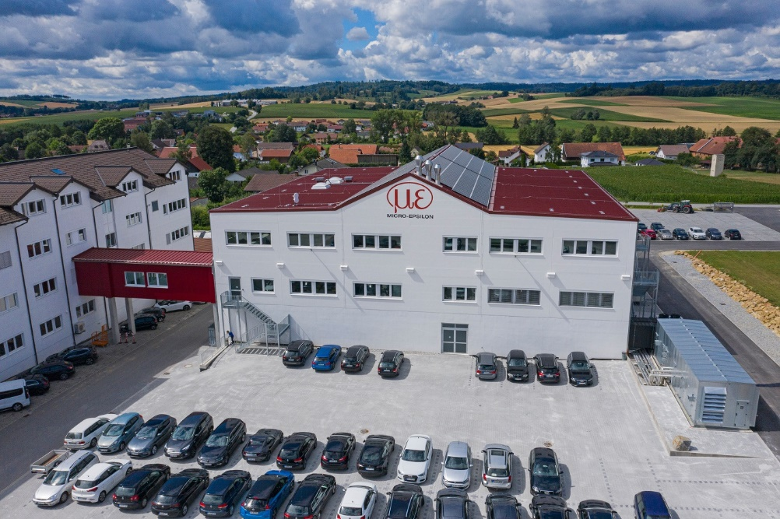
The new production centre for micromechatronics at the Micro-Epsilon headquarters in Ortenburg.

Note to Editors:

About Micro-Epsilon
Manufacturing processes throughout all industries are evolving at a rapid pace, and the quality and tolerances expected from the end user are forever increasing. Thus, the need for smarter measurement solutions is continuously growing. Micro-Epsilon (www.micro-epsilon.co.uk) is renowned globally for being at the forefront of measurement technology.
For more than 50 years, we have continuously offered reliable, high performance, unique solutions particularly when high precision measurement or inspection is required. Our product range covers sensors for the measurement of distance and displacement, sensors for IR temperature measurement and colour detection, as well as turnkey systems for dimensional measurement and defect detection.
We understand that our customers are our business partners and aim to develop long term relationships with them. We work closely with our customers to fully understand their requirements; our salespeople are engineers and understand more than just the sensor performance. We are problem solvers.
We operate a fair working policy, which results in excellent customer service and support even post sale.
Our high performance products and way of working provide our customers with a genuine competitive advantage.

To download high resolution images for this article, please go to www.silverbulletpr.co.uk/press . Alternatively, you can request an image by contacting:

Issued by: Dean Palmer
Director
SilverBullet PR Ltd
19, Glen Crescent, Stamford,
Lincolnshire PE9 1SW
Tel: 07703 023771
Email: dean@silverbulletpr.co.uk

Reader Enquiries/Advertising:
Glenn Wedgbrow,
Business Development Manager,
Micro-Epsilon UK Ltd
1, Shorelines Building,
Shore Road
Birkenhead
Cheshire CH41 1AU
Tel: +44 (0) 151 355 6070
Email: glenn.wedgbrow@micro-epsilon.co.uk

