Ref. ME423 7th December 2022

Autonetics chooses non-contact optical micrometers and laser triangulation sensors from Micro-Epsilon to measure shaft diameters and splines
Autonetics, a specialist in custom measurement solutions that are used in a wide range of industries, has chosen to use non-contact laser micrometers and non-contact laser triangulation sensors from Micro-Epsilon on its Vertical Gauging Unit (VGU), a measuring tool for the precise measurement of shafts and axes.

The VGU is equipped with a tailstock and servo drive, linear drives with rack, and a precision turntable. In addition, four optoCONTROL 2600 laser micrometers and an optoNCDT 2300 laser triangulation distance sensor from Micro-Epsilon are integrated into the VGU. All components together measure axial lengths, diameters, concentricity and splines, achieving cycle times and accuracies that cannot be achieved using manual measurement techniques. Not only do the sensors enable fast, non-contact measurement of shafts and splines, they also ensure stable measurements to sub-micrometer accuracy, even on metal surfaces. Comprehensive software enables evaluation of measurement data, recording of key values and data output to a PLC. The measurement data is automatically sent to the CNC controller so that tool adjustments can be made automatically in real time to compensate for tool wear.

Measuring tractor axle shafts
The VGU is used, for example, in an automated machining centre for tractor axle shafts. The shafts are guided into the VGU by a robot and clamped into position. The measuring station moves along the shaft and uses the four integrated optoCONTROL 2600 optical micrometers to determine the diameters. The four micrometers individually have a 40 mm measurement range but are arranged in pairs and offset in order to detect a range of shaft diameters from 58 mm up to 178 mm. In addition, the optoNCDT 2300 laser triangulation sensor, in combination with the rotary stage, is used to measure the splines of the shaft.

The optoCONTROL 2600 is an optical measuring system (sensor unit and controller) with integrated high resolution CCD camera. The sensor has been developed with solid state (non-rotating) optics and so the measurement accuracy does not drift over time. Using a special lens arrangement, an LED light source produces a parallel light curtain (visible red light), which is imaged on the CCD camera via a telecentric lens. If an object to be measured is placed in the light curtain, the shadow it creates is detected by the CCD array – even transparent targets can be measured. The measured data is output via analogue and digital interfaces, enabling easy integration for both OEMs and end users. The system is insensitive to high external light conditions, as well as dirt and moisture. The optoCONTROL 2600 has a measuring range of 40mm, resolution of 0.1µm and measuring rate of 2.3 kHz.

The optoNCDT 2300 is the high performance model of Micro-Epsilon’s laser triangulation sensor range, with an adjustable measuring rate up to 49.14 kHz and a resolution of 0.03µm. The entire electronics is integrated in a compact sensor housing. The laser sensor is particularly suitable for high speed applications such as measurements on challenging surfaces, including diffuse reflective surfaces, glass and transparent plastics. The A-RTSC (Advanced Real Time Surface Compensation) feature enables more precise real time surface compensation during the measurement process. A range of interfaces are available including analogue, RS422, Ethernet, EtherCAT, Profinet and Ethernet/IP.

For more information on the optoCONTROL range of optical micrometers or the optoNCDT range of laser triangulation sensors from Micro-Epsilon, please visit www.micro-epsilon.co.uk or call the Micro-Epsilon sales department on +44 (0)151 355 6070 or email mailto:info@micro-epsilon.co.uk

– ENDS – [565 words]

Photos and captions:

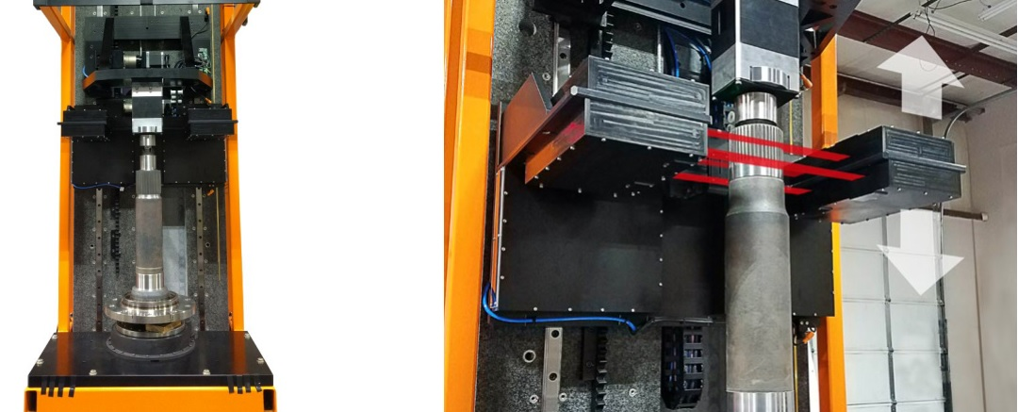
The Autonetics Vertical Gauging Unit for the precise measurement of shafts and axes.

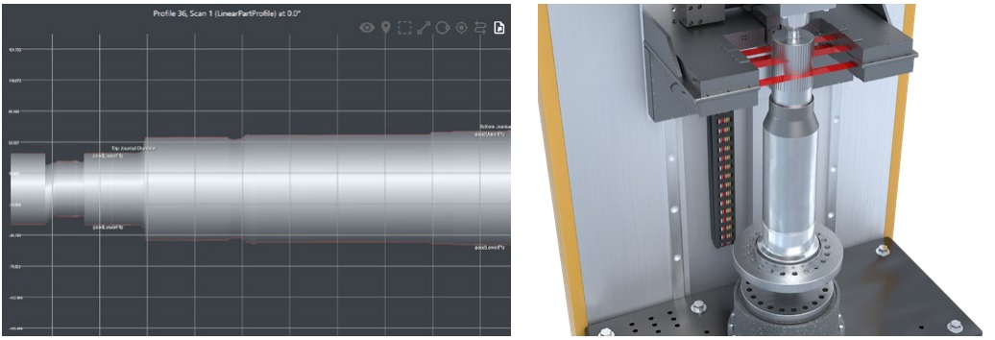
The measuring station moves along the shaft and uses the four offset optoCONTROL 2600 optical micrometers to measure the shaft diameters.

Note to Editors:

About Micro-Epsilon
Manufacturing processes throughout all industries are evolving at a rapid pace, and the quality and tolerances expected from the end user are forever increasing. Thus, the need for smarter measurement solutions is continuously growing. Micro-Epsilon (www.micro-epsilon.co.uk) is renowned globally for being at the forefront of measurement technology.
For more than 50 years, we have continuously offered reliable, high performance, unique solutions particularly when high precision measurement or inspection is required. Our product range covers sensors for the measurement of distance and displacement, sensors for IR temperature measurement and colour detection, as well as turnkey systems for dimensional measurement and defect detection.
We understand that our customers are our business partners and aim to develop long term relationships with them. We work closely with our customers to fully understand their requirements; our salespeople are engineers and understand more than just the sensor performance. We are problem solvers.
We operate a fair working policy, which results in excellent customer service and support even post sale.
Our high performance products and way of working provide our customers with a genuine competitive advantage.

To download high resolution images for this article, please go to www.silverbulletpr.co.uk/press . Alternatively, you can request an image by contacting:

Issued by: Dean Palmer
Director
SilverBullet PR Ltd
19, Glen Crescent, Stamford,
Lincolnshire PE9 1SW
Tel: 07703 023771
Email: dean@silverbulletpr.co.uk

Reader Enquiries/Advertising:
Glenn Wedgbrow,
Business Development Manager,
Micro-Epsilon UK Ltd
1, Shorelines Building,
Shore Road
Birkenhead
Cheshire CH41 1AU
Tel: +44 (0) 151 355 6070
Email: glenn.wedgbrow@micro-epsilon.co.uk

