Ref. ME424 4th January 2023

QSigma chooses high speed, compact 3D laser profile scanner from Micro-Epsilon to measure wire diameter of coil springs
QSigma GmbH, a supplier of optical measurement solutions for industrial applications, has chosen 3D laser profile scanners from Micro-Epsilon for use on its Spring Measurement Solution (SMS), a measurement system for precise 3D measurement of coil springs and other manufactured components.

The SMS is used, for example, in the development of spring prototypes and for 100% inspection of series produced parts. The SMS automatically identifies the spring, evaluates the wire contour and determines the wire diameter, even if the spring geometry is subject to strong fluctuations. For comparative evaluations, an automatic centreline determination is performed. The resulting data can then be analysed and compared with a stored target geometry. Non-contact sensors from Micro-Epsilon are used in these high precision measurement tasks.

Converts data into 3D point clouds
The SMS is a compact measuring cell in which the spring to be tested rotates on a longitudinal axis. During rotation, two linear axes move a scanCONTROL 2950 laser profile scanner from Micro-Epsilon over the part in the horizontal and vertical directions. To achieve maximum accuracy, the sensors are optimally positioned using algorithms developed by QSigma. The laser profile scanner transmits the generated individual profiles to a computer via a Gigabit Ethernet interface, which converts the data into a 3D point cloud and displays it on a monitor.

The scanCONTROL 2950 laser profile scanner has a large measuring field in both the Z- and X-axis. This enables extremely high speed scanning of springs up to a height of 70 cm and radially up to 30 cm. This wide field combined with the scanner’s high point density and profile capture rate (up to 1,000 profiles per second) enables precise evaluation of the spring geometry and wire diameter. Due to the large Z-axis range of the scanner, both the spring path and the spring end can be detected automatically. As the scanCONTROL 2950 works almost independently of the surface type, even painted or powder-coated springs can be measured reliably.

The scanCONTROL 29x0 series of 3D laser profile sensors are designed for industrial measurement tasks where compact design and high accuracy are required. Due to their high resolution, versatility and excellent price-performance ratio, the scanners are particularly suitable for static and dynamic applications, for example, on robots. The scanners measure and evaluate a variety of geometrical features such as angles, steps, gaps, distances and extreme values.

For more information on the scanCONTROL 29x0 series of 3D laser profile sensors from Micro-Epsilon, please visit www.micro-epsilon.co.uk or call the Micro-Epsilon sales department on +44 (0)151 355 6070 or email mailto:info@micro-epsilon.co.uk

– ENDS – [422 words]

Photos and captions:

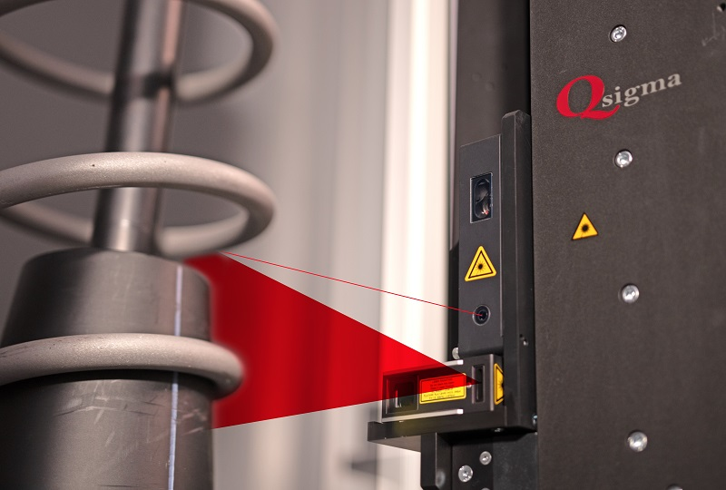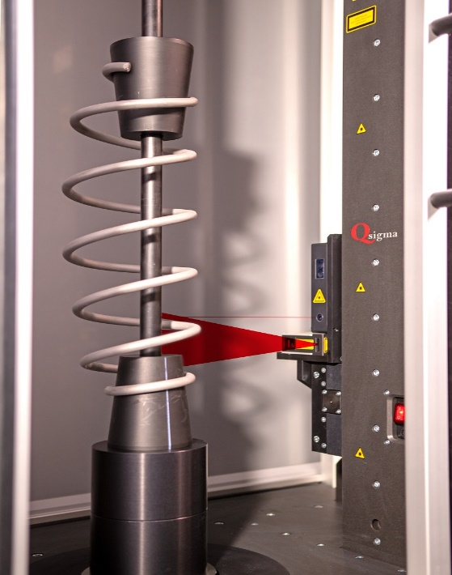
The Spring Measurement System from QSigma for precise 3D measurement of coil springs.

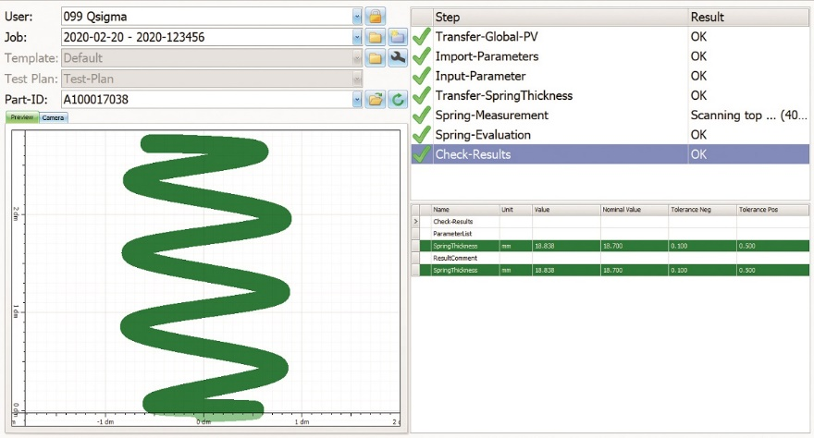
The 3D laser scanner transmits the generated individual profiles to a PC via a Gigabit Ethernet interface, which converts the data into a 3D point cloud and displays it on a monitor.

Note to Editors:

About Micro-Epsilon
Manufacturing processes throughout all industries are evolving at a rapid pace, and the quality and tolerances expected from the end user are forever increasing. Thus, the need for smarter measurement solutions is continuously growing. Micro-Epsilon (www.micro-epsilon.co.uk) is renowned globally for being at the forefront of measurement technology.
For more than 50 years, we have continuously offered reliable, high performance, unique solutions particularly when high precision measurement or inspection is required. Our product range covers sensors for the measurement of distance and displacement, sensors for IR temperature measurement and colour detection, as well as turnkey systems for dimensional measurement and defect detection.
We understand that our customers are our business partners and aim to develop long term relationships with them. We work closely with our customers to fully understand their requirements; our salespeople are engineers and understand more than just the sensor performance. We are problem solvers.
We operate a fair working policy, which results in excellent customer service and support even post sale.
Our high performance products and way of working provide our customers with a genuine competitive advantage.

To download high resolution images for this article, please go to www.silverbulletpr.co.uk/press . Alternatively, you can request an image by contacting:

Issued by: Dean Palmer
Director
SilverBullet PR Ltd
19, Glen Crescent, Stamford,
Lincolnshire PE9 1SW
Tel: 07703 023771
Email: dean@silverbulletpr.co.uk

Reader Enquiries/Advertising:
Glenn Wedgbrow,
Business Development Manager,
Micro-Epsilon UK Ltd
1, Shorelines Building,
Shore Road
Birkenhead
Cheshire CH41 1AU
Tel: +44 (0) 151 355 6070
Email: glenn.wedgbrow@micro-epsilon.co.uk

