Ref. ME428 9th February 2023

Laser scanner now even more robust and space-saving in installation
In many applications the cable exit from a sensor has little impact on its installation location, but when it comes to mounting sensors in tight spaces such as pipes and tubes then every millimetre counts!

Precision sensor manufacturer Micro-Epsilon has introduced two new model options for its scanCONTROL 30xx range of laser profile sensors (laser scanners) – a rear tail cable option and a protective housing option.

The rear-tail option with cable integrated on the rear of the sensor allows even more space-saving installation. The length of the integrated cable is 30cm. This version eliminates the need for upward wiring, which means around 80mm less installation height is required. Compared to the standard sensor model, almost 50% of the installation space can be saved.

The new protective housing option makes the sensors even more robust in harsh industrial environments. The housing is available for sensors in the 25x0 and 29x0 series with measuring ranges of 25, 50 and 100mm, as well as sensors in the 30x0 and 30x2 series with measuring ranges of 25 to 200mm.

The protective housing offers connections for air flushing and liquid cooling, an adjustable splash guard, a replaceable protective glass and a free-blowing device. If the built-in free blowing device is supplied with compressed air, dirt, dust and other contaminants can be removed directly, which extends cleaning intervals. The protective housing with additional water cooling offers protection against mechanical damage as well as protection against high ambient temperatures. Alternatively, it is also possible to heat the sensor at particularly low outside temperatures. If the protective screen is damaged, it can be replaced easily and cost-effectively.

The scanCONTROL 30xx sensor is among the highest performing laser scanners in terms of its size, accuracy and measuring rate. The sensor has a compact housing with integrated controller, allowing fast integration into confined spaces. Available with either red or blue laser technology, the sensor provides calibrated 2D profile data with up to 5.5 million points per second. A maximum profile frequency of 10kHz and innovative exposure control enable precise profile measurements in high speed, dynamic processes. A high resolution sensor matrix offers a resolution of 2,048 points per profile with an ultimate point distance spacing of just 12µm, allowing measurements of extremely fine surface/geometrical details.

For more information on the scanCONTROL 30xx series of laser profile scanners from Micro-Epsilon, please visit www.micro-epsilon.co.uk or call the Micro-Epsilon sales department on +44 (0)151 355 6070 or email mailto:info@micro-epsilon.co.uk

– ENDS – [406 words]

Photos and captions:
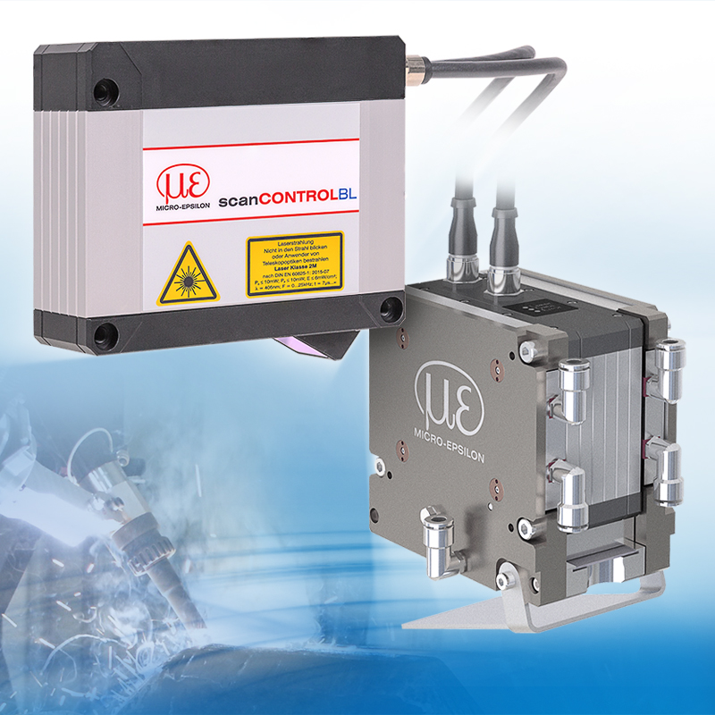
scanCONTROL 30xx laser scanners are now available with a rear tail option and protective housing.

Note to Editors:

About Micro-Epsilon
Manufacturing processes throughout all industries are evolving at a rapid pace, and the quality and tolerances expected from the end user are forever increasing. Thus, the need for smarter measurement solutions is continuously growing. Micro-Epsilon (www.micro-epsilon.co.uk) is renowned globally for being at the forefront of measurement technology.
For more than 50 years, we have continuously offered reliable, high performance, unique solutions particularly when high precision measurement or inspection is required. Our product range covers sensors for the measurement of distance and displacement, sensors for IR temperature measurement and colour detection, as well as turnkey systems for dimensional measurement and defect detection.
We understand that our customers are our business partners and aim to develop long term relationships with them. We work closely with our customers to fully understand their requirements; our salespeople are engineers and understand more than just the sensor performance. We are problem solvers.
We operate a fair working policy, which results in excellent customer service and support even post sale.
Our high performance products and way of working provide our customers with a genuine competitive advantage.

To download high resolution images for this article, please go to www.silverbulletpr.co.uk/press . Alternatively, you can request an image by contacting:

Issued by: Dean Palmer
Director
SilverBullet PR Ltd
19, Glen Crescent, Stamford,
Lincolnshire PE9 1SW
Tel: 07703 023771
Email: dean@silverbulletpr.co.uk

Reader Enquiries/Advertising:
Glenn Wedgbrow,
Business Development Manager,
Micro-Epsilon UK Ltd
1, Shorelines Building,
Shore Road
Birkenhead
Cheshire CH41 1AU
Tel: +44 (0) 151 355 6070
Email: glenn.wedgbrow@micro-epsilon.co.uk

