Ref. ME434 25th April 2023

New adapter from Micro-Epsilon enables easy integration of scanCONTROL laser profile sensors with Cognex VisionPro software
Precision sensor manufacturer Micro-Epsilon has introduced a software adapter that enables easy, fast integration of the scanCONTROL series of laser profile sensors with Cognex VisionPro software via the Cognex AIK Server.

Cognex VisionPro is designed to setup and deploy vision applications, regardless of the camera type or frame grabber. The software enables users to perform a wide range of functions, from geometric object location and inspection to identification, measurement, and alignment, as well as specialised functions specific to semiconductor and electronics applications.

Developed in cooperation with COGNEX®, the free scanCONTROL AIK Adapter combines the advantages of Cognex VisionPro with the benefits of native scanCONTROL integration. Cognex integrators and Cognex VisionPro users can use the scanCONTROL AIK Adapter to generate Cognex Range Images from the scanCONTROL measuring points and process these conveniently within the VisionPro data evaluation algorithms. In addition, all known configuration options for scanCONTROL laser profile sensors are available to the user.

For a rapid start, the scanCONTROL AIK Adapter for Cognex VisionPro contains detailed documentation about all sensor settings and the necessary configuration steps in Cognex VisionPro. The scanCONTROL AIK Adapter is available as a free download from the Micro-Epsilon website, as well as a tutorial video that shows users how to quickly get connected and setup with the Cognex VisionPro software. The adapter supports all current scanCONTROL series: 25xx, 26xx, 29xx and 30xx.

For more information on the scanCONTROL AIK Adapter from Micro-Epsilon, please visit www.micro-epsilon.co.uk or call the Micro-Epsilon sales department on +44 (0)151 355 6070 or email mailto:info@micro-epsilon.co.uk

– ENDS – [269 words]

Photos and captions:
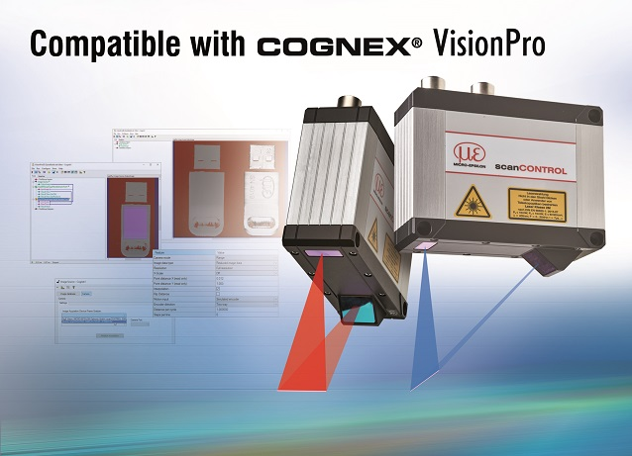
The scanCONTROL AIK Adapter enables fast integration of scanCONTROL sensors with Cognex VisionPro software.

Note to Editors:

About Micro-Epsilon
Manufacturing processes throughout all industries are evolving at a rapid pace, and the quality and tolerances expected from the end user are forever increasing. Thus, the need for smarter measurement solutions is continuously growing. Micro-Epsilon (www.micro-epsilon.co.uk) is renowned globally for being at the forefront of measurement technology.
For more than 50 years, we have continuously offered reliable, high performance, unique solutions particularly when high precision measurement or inspection is required. Our product range covers sensors for the measurement of distance and displacement, sensors for IR temperature measurement and colour detection, as well as turnkey systems for dimensional measurement and defect detection.
We understand that our customers are our business partners and aim to develop long term relationships with them. We work closely with our customers to fully understand their requirements; our salespeople are engineers and understand more than just the sensor performance. We are problem solvers.
We operate a fair working policy, which results in excellent customer service and support even post sale.
Our high performance products and way of working provide our customers with a genuine competitive advantage.

To download high resolution images for this article, please go to www.silverbulletpr.co.uk/press . Alternatively, you can request an image by contacting:

Issued by: Dean Palmer
Director
SilverBullet PR Ltd
19, Glen Crescent, Stamford,
Lincolnshire PE9 1SW
Tel: 07703 023771
Email: dean@silverbulletpr.co.uk

Reader Enquiries/Advertising:
Glenn Wedgbrow,
Business Development Manager,
Micro-Epsilon UK Ltd
1, Shorelines Building,
Shore Road
Birkenhead
Cheshire CH41 1AU
Tel: +44 (0) 151 355 6070
Email: glenn.wedgbrow@micro-epsilon.co.uk

