Ref. ME435 10th May 2023

Inrotech A/S chooses 2D/3D laser profile scanners from Micro-Epsilon to optimise
the quality of weld seams
Inrotech, a designer and manufacturer of automated welding solutions for shipbuilding, renewables, offshore and heavy industries, has chosen 2D/3D laser profile scanners from Micro-Epsilon for use on its ‘Inrotech-Crawler’ welding robot, which calculates welding processes in advance before carrying them out.

A scanCONTROL 2900 laser profile scanner from Micro-Epsilon is mounted on the Inrotech-Crawler and measures the geometry of the seam to be welded before the actual welding process starts. Only these high precision profile measurements enable the welding process to be automated. Due to its compact, lightweight design with integrated controller, the scanCONTROL 2900 is ideally suited to this measurement task. In this particular application, the laser scanner has a measuring width of 100mm, a measuring rate of 300Hz and a resolution in the Z-axis of 12µm.

Various connectivity options offered by the SDK (Software Development Kit) enable Inrotech to directly transmit the profile data, from the sensor, calibrated to their own software via the scanCONTROL DLL. The Weldlogic technology from Inrotech then calculates, among other things, the number of weld passes, the position of the weld seams, the weld speed and the oscillation width required to produce a quality weld. Directly after the calculation, the Inrotech-Crawler automatically performs the welding process.

The welding robot enables the scanning of weld geometries such as plates or curves with various characteristics. Based on the optimal exposure time control and high resolution, the laser profile scanner reliably measures almost any measurement object.

Designed for mobile applications, the Inrotech-Crawler is ideal for different environments, for example, for pipeline welding tasks in the oil & gas industry, offshore, shipbuilding, wind turbines and building construction. A resistant sensor is the base requirement in this and many other environments. The scanCONTROL 2900 laser profile scanner is ideally suited to these requirements and is integrated into a protective housing by Inrotech.

The scanCONTROL 29x0 series of 3D laser profile sensors are designed for industrial measurement tasks where compact design and high accuracy are required. Due to their high resolution, self-contained housing, versatility and excellent price-performance ratio, the scanners are particularly suitable for static and dynamic applications, for example, on robots. The scanners measure and evaluate a variety of geometrical features such as angles, steps, gaps, distances and extreme values.

For more information on the scanCONTROL 29x0 series of 3D laser profile sensors from Micro-Epsilon, please visit www.micro-epsilon.co.uk or call the Micro-Epsilon sales department on +44 (0)151 355 6070 or email mailto:info@micro-epsilon.co.uk

– ENDS – [404 words]

Photos and captions:
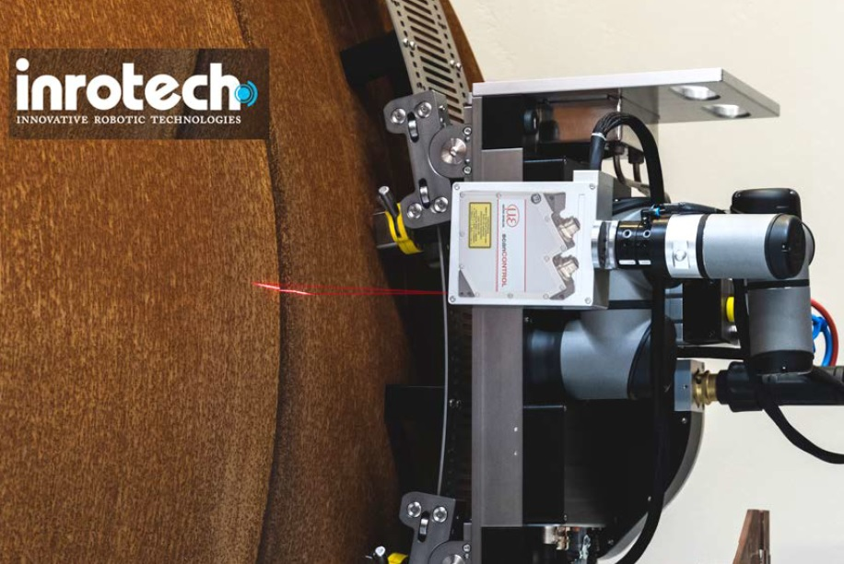
The Inrotech-Crawler weld robot uses the scanCONTROL 2900 laser profile scanner from Micro-Epsilon to optimise the quality of weld seams in a fully automatic process.

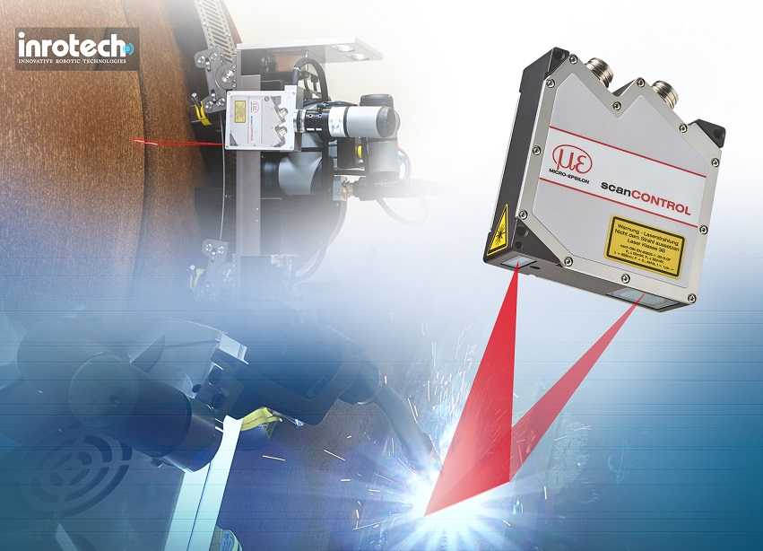
The scanCONTROL 2900 laser profile scanner measures the geometry of the seam to be welded before the actual welding process starts.

Note to Editors:

About Micro-Epsilon
Manufacturing processes throughout all industries are evolving at a rapid pace, and the quality and tolerances expected from the end user are forever increasing. Thus, the need for smarter measurement solutions is continuously growing. Micro-Epsilon (www.micro-epsilon.co.uk) is renowned globally for being at the forefront of measurement technology.
For more than 50 years, we have continuously offered reliable, high performance, unique solutions particularly when high precision measurement or inspection is required. Our product range covers sensors for the measurement of distance and displacement, sensors for IR temperature measurement and colour detection, as well as turnkey systems for dimensional measurement and defect detection.
We understand that our customers are our business partners and aim to develop long term relationships with them. We work closely with our customers to fully understand their requirements; our salespeople are engineers and understand more than just the sensor performance. We are problem solvers.
We operate a fair working policy, which results in excellent customer service and support even post sale.
Our high performance products and way of working provide our customers with a genuine competitive advantage.

To download high resolution images for this article, please go to www.silverbulletpr.co.uk/press . Alternatively, you can request an image by contacting:

Issued by: Dean Palmer
Director
SilverBullet PR Ltd
19, Glen Crescent, Stamford,
Lincolnshire PE9 1SW
Tel: 07703 023771
Email: dean@silverbulletpr.co.uk

Reader Enquiries/Advertising:
Glenn Wedgbrow,
Business Development Manager,
Micro-Epsilon UK Ltd
1, Shorelines Building,
Shore Road
Birkenhead
Cheshire CH41 1AU
Tel: +44 (0) 151 355 6070
Email: glenn.wedgbrow@micro-epsilon.co.uk

