Ref. ME436 24th May 2023

New ultra-compact confocal measuring system for displacement, distance and thickness measurements to sub-micrometer accuracy
Precision sensor manufacturer Micro-Epsilon has introduced a confocal measuring system that consists of an extremely compact lightweight controller and a high performance confocal sensor, which are factory-calibrated and delivered as a complete measuring system. The newly developed IFS2404 confocal sensor is bundled with the controller and is available with measuring ranges of 1,2,3 and 6 mm.

One of the key advantages of confocal technology is its ability to measure on any surface including highly polished and even transparent materials. Despite its compact size, the new controller is still capable of displacement and distance measurements, and is also suitable for thickness measurement of transparent materials (one layer). An adjustable measuring rate of up to 8 kHz and sub-micrometer resolution down to 12 nm make the IFD2411 suitable for a wide range of measurement tasks. The Active Exposure Regulation of the CCD line enables high speed measurements on difficult changing surfaces.

Typical applications include semiconductor wafer positioning and acid height inspection; displacement and distance measurements in 3D printing machines; testing of electronic components (pins) and paint thickness of printed circuit boards; thickness measurement of flat glass and container glass; and quality control of smartphone glass.

Ease of integration
The confocal controller is now even smarter due to its integrated Industrial Ethernet interface (EtherCAT), which simplifies integration with PLCs. This enables real time measurement data without time delays and reduced installation effort.

The connection is established automatically. After the power supply is switched on, the sensor boots in EtherCAT mode by default. Using the multi-function button on the controller, the IFD2411 can also boot in Ethernet mode and can then be controlled via the intuitive web interface. Parameter set up is simple: settings made are stored and applied directly to the EtherCAT mode on the next boot process. This eliminates time-consuming setting effort in the programming environment. It is therefore not necessary to know all commands in the TwinCAT Manager, which means less experienced users can set up the sensor. Ethernet/IP and ProfiNET versions will also soon be available.

Due to its extremely compact design and robust IP40 aluminium housing, the IFD2411 controller can be integrated in almost all existing plants and systems. The controller also provides RS422 and analogue output, as well as one encoder input channel as standard. In addition, integrated DIN rail mounting enables rapid installation in control cabinets.

For more information on the confocalDT IFD2411 from Micro-Epsilon, please visit www.micro-epsilon.co.uk or call the Micro-Epsilon sales department on +44 (0)151 355 6070 or email mailto:info@micro-epsilon.co.uk

– ENDS – [415 words]

Photos and captions:
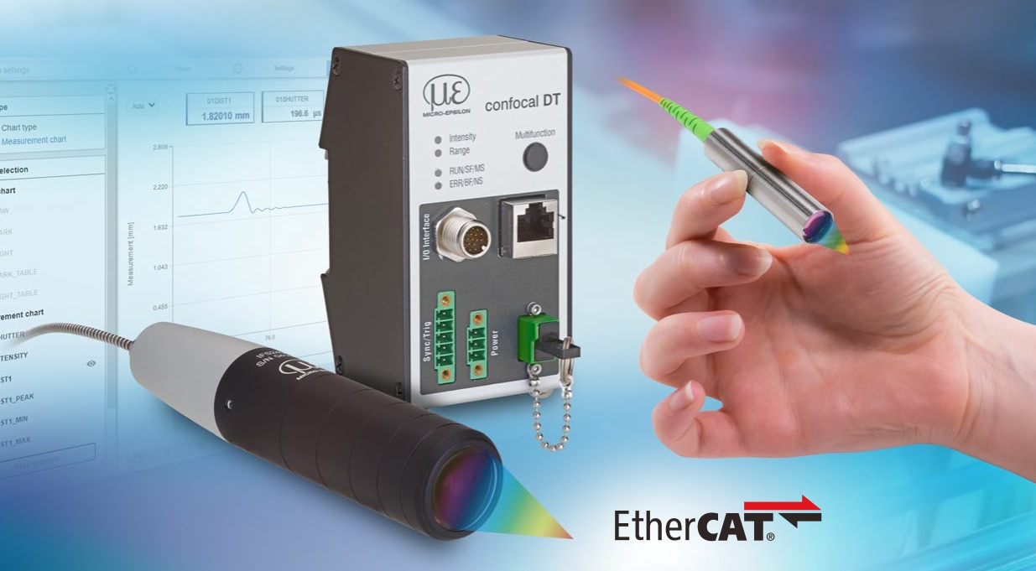
The confocalDT IFD2411 includes a controller and sensor with measuring ranges of 1,2,3 and 6 mm.

Note to Editors:

About Micro-Epsilon
Manufacturing processes throughout all industries are evolving at a rapid pace, and the quality and tolerances expected from the end user are forever increasing. Thus, the need for smarter measurement solutions is continuously growing. Micro-Epsilon (www.micro-epsilon.co.uk) is renowned globally for being at the forefront of measurement technology.
For more than 50 years, we have continuously offered reliable, high performance, unique solutions particularly when high precision measurement or inspection is required. Our product range covers sensors for the measurement of distance and displacement, sensors for IR temperature measurement and colour detection, as well as turnkey systems for dimensional measurement and defect detection.
We understand that our customers are our business partners and aim to develop long term relationships with them. We work closely with our customers to fully understand their requirements; our salespeople are engineers and understand more than just the sensor performance. We are problem solvers.
We operate a fair working policy, which results in excellent customer service and support even post sale.
Our high performance products and way of working provide our customers with a genuine competitive advantage.

To download high resolution images for this article, please go to www.silverbulletpr.co.uk/press . Alternatively, you can request an image by contacting:

Issued by: Dean Palmer
Director
SilverBullet PR Ltd
19, Glen Crescent, Stamford,
Lincolnshire PE9 1SW
Tel: 07703 023771
Email: dean@silverbulletpr.co.uk

Reader Enquiries/Advertising:
Glenn Wedgbrow,
Business Development Manager,
Micro-Epsilon UK Ltd
1, Shorelines Building,
Shore Road
Birkenhead
Cheshire CH41 1AU
Tel: +44 (0) 151 355 6070
Email: glenn.wedgbrow@micro-epsilon.co.uk

