Ref. ME437 8th June 2023

New compact all-in-one confocal sensor and controller saves space and simplifies installation in production lines and machines
Precision sensor manufacturer Micro-Epsilon has extended its confocal sensor system portfolio with the new, innovative high performance series, confocalDT IFD2410 and the confocalDT IFD2415. Each system combines both sensor and controller together to save space and simplify installation in production lines and machines, as no fibre optic cabling is needed between the sensor and controller.

The confocalDT IFD241x series is the only one in the world that combines high precision and a compact design with integrated Industrial Ethernet. Comparable models from other manufacturers only offer Industrial Ethernet via a separate external module.

One of the key advantages of confocal technology is its ability to measure on any surface including highly polished and even transparent materials. Despite its compact size, the confocalDT IFD241x is still capable of displacement and distance measurements, and is also suitable for thickness measurement of transparent materials.

The new confocal sensor system is available in two versions, each with three measuring ranges. The entry-level version, the IFD2410, offers an attractive price-performance ratio and single layer transparent thickness measurements. The high performance version, the IFD2415, is best-in-class for high precision distance, thickness and transparent multi-layer measurements.

Industrial series production
The IFD2410 is ideal for high precision distance and thickness measurements in industrial series applications such as production lines and plants. An adjustable measuring rate of up to 8kHz and sub-micrometer resolution down to 12nm make the IFD2410 suitable for a wide range of measurement tasks. The Active Exposure Time Regulation of the CCD array enables high speed, stable measurements on various surfaces. The sensor is available in measuring ranges of 1mm, 3mm and 6mm. Typical applications include inline inspection and coordinate measuring machines; inline thickness measurement of flat glass and container glass; and inspection of electronic components.

For higher precision
For those applications where higher distance and thickness measurement precision is required, the IFD2415 is ideal. Based on the sensors from the IFS2405 range, the sensors have precision lenses and wide Numerical Apertures that allow high degrees of tilt from reflective surfaces and can be used with transparent materials for multi-layer thickness measurements of up to five layers. The Active Exposure Time Regulation of the CCD array enables high speed, stable measurements on difficult, changing surfaces, even in dynamic processes up to 25kHz. The measuring system is also characterised by high luminous intensity. Therefore, the IFD2415 can measure quickly and reliably, even on darker surfaces. The sensor is available in measuring ranges of 1mm, 3mm and 10mm. Typical applications include inline inspection and coordinate measuring machines, robotics and 3D printers.

Ease of integration
The combined sensor and electronics in one compact housing offers greater flexibility for system integrators and machine builders, as there is no longer any need to route or connect fibre optic cables. The confocalDT IFD241x series has an integrated Industrial Ethernet (EtherCAT) interface, which simplifies integration with PLCs. Ethernet/IP and ProfiNET will also be available shortly. This enables real time measurement data without time delays and reduced installation effort. The connection is established automatically. After the power supply is switched on, the sensor boots in EtherCAT mode by default. Using the multi-function button on the controller, the IFD241x can also boot in Ethernet mode and can then be controlled via the intuitive web interface. Parameter set up is simple: settings made are stored and applied directly to the EtherCAT mode on the next boot process. This eliminates time-consuming setting effort in the programming environment.

In addition to Industrial Ethernet, RS422 and analogue outputs are also possible. For those who wish to synchronise measurement data with positional information, the controller can also accept up to two incremental encoder signals directly without the need for additional interface hardware.

For more information on the confocalDT IFD241x series from Micro-Epsilon, please visit www.micro-epsilon.co.uk or call the Micro-Epsilon sales department on +44 (0)151 355 6070 or email mailto:info@micro-epsilon.co.uk

– ENDS – [638 words]

Photos and captions:
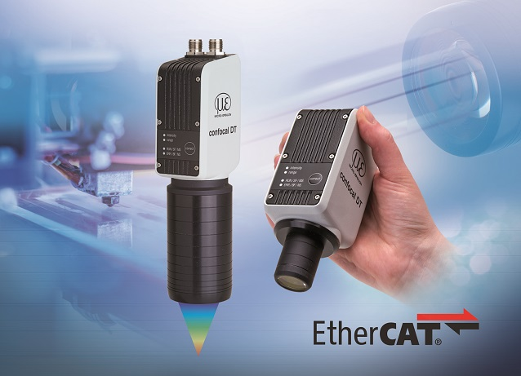
The confocalDT IFD241x with integral controller and EtherCAT is easy to integrate into plant and machines without requiring any fibre optic cabling.

Note to Editors:

About Micro-Epsilon
Manufacturing processes throughout all industries are evolving at a rapid pace, and the quality and tolerances expected from the end user are forever increasing. Thus, the need for smarter measurement solutions is continuously growing. Micro-Epsilon (www.micro-epsilon.co.uk) is renowned globally for being at the forefront of measurement technology.
For more than 50 years, we have continuously offered reliable, high performance, unique solutions particularly when high precision measurement or inspection is required. Our product range covers sensors for the measurement of distance and displacement, sensors for IR temperature measurement and colour detection, as well as turnkey systems for dimensional measurement and defect detection.
We understand that our customers are our business partners and aim to develop long term relationships with them. We work closely with our customers to fully understand their requirements; our salespeople are engineers and understand more than just the sensor performance. We are problem solvers.
We operate a fair working policy, which results in excellent customer service and support even post sale.
Our high performance products and way of working provide our customers with a genuine competitive advantage.

To download high resolution images for this article, please go to www.silverbulletpr.co.uk/press . Alternatively, you can request an image by contacting:

Issued by: Dean Palmer
Director
SilverBullet PR Ltd
19, Glen Crescent, Stamford,
Lincolnshire PE9 1SW
Tel: 07703 023771
Email: dean@silverbulletpr.co.uk

Reader Enquiries/Advertising:
Glenn Wedgbrow,
Business Development Manager,
Micro-Epsilon UK Ltd
1, Shorelines Building,
Shore Road
Birkenhead
Cheshire CH41 1AU
Tel: +44 (0) 151 355 6070
Email: glenn.wedgbrow@micro-epsilon.co.uk

