Ref. ME439 4th July 2023

Draw-wire sensors now offer larger measuring ranges and CANopen interface
Draw-wire displacement sensors from Micro-Epsilon are used successfully in many different industries, one of the most important being mobile machinery, where the sensors need to be compact, provide large measuring ranges (typically 6 m to 8 m) and offer an attractive price/performance ratio.

A common application for draw-wire sensors in mobile machinery is the measurement of boom and support positions. Telescopic loaders, for example, often require a measuring range of 8 m. In addition to analogue outputs, the demand for digital interfaces is also increasing, particularly for CANopen.

To better serve these applications, Micro-Epsilon has expanded its wireSENSOR WPS-MK88 and wireSENSOR WPS-K100 series of draw-wire sensors with larger measuring ranges and CANopen interface.

The wireSENSOR K100 series of draw-wire displacement sensors measure distance and position precisely, combining high performance for outdoor use with an excellent price/performance ratio. The series now offers a larger measuring range of up to 8 m, as well as a CANopen interface for all measuring ranges up to 8 m, making the sensors ideal for off-highway vehicles, mobile machinery, mobile cranes and lifting technology. The compact K100 series is protected by a glass fibre-reinforced plastic housing, as well as separate drum and spring spaces, making the sensors extremely robust (IP69K) against external influences.

The MK88 series of draw-wire sensors has also been expanded with a larger measuring range of up to 6 m, as well as a CANopen interface for all measuring ranges up to 6 m. The MK88 is specially designed for mobile applications in series such as mobile cranes and mobile working platforms. The combination of compact size, robustness and price makes the sensors unique, offering new potential in design and cost optimisation.

Ever-expanding portfolio
Draw-wire displacement sensors from Micro-Epsilon are extremely robust and flexible. They measure positions and distances between 50 mm and 50 m. Robust housings protect against external influences. Due to their compact design, the sensors can also be integrated in narrow installation spaces. Measurements are performed in a simple way, quickly and with a long sensor service life. Output of measurement values is either analogue or digital, depending on the sensor model. For customer applications, various adaptations can also be implemented at any time. For example, the measuring wire can be guided over deflection pulleys to achieve an ideal measuring situation. Micro-Epsilon’s portfolio of draw-wire displacement sensors includes more than 120 models in different designs and measuring ranges.

For more information on draw-wire displacement sensors, please call the Micro-Epsilon sales department on +44 (0)151 355 6070 or email info@micro-epsilon.co.uk

– ENDS – [372 words]

Photos and captions:

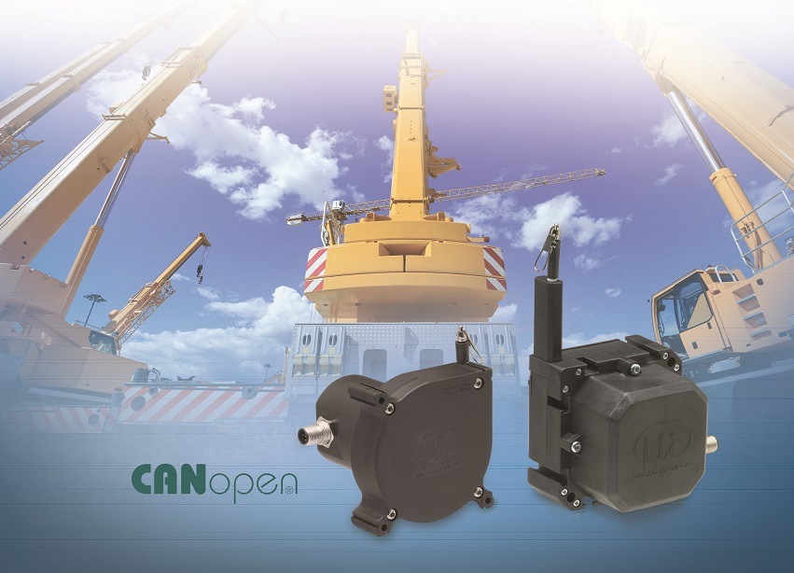
Larger measuring ranges and CANopen interfaces are now available in the wireSENSOR WPS- MK88 and wireSENSOR WPS-K100 series.

Note to Editors:

About Micro-Epsilon
Manufacturing processes throughout all industries are evolving at a rapid pace, and the quality and tolerances expected from the end user are forever increasing. Thus, the need for smarter measurement solutions is continuously growing. Micro-Epsilon (www.micro-epsilon.co.uk) is renowned globally for being at the forefront of measurement technology.
For more than 50 years, we have continuously offered reliable, high performance, unique solutions particularly when high precision measurement or inspection is required. Our product range covers sensors for the measurement of distance and displacement, sensors for IR temperature measurement and colour detection, as well as turnkey systems for dimensional measurement and defect detection.
We understand that our customers are our business partners and aim to develop long term relationships with them. We work closely with our customers to fully understand their requirements; our salespeople are engineers and understand more than just the sensor performance. We are problem solvers.
We operate a fair working policy, which results in excellent customer service and support even post sale.
Our high performance products and way of working provide our customers with a genuine competitive advantage.

To download high resolution images for this article, please go to www.silverbulletpr.co.uk/press . Alternatively, you can request an image by contacting:

Issued by: Dean Palmer
Director
SilverBullet PR Ltd
19, Glen Crescent, Stamford,
Lincolnshire PE9 1SW
Tel: 07703 023771
Email: dean@silverbulletpr.co.uk

Reader Enquiries/Advertising:
Glenn Wedgbrow,
Business Development Manager,
Micro-Epsilon UK Ltd
1, Shorelines Building,
Shore Road
Birkenhead
Cheshire CH41 1AU
Tel: +44 (0) 151 355 6070
Email: glenn.wedgbrow@micro-epsilon.co.uk

