Ref. ME441 24th July 2023

New true colour recognition controller offers colour space raw data output at speeds up to 500 Hz and colour evaluations up to 30 kHz
High precision sensor supplier Micro-Epsilon has extended its true-colour recognition CFO series with a new controller model. The existing colorSENSOR CFO100 and colorSENSOR200 focus on fast, precise evaluation of colours, the output of the raw Lab or XYZ measurement values was at the rate of just a few Hertz. The new colorSENSOR CFO250 controller offers a significantly faster raw measurement data output up to 500 Hz. With a wide range of sensor heads to choose from, the CFO250 is particularly suitable for high speed processes such as the monitoring of mixing processes (granulates and powders) and in-quality inspection in filling plants.

The colorSENSOR CFO250 true colour controller performs colour evaluations at very high speeds (measuring rates) of up to 30 kHz. In the process, taught colours are compared with the current measurement value, controllers are internally evaluated (colour detected/not detected) and output via the digital switching outputs. In addition to the evaluated result, the unevaluated raw data can also be provided in Lab or XYZ colour spaces at up to 500 Hz via UDP, RS232 or USB interface. Using a Micro-Epsilon-specific simplified binary 3-byte protocol, the data can be transferred directly to a PLC for further processing.

The need to regulate high speed processes
For applications where a pure OK/NOK evaluation is insufficient, but at the same time there is a need to regulate high speed processes, the CFO250 offers new possibilities in evaluation and further processing. For example, when filling powders, paints or other similar products, it must be ensured that the contents have not been contaminated. The fast raw measurement data output of the Lab or XYZ colour space, at up to 500 Hz, offers users advantages in terms of the monitoring of the mixing processes such as in granulate and powder production where changes in the ratio of ingredients can quickly impact the final colour desired.

Edge and level triggers
Output of measurement data can be continuous or on-demand (trigger-based). A demand-controlled output via trigger functions enables a reduction in data volumes and always provides valid measurement values. Two options are available for this: an edge trigger that determines how many measurements are made and transmitted after a trigger event; with a level trigger, measurement data is transmitted as long as a corresponding level (e.g. a 5V signal) is present at the input.

Powerful software
The new trigger functions can be set up via the intuitive web interface. Edge and level triggering are selected in the ‘Outputs’ section. The web interface allows teach-in of 254 colour groups with 320 colours in total. One function automatically adapts the illumination, averaging and signal amplification to the current measurement situation.

Micro-Epsilon’s freely downloadable sensorTOOL software can be used to make recordings up to 500 Hz using the CFO250.

For more information on the colorSENSOR series, please call the Micro-Epsilon sales department on +44 (0)151 355 6070 or email info@micro-epsilon.co.uk

– ENDS – [479 words]

Photos and captions:

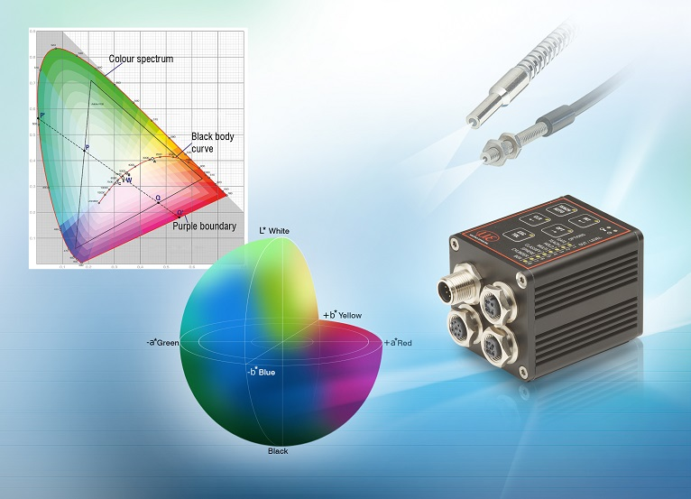
The colorSENSOR CFO250 true colour controller performs colour evaluations at very high speeds (measuring rates) of up to 30 kHz.

Note to Editors:

About Micro-Epsilon
Manufacturing processes throughout all industries are evolving at a rapid pace, and the quality and tolerances expected from the end user are forever increasing. Thus, the need for smarter measurement solutions is continuously growing. Micro-Epsilon (www.micro-epsilon.co.uk) is renowned globally for being at the forefront of measurement technology.
For more than 50 years, we have continuously offered reliable, high performance, unique solutions particularly when high precision measurement or inspection is required. Our product range covers sensors for the measurement of distance and displacement, sensors for IR temperature measurement and colour detection, as well as turnkey systems for dimensional measurement and defect detection.
We understand that our customers are our business partners and aim to develop long term relationships with them. We work closely with our customers to fully understand their requirements; our salespeople are engineers and understand more than just the sensor performance. We are problem solvers.
We operate a fair working policy, which results in excellent customer service and support even post sale.
Our high performance products and way of working provide our customers with a genuine competitive advantage.

To download high resolution images for this article, please go to www.silverbulletpr.co.uk/press . Alternatively, you can request an image by contacting:

Issued by: Dean Palmer
Director
SilverBullet PR Ltd
19, Glen Crescent, Stamford,
Lincolnshire PE9 1SW
Tel: 07703 023771
Email: dean@silverbulletpr.co.uk

Reader Enquiries/Advertising:
Glenn Wedgbrow,
Business Development Manager,
Micro-Epsilon UK Ltd
1, Shorelines Building,
Shore Road
Birkenhead
Cheshire CH41 1AU
Tel: +44 (0) 151 355 6070
Email: glenn.wedgbrow@micro-epsilon.co.uk

