Ref. ME442 3rd October 2023

MAHLE Engine Systems chooses thicknessGAUGE from Micro-Epsilon to measure the thickness and warp of metal strip materials
MAHLE Engine Systems Kilmarnock, a supplier of aluminium tin bi-metal and sinter (copper/bronze) bi-metal coils to MAHLE Bearings plants globally, has chosen the thicknessGAUGE system from Micro-Epsilon to measure the thickness of strip materials. The thicknessGAUGE is also used to measure the cross-strip profile of the material to check for warp (i.e. bowed, curved or tilted), which would adversely affect the downstream cold bonding process.

The thicknessGAUGE measurement system is a complete ‘out-of-the-box’ solution for thickness gauging and quality control. The system is suitable for both offline and inline thickness gauging and is available in several versions that use one of three different sensor types – laser triangulation, laser profile or confocal chromatic sensors.

MAHLE Engine Systems’ Kilmarnock plant uses the thicknessGAUGE.C.L, a C-frame system that uses laser triangulation sensors. These compact systems comprise of the measuring frame housing the laser sensors, an integrated linear unit including motor control, a compact bus terminal box, automatic calibration unit, as well as a multi-touch PC with pre-installed software. The laser sensors acquire data at high measuring rates (up to 4 kHz) with measurement accuracies to ±2 µm. The gauge has a 10mm measurement range and a 400mm traversing range.

Charles McMillan, Head of Quality/Process Engineering at MAHLE Engine Systems UK comments: “The metal alloys that we produce at Kilmarnock are supplied in coils to other inter-group companies where they are used in the manufacture of automotive components such as engine bearings and thrust washers.”

The quality team at Kilmarnock decided it needed some sort of thickness measurement system for the strip material that the plant produces. The strip itself goes through various different manufacturing steps, including ovens and rolling operations to produce the desired strip thickness for customers. As McMillan explains: “We eventually reach a point in our production process where the alloy strip material is ready to be sent to our cold roll bonding mill, where it is bonded onto a steel backing. We already have a fixed 100% inspection thickness measurement system and automatic gap control system on the cold roll bonding mill. However, this only gives us information on the bonded material output. We never really had any measurements of the incoming steel or of the alloy that we were producing in-house – just sample spot checks using a micrometer.”

Flexible measurement system
McMillan says his team wanted a thickness measurement system that could provide them with process capability but which would also be flexible enough to be moved around their different production lines and machines.

“We had used Micro-Epsilon products before, so we approached them to see if they had a suitable thickness measurement solution. After an on-site demonstration of the thicknessGAUGE at Kilmarnock, we gave Micro-Epsilon some strip samples taken from various steps in our production processes. Micro-Epsilon carried out some process/machine capability tests and at that point we were confident that the solution would provide us with the measurements we needed,” states McMillan.

After a day of on-site training provided by Micro-Epsilon, the Quality team at Kilmarnock used the thicknessGAUGE in various steps of its production process. As McMillan comments: “We now use the thicknessGAUGE to check the thickness of the incoming steel that we purchase, and to check the metal alloys that we produce in-house before we send these for cold bonding. Longer term, we’ll consider installing a permanent 100% thickness measurement system for incoming steel, for example, but at the moment we’re using the thicknessGAUGE to help us build up an overall picture of our process and machine capability at the plant.”

Powerful analysis and control software
All thicknessGAUGE systems are supplied with a multi-touch panel industrial PC that is pre-installed with the thicknessCONTROL software package from Micro-Epsilon. This software provides convenient touch gesture control similar to that of modern smart phones. The measured process values can be displayed in multiple ways, including simple large values of thickness, cross profiles and length trends or combinations of each. Full SPC data of the measurements is available and an automated verification of the system’s capability can be completed by the customer themselves.

Checking for material warp
As well as thickness measurements, MAHLE also wanted to check the cross-strip profile and shape of the strip as it moves through its production process. Therefore, in the thicknessCONTROL software provided by Micro-Epsilon, an extra feature was added that allows the Quality team to view the ‘warp’ of the strip material. Essentially, this is a plot of the individual profile of the top and bottom laser sensors, which allows the user to see if the material shape is bowed, curved or tilted.

“If the strip is bowed, for example, it might mean that we end up with problems downstream when we have to match the alloy to the steel for bonding. In this scenario, we would feed back to our steel supplier that they need to improve the shape of the steel, or we would have to focus on making our alloy flatter,” explains McMillan.

Benefits of the system
The plant is seeing benefits from thicknessGAUGE already. McMillan says that in the final process before the alloy strip goes to the cold bonding operation, the thicknessGAUGE has helped identify potential issues after start-up. He explains: “On start up, one particular batch of alloy strip was OK, but within about 40 metres into the coil, the thickness of the strip became harder to control and was more than 100 microns outside the target thickness. This immediately warned us that there would be a problem in our downstream bonding process. The finished product would basically be out of specification.”

Before using the thicknessGAUGE, the quality team took only sample measurements, so this type of issue may have been missed completely. “We wouldn’t know if the strip was the same thickness all the way through, or if it varied. With the thicknessGAUGE, we can now check our various processes to see what we need to do to change the number of reduction passes on the alloy.”

Although the plant is not using the thicknessGAUGE in a fixed, in-process control manner at present, it has seen enough already to suggest that it will go down the in-process route in the future.

As McMillan concludes: “Working with Micro-Epsilon has been great and the support they’ve provided has been fantastic. The on-site demonstration and training were excellent, and they turned around the sample strip tests really quickly for us. The thicknessGAUGE system itself is very intuitive, easy to use and has proved very reliable.

For more information on the thicknessGAUGE from Micro-Epsilon, please visit www.micro-epsilon.co.uk or call the Micro-Epsilon sales department on +44 (0)151 355 6070 or email mailto:info@micro-epsilon.co.uk

– ENDS – [1,101 words]

Photos and captions:
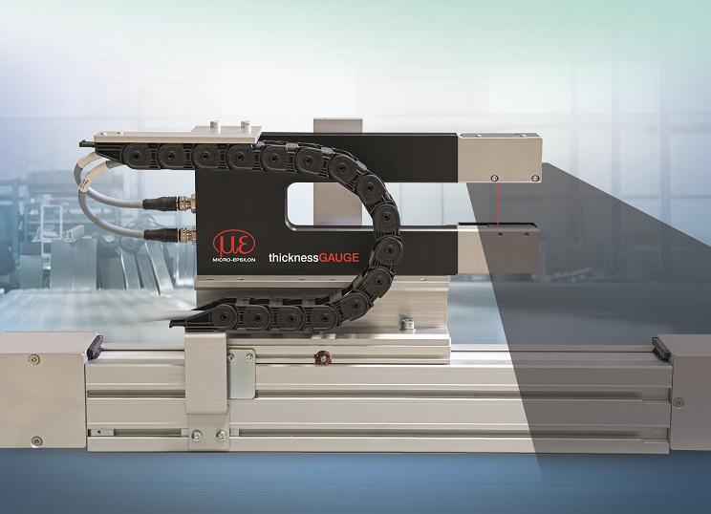
The C-frame thicknessGAUGE thickness measurement system from Micro-Epsilon.

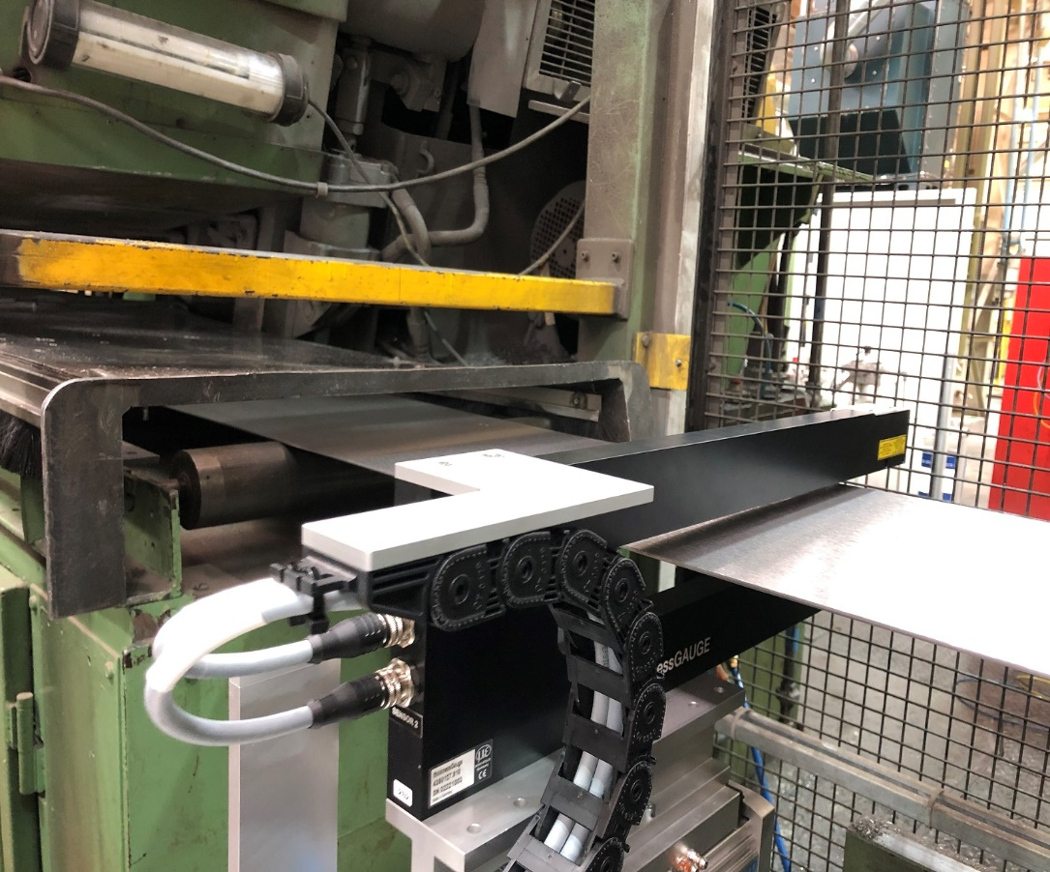
MAHLE Engine Systems Kilmarnock uses the thicknessGAUGE to measure the thickness of strip materials.

Note to Editors:

About Micro-Epsilon
Manufacturing processes throughout all industries are evolving at a rapid pace, and the quality and tolerances expected from the end user are forever increasing. Thus, the need for smarter measurement solutions is continuously growing. Micro-Epsilon (www.micro-epsilon.co.uk) is renowned globally for being at the forefront of measurement technology.
For more than 50 years, we have continuously offered reliable, high performance, unique solutions particularly when high precision measurement or inspection is required. Our product range covers sensors for the measurement of distance and displacement, sensors for IR temperature measurement and colour detection, as well as turnkey systems for dimensional measurement and defect detection.
We understand that our customers are our business partners and aim to develop long term relationships with them. We work closely with our customers to fully understand their requirements; our salespeople are engineers and understand more than just the sensor performance. We are problem solvers.
We operate a fair working policy, which results in excellent customer service and support even post sale.
Our high performance products and way of working provide our customers with a genuine competitive advantage.

To download high resolution images for this article, please go to www.silverbulletpr.co.uk/press . Alternatively, you can request an image by contacting:

Issued by: Dean Palmer
Director
SilverBullet PR Ltd
19, Glen Crescent, Stamford,
Lincolnshire PE9 1SW
Tel: 07703 023771
Email: dean@silverbulletpr.co.uk

Reader Enquiries/Advertising:
Glenn Wedgbrow,
Business Development Manager,
Micro-Epsilon UK Ltd
1, Shorelines Building,
Shore Road
Birkenhead
Cheshire CH41 1AU
Tel: +44 (0) 151 355 6070
Email: glenn.wedgbrow@micro-epsilon.co.uk

