Ref. ME443 7th September 2023

Laser distance sensors reliably measure fill levels in dusty storage silos
In order to keep logistics and production processes running smoothly, it is often important to measure the precise quantity or volume of bulk goods such as plastic granules, grain, flour, animal feeds, gravel and rock at storage locations. To avoid production downtime due to a lack of material, the fill levels in storage silos must be recorded reliably and automatically.

High precision sensor supplier Micro-Epsilon offers a range of sensors that are specially designed for these types of applications. The optoNCDT ILR range of non-contact laser distance sensors measure distances from 0.05m up to 270m. The sensors are designed for use with or without a reflector film, which is used depending on the distance and the environment. The sensors provide reliable results even under harsh conditions. Their robust design protects them from dust and splashing water. Sensor variants are available with integrated heating and increased protection classes, particularly for outdoor use.

Monitoring plastic granulate fill levels
Brückner Maschinenbau GmbH is a leading supplier of production equipment for manufacturing high quality monoaxially and biaxially stretched films, which are used as packaging material or in high-tech applications such as electromobility, energy generation and storage, or media technology.

For years, Brückner Maschinenbau has been using Micro-Epsilon laser distance sensors to monitor the fill level in storage silos. Plastic granulate, which is used for the production of films, is stored in the silos. In order to prevent production downtime due to a lack of granulate, the fill levels in the storage silos are monitored on a continuous basis.

Specially adapted optoNCDT ILR2250-100 laser distance sensors from Micro-Epsilon are used to measure the fill levels. The sensors are equipped with an air pressure flushing system to counteract the high dust formation. The sensors are mounted on the roof of the silos and measure the bulk material or granulate. From there, they measure the filling and emptying of the silos in real time and guarantee smooth flowing production and logistics processes. Due to the sensors, production stoppages due to missing material have been avoided and costs have been significantly reduced. Retrofitting the laser distance sensors to existing silos is easily possible at any time.

Compact, high performance sensor
The optoNCDT ILR2250-100 laser distance sensor measures distances up to 150m with an accuracy of < ± 1mm. The sensor measures accurately even on difficult surfaces such as dark, structured or weakly reflecting objects. Without any special adaptations to the target, the sensor has an impressive range up to 100m. Adding a reflector to the target extends the range to 150m.

Protected by an IP65 die cast aluminium housing, the optoNCDT ILR2250-100 is suitable for a wide range of applications, from transport, logistics and conveyor systems, to automation, metal processing, production monitoring and unmanned drones or vehicles. It has already found uses in monitoring large coil diameters and gantry cranes. The combined long range and high accuracy of the sensor has also found particular benefits in the measurement and control of diameters for hot ring rolling.

In terms of its technical performance, the sensor is unsurpassed in its field, providing excellent repeatability (<300µm), resolution (0.1mm) and linearity (< ± 1mm), resulting in extremely stable measurements and excellent signal stability. The sensor’s small footprint (102 x 53 x 50mm) and weight (254g) represent a 65% reduction in size and weight compared to its predecessor, allowing it to be easily installed in narrow or restricted spaces in production lines and machines.

For more information on the optoNCDT2250-100, please call the Micro-Epsilon sales department on +44 (0)151 355 6070 or email info@micro-epsilon.co.uk

– ENDS – [591 words]

Photos and captions:

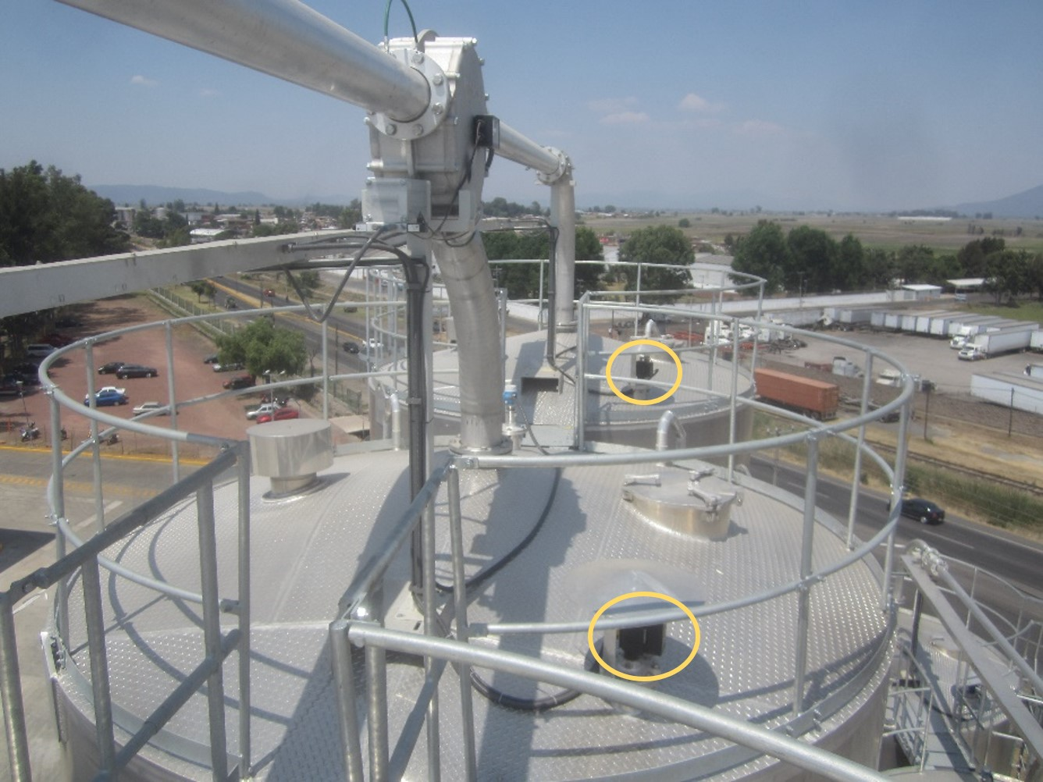
At Brückner Maschinenbau, the optoNCDT2250-100 laser distance sensors are mounted on the roof of the storage silos, where they measure the fill level of plastic granulate.

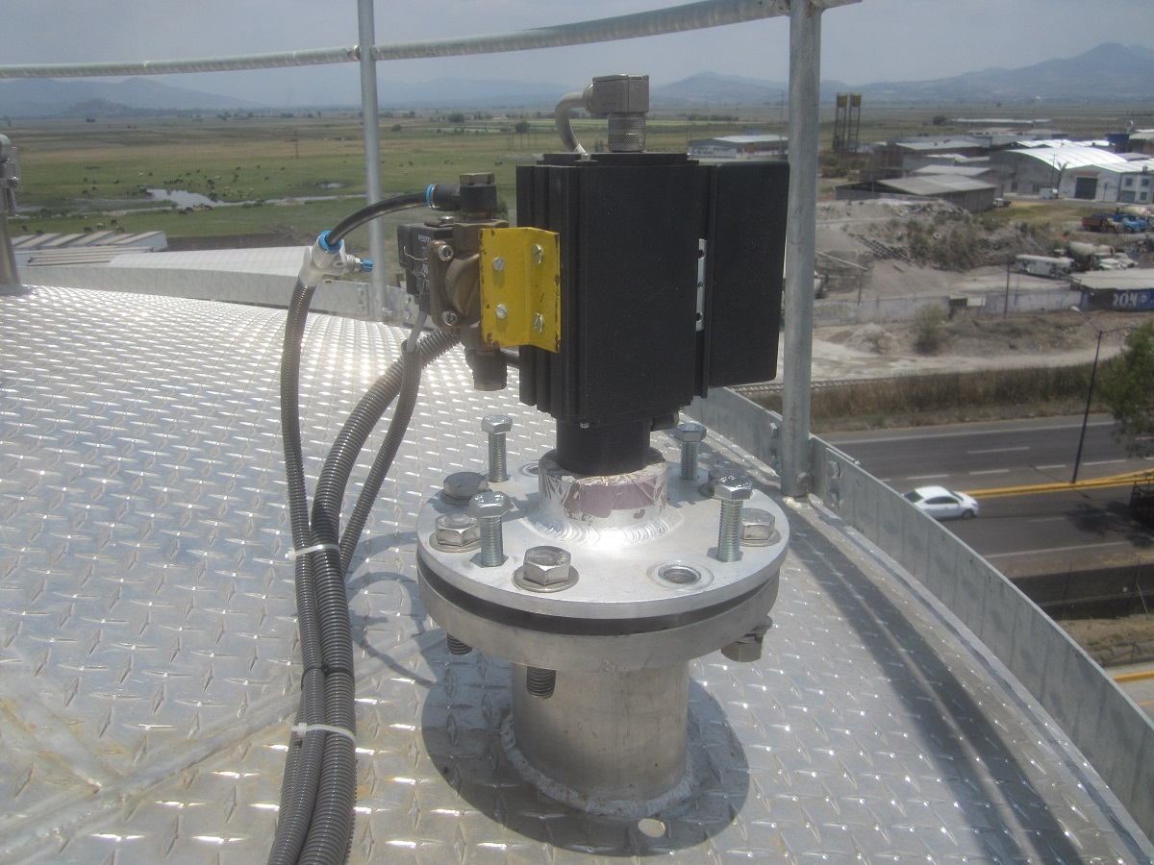
The optoNCDT2250-100 laser distance sensors are specially adapted to the application and are equipped with an air pressure flushing system to counteract the high dust formation.

Note to Editors:

About Micro-Epsilon
Manufacturing processes throughout all industries are evolving at a rapid pace, and the quality and tolerances expected from the end user are forever increasing. Thus, the need for smarter measurement solutions is continuously growing. Micro-Epsilon (www.micro-epsilon.co.uk) is renowned globally for being at the forefront of measurement technology.
For more than 50 years, we have continuously offered reliable, high performance, unique solutions particularly when high precision measurement or inspection is required. Our product range covers sensors for the measurement of distance and displacement, sensors for IR temperature measurement and colour detection, as well as turnkey systems for dimensional measurement and defect detection.
We understand that our customers are our business partners and aim to develop long term relationships with them. We work closely with our customers to fully understand their requirements; our salespeople are engineers and understand more than just the sensor performance. We are problem solvers.
We operate a fair working policy, which results in excellent customer service and support even post sale.
Our high performance products and way of working provide our customers with a genuine competitive advantage.

To download high resolution images for this article, please go to www.silverbulletpr.co.uk/press . Alternatively, you can request an image by contacting:

Issued by: Dean Palmer
Director
SilverBullet PR Ltd
19, Glen Crescent, Stamford,
Lincolnshire PE9 1SW
Tel: 07703 023771
Email: dean@silverbulletpr.co.uk

Reader Enquiries/Advertising:
Glenn Wedgbrow,
Business Development Manager,
Micro-Epsilon UK Ltd
1, Shorelines Building,
Shore Road
Birkenhead
Cheshire CH41 1AU
Tel: +44 (0) 151 355 6070
Email: glenn.wedgbrow@micro-epsilon.co.uk

