Ref. ME444 20th September 2023

H.D.Lenzen chooses inline colour measurement system from Micro-Epsilon to measure the colour of zinc-coated strip materials
H.D.Lenzen, a specialist in the surface finishing of strip materials, has chosen an inline colour measurement system from Micro-Epsilon to continuously measure the colour of zinc coated strip during production. In addition to providing 100% quality control during production, the colour measurement system is also helping to reduce waste and customer complaints due to colour variations.

Classic strip material is used to produce punched, bent and deep-drawn components, filters and gaskets, electronic components and packaging components. The raw material, in this case steel or aluminium, is coated for refinement purposes and not only serves to enhance the appearance but also the resistance, while the material becomes easier
to process.

Consistent product quality
During the surface finishing process at H.D.Lenzen, steel and aluminium strips are coated with zinc, which is deposited onto the cleaned strip from an electrolyte solution by applying a high electrical current. As well as receiving corrosion- and wear-resistant protection, the strip material also has a defined colour. Reliable testing of this colouring is necessary in order to ensure consistent product quality.

In order to fulfill the high requirements for precision and speed, the innovative colorCONTROL ACS7000 colour measuring system from Micro-Epsilon is used, which recognises colour shades to an accuracy of ∆E < 0.08. Manual, visual inspection is not possible in this area, as a trained human eye can only recognise colour distances up to a maximum of ∆E 0.5.

In addition, the colour measuring system must keep pace with high speed inline
measurements. Therefore, the system is installed on a traversing unit that moves
over the continuous material, which has a width of 720mm. Influences
induced by fluctuating temperatures are minimised by continuous referencing. Via an Ethernet interface, these high precision measurement values are directly transmitted and evaluated by a connected production monitoring PC. Should any deviations occur, the plant operator can rapidly intervene, which means waste is reduced.

The core component of this 100% quality inspection system is the colorCONTROL ACS7000 colour measuring system with an ACS1 sensor head from Micro-Epsilon. The ACS1 sensor is designed with the transmitter and receiver mounted inside one sensor head. The optics are arranged at an angle of 30°/0° to each other, producing a working distance of 50mm from the target.

Plant integration, including software for monitoring and retracing all past production parameters, was designed by TriDiCam GmbH (info@tridicam.de), an official system partner of Micro-Epsilon.

Continuous inline colour measurements
The colorCONTROL ACS7000 identifies colours using any of the XYZ; L*a*b*; L*u*v*; RGB and DIN99 measurement definitions (user selectable). The system can be set up to continually monitor a production process and output the colour measurement via Ethernet, EtherCAT or RS422 and can also be taught pass fail/limits and then output out-of-tolerance alarms using digital I/O.

The system is therefore suitable for a wide range of applications where colours and shades must be examined on-the-fly and to very high accuracies. Existing applications include automotive paint inspection, colour measurement of car interiors, coloured glass, transparent film and sheet production, printing, packaging, medical technology, food, cosmetics, pharmaceuticals and in the processing of plastics, food, wood, paper, veneer and textiles.

For more information on the colorCONTROL ACS7000 colour measurement system from Micro-Epsilon, please visit www.micro-epsilon.co.uk or call the Micro-Epsilon sales department on +44 (0)151 355 6070 or email mailto:info@micro-epsilon.co.uk

– ENDS – [546 words]

Photos and captions:
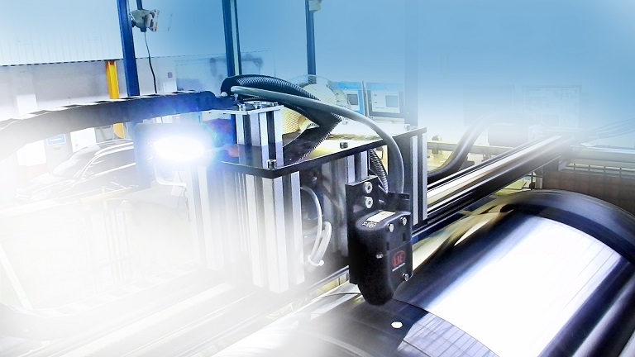
The ACS7000 non-contact colour measurement system is installed on a traversing unit that moves over the continuous material, which has a width of 72cm.

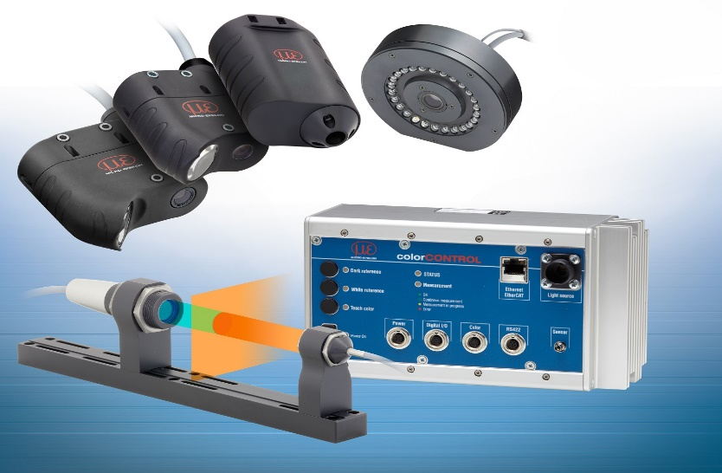
The ACS7000 non-contact colour measurement system is suitable for a wide range of applications where colours and shades must be examined on-the-fly and to very high accuracies.

Note to Editors:

About Micro-Epsilon
Manufacturing processes throughout all industries are evolving at a rapid pace, and the quality and tolerances expected from the end user are forever increasing. Thus, the need for smarter measurement solutions is continuously growing. Micro-Epsilon (www.micro-epsilon.co.uk) is renowned globally for being at the forefront of measurement technology.
For more than 50 years, we have continuously offered reliable, high performance, unique solutions particularly when high precision measurement or inspection is required. Our product range covers sensors for the measurement of distance and displacement, sensors for IR temperature measurement and colour detection, as well as turnkey systems for dimensional measurement and defect detection.
We understand that our customers are our business partners and aim to develop long term relationships with them. We work closely with our customers to fully understand their requirements; our salespeople are engineers and understand more than just the sensor performance. We are problem solvers.
We operate a fair working policy, which results in excellent customer service and support even post sale.
Our high performance products and way of working provide our customers with a genuine competitive advantage.

To download high resolution images for this article, please go to www.silverbulletpr.co.uk/press . Alternatively, you can request an image by contacting:

Issued by: Dean Palmer
Director
SilverBullet PR Ltd
19, Glen Crescent, Stamford,
Lincolnshire PE9 1SW
Tel: 07703 023771
Email: dean@silverbulletpr.co.uk

Reader Enquiries/Advertising:
Glenn Wedgbrow,
Business Development Manager,
Micro-Epsilon UK Ltd
1, Shorelines Building,
Shore Road
Birkenhead
Cheshire CH41 1AU
Tel: +44 (0) 151 355 6070
Email: glenn.wedgbrow@micro-epsilon.co.uk

