Ref. ME446 18th October 2023

New white light interferometer offers nanometre-accurate thickness measurements of monocrystalline silicon wafers
Precision sensor manufacturer Micro-Epsilon has further developed its interferoMETER range of white light interferometers to include a system specially designed for non-contact, high precision thickness measurement of monocrystalline silicon wafers. This further expands the range of potential applications in the semiconductor industry.

The new interferoMETER IMS5420-TH24 system incorporates a broadband superluminscent diode (SLED) with a wavelength range of 1,100 nm, allowing thickness measurements of undoped, doped and highly doped silicon wafers using only one measuring system. Thicknesses from 50 to 1050 µm can be measured with a doping of up to 5 mΩ cm from a distance of 24 mm and signal stabilities (z-axis resolution) of less than 1 nm can be achieved. Even for highly doped wafers with a specific resistance of 0.005 Ω cm, thicknesses from 0.05 mm to 0.85 mm can be measured.

With a measuring rate of up to 6 kHz, the interferoMETER IMS5420-TH24 is suitable for in-line and at-line thickness measurements, for example, after and during grinding and lapping, as well as during quality control. Other applications for the measurement system include thickness measurement of glass, film or silicon carbide wafers.

Multi-layer thickness measurements
The interferoMETER IMS5420 is available either as a thickness measuring system or as a multi-peak (MP) version for thickness measurement of up to five layers (e.g. wafer thickness, air gap, film and coatings > 50 µm) with silicon thicknesses from 0.05 to 1.05 mm. The measurable thickness of air gaps is up to 4 mm. In addition, a version of the controller with IP67 protection, a stainless steel housing and suitable fibre optics/sensors is available for thickness measurements during lapping or for use in other harsh industrial environments.

Patented pilot laser
White light interferometers work with infrared, non-visible light (approx. 100 nm), which means that the measurement position cannot be seen directly. To visualise the measuring position, all interferoMETER systems are equipped with a pilot laser that projects a light spot onto the measuring position. The pilot laser uses a patented method to provide feedback on the distance to the target and if the sensor is within the measuring range, a constant glow is emitted by the pilot laser. If the measuring object is outside the measuring range, the pilot laser flashes.

Unmatched accuracy
The interferoMETER range of high performance white light interferometers from Micro-Epsilon provide unmatched accuracy levels in absolute non-contact optical distance and thickness measurement. With measurement resolution from 30 picometres and linearity from ±10 nm, these interferometers represent a step change in accuracy from its confocal measurement systems. The interferoMETER range comprises of a controller, a sensor and a fibre optic cable. Unlike traditional laser interferometers that use a single wavelength and only perform relative measurements, the interferoMETER range operates with a broadband super-luminescent diode (SLED) and can make absolute measurements, ideal for step height and surface measurements.

For easy set up and configuration, a modern, intuitive web interface is provided. In addition, various interfaces (EtherCAT, Ethernet, Profinet, EtherNet/IP, RS422, analogue) offer numerous integration options.

For more information on the interferoMETER IMS5420-TH24 from Micro-Epsilon, please visit www.micro-epsilon.co.uk or call the Micro-Epsilon sales department on +44 (0)151 355 6070 or email mailto:info@micro-epsilon.co.uk

– ENDS – [523 words]

Photos and captions:

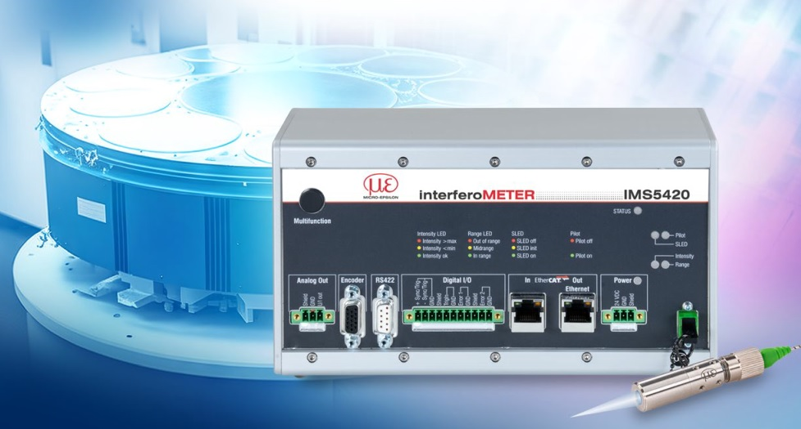
The interferoMETER IMS5420-TH24 is designed for thickness measurement of monocrystalline silicon wafers.

Note to Editors:

About Micro-Epsilon
Manufacturing processes throughout all industries are evolving at a rapid pace, and the quality and tolerances expected from the end user are forever increasing. Thus, the need for smarter measurement solutions is continuously growing. Micro-Epsilon (www.micro-epsilon.co.uk) is renowned globally for being at the forefront of measurement technology.
For more than 50 years, we have continuously offered reliable, high performance, unique solutions particularly when high precision measurement or inspection is required. Our product range covers sensors for the measurement of distance and displacement, sensors for IR temperature measurement and colour detection, as well as turnkey systems for dimensional measurement and defect detection.
We understand that our customers are our business partners and aim to develop long term relationships with them. We work closely with our customers to fully understand their requirements; our salespeople are engineers and understand more than just the sensor performance. We are problem solvers.
We operate a fair working policy, which results in excellent customer service and support even post sale.
Our high performance products and way of working provide our customers with a genuine competitive advantage.

To download high resolution images for this article, please go to www.silverbulletpr.co.uk/press . Alternatively, you can request an image by contacting:

Issued by: Dean Palmer
Director
SilverBullet PR Ltd
19, Glen Crescent, Stamford,
Lincolnshire PE9 1SW
Tel: 01780 754 254
Mobile: 07703 023771
Email: dean@silverbulletpr.co.uk

Reader Enquiries/Advertising:
Glenn Wedgbrow,
Business Development Manager,
Micro-Epsilon UK Ltd
1, Shorelines Building,
Shore Road
Birkenhead
Cheshire CH41 1AU
Tel: +44 (0) 151 355 6070
Email: glenn.wedgbrow@micro-epsilon.co.uk

