Ref. ME450 8th November 2023

New capacitive measurement controller with integrated Profinet interface
Precision sensor manufacturer Micro-Epsilon has further expanded its capaNCDT 62xx range of multi-channel capacitive controllers with the addition of the DT6240 controller with integrated Profinet interface. This means users benefit from real-time measurement data without any time delays, as well as reduced installation and wiring effort. Capacitive systems from Micro-Epsilon offer some of the highest precision measurements available to industry.

The new DT6240-PROFINET controller enables direct integration of the full capacitive sensor performance directly into PLCs and other control systems via Profinet without requiring additional separate interface modules. The controller is configured and parameterised directly via Industrial Ethernet. As well as an attractive price-performance ratio, the DT6240-PROFINET controller has a modular design that allows it to be expanded at any time by up to four measuring channels. The controller is compatible with all sensors and cables from the capaNCDT series of capacitive displacement sensors from Micro-Epsilon.

Like the DT6220 and DT6230 capacitive controllers, the DT6240-PROFINET also uses the DL6220 and DL6230 demodulators for operation. The DT6240-PROFINET can be used as a benchtop unit, wall-mounted unit or DIN rail-mounted via an adapter.

Capacitive controller range
The capaNCDT 62xx range of controllers from Micro-Epsilon is an entirely modular, multi-channel measuring system. Based on the basic single-channel system, the user can autonomously expand the system by up to four measuring channels. The range now comprises of four basic controller models:
- DT6220 – Ethernet, 5 kHz
- DT6230 – Ethernet/EtherCAT + external synchronisation, 5 kHz
- DT6222 – Ethernet, 20kHz
- DT6240 – Profinet, 5 kHz

Depending on user requirements, the controller can be combined and expanded with different demodulators. Each demodulator can have its own set of characteristics for extended cable length and/or adjustment of the connected sensors measurement range to either increase or decrease the range by factor 2. In terms of modularity, interfaces and precision, the DT62xx range is the most innovative capacitive measuring system available on the market. Customers come from a range of industries including semiconductors, laboratories and research, automation and medical engineering, with applications ranging from thickness measurement to oscillation measurement, coordinate measurement, evenness and brake test stands.

For more information on the capaNCDT 62xx range of controllers from Micro-Epsilon, please visit www.micro-epsilon.co.uk or call the Micro-Epsilon sales department on +44 (0)151 355 6070 or email mailto:info@micro-epsilon.co.uk

– ENDS – [472 words]

Photos and captions:

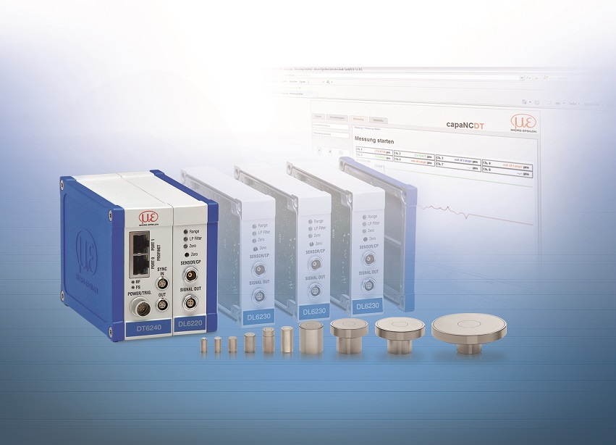
The DT6240 capacitive controller with integrated Profinet industrial Ethernet interface.

Note to Editors:

About Micro-Epsilon
Manufacturing processes throughout all industries are evolving at a rapid pace, and the quality and tolerances expected from the end user are forever increasing. Thus, the need for smarter measurement solutions is continuously growing. Micro-Epsilon (www.micro-epsilon.co.uk) is renowned globally for being at the forefront of measurement technology.
For more than 50 years, we have continuously offered reliable, high performance, unique solutions particularly when high precision measurement or inspection is required. Our product range covers sensors for the measurement of distance and displacement, sensors for IR temperature measurement and colour detection, as well as turnkey systems for dimensional measurement and defect detection.
We understand that our customers are our business partners and aim to develop long term relationships with them. We work closely with our customers to fully understand their requirements; our salespeople are engineers and understand more than just the sensor performance. We are problem solvers.
We operate a fair working policy, which results in excellent customer service and support even post sale.
Our high performance products and way of working provide our customers with a genuine competitive advantage.

To download high resolution images for this article, please go to www.silverbulletpr.co.uk/press . Alternatively, you can request an image by contacting:

Issued by: Dean Palmer
Director
SilverBullet PR Ltd
19, Glen Crescent, Stamford,
Lincolnshire PE9 1SW
Tel: 01780 754 254
Mobile: 07703 023771
Email: dean@silverbulletpr.co.uk

Reader Enquiries/Advertising:
Glenn Wedgbrow,
Business Development Manager,
Micro-Epsilon UK Ltd
1, Shorelines Building,
Shore Road
Birkenhead
Cheshire CH41 1AU
Tel: +44 (0) 151 355 6070
Email: glenn.wedgbrow@micro-epsilon.co.uk

