Ref. ME451 15th November 2023

2D/3D laser line profile scanners now offer larger measuring fields
up to 788 mm wide by 610 mm deep
Precision sensor manufacturer Micro-Epsilon has extended its scanCONTROL LLT30xx range of 2D/3D laser line profile sensors (profile scanners) with two larger measuring fields now available. The scanCONTROL LLT30xx-430 and scanCONTROL LLT30xx-600 provide measuring fields of up to 560 x 390 mm and 788 x 610 mm respectively, enabling precise profile measurements on almost all surfaces. The larger measuring fields open up greater opportunities for 2D/3D profile measurements in a wide variety of industrial applications, including automation, machine building, quality control, production and process monitoring. Due to their large measuring range, one of these new sensors can perform the same task that previously would have required several sensors.

Laser line profile scanners from Micro-Epsilon are among the highest performing profile sensors in terms of accuracy and measuring rate. All common measuring ranges from 10 mm to 788 mm are now available.

Fast, precise 2D/3D profile measurements
The scanCONTROL LLT30xx laser profile scanners provide calibrated 2D profile data with up to 9.6 million points per second. The laser scanner has an integrated controller and various interfaces (including Profinet, EtherCAT and EtherNet/IP) that allow fast, easy integration into production lines and machines. With a maximum profile frequency of 10kHz and innovative exposure control, the scanners enable precise profile measurements in high speed, dynamic processes. A high resolution sensor matrix offers a resolution of 2,048 points per profile, allowing measurements of extremely fine surface/geometrical details. Due to their high accuracy, high profile frequency and versatility, the laser scanners are suitable for demanding applications, including measurement of angles, steps, gaps, distances and circles.

Innovative exposure control
The user can choose from predefined operating modes to suit each measurement task. The ‘High Dynamic Range’ (HDR) mode is for optimal profile detection on difficult/inhomogeneous or dark surfaces. In HDR mode, the rows of the sensor matrix are exposed differently but simultaneously, which avoids time offsets between recordings, allowing reliable measurements of moving objects. The areas for auto-exposure can be selected individually. Other operating modes include a ‘High Resolution’ mode for maximum precision measurements and a ‘High Speed’ mode for ultra-fast measurements on rapidly moving objects.

The scanCONTROL LLT30xx-430 and LLT30xx-600 are available with a range of optional extras, including hardware switch-off of the laser line, and increased laser power (class 3R).

For more information on the scanCONTROL LLT30xx range of laser profile sensors from Micro-Epsilon, please visit www.micro-epsilon.co.uk or call the Micro-Epsilon sales department on +44 (0)151 355 6070 or email mailto:info@micro-epsilon.co.uk

– ENDS – [405 words]

Photos and captions:

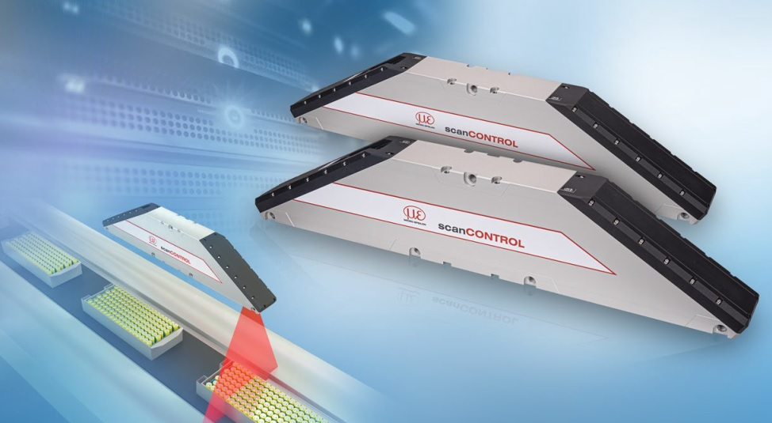
The scanCONTROL LLT30xx-430 and LLT30xx-600 enable measurement of large objects at a large offset distance.

Note to Editors:

About Micro-Epsilon
Manufacturing processes throughout all industries are evolving at a rapid pace, and the quality and tolerances expected from the end user are forever increasing. Thus, the need for smarter measurement solutions is continuously growing. Micro-Epsilon (www.micro-epsilon.co.uk) is renowned globally for being at the forefront of measurement technology.
For more than 50 years, we have continuously offered reliable, high performance, unique solutions particularly when high precision measurement or inspection is required. Our product range covers sensors for the measurement of distance and displacement, sensors for IR temperature measurement and colour detection, as well as turnkey systems for dimensional measurement and defect detection.
We understand that our customers are our business partners and aim to develop long term relationships with them. We work closely with our customers to fully understand their requirements; our salespeople are engineers and understand more than just the sensor performance. We are problem solvers.
We operate a fair working policy, which results in excellent customer service and support even post sale.
Our high performance products and way of working provide our customers with a genuine competitive advantage.

To download high resolution images for this article, please go to www.silverbulletpr.co.uk/press . Alternatively, you can request an image by contacting:

Issued by: Dean Palmer
Director
SilverBullet PR Ltd
19, Glen Crescent, Stamford,
Lincolnshire PE9 1SW
Tel: 01780 754 254
Mobile: 07703 023771
Email: dean@silverbulletpr.co.uk

Reader Enquiries/Advertising:
Glenn Wedgbrow,
Business Development Manager,
Micro-Epsilon UK Ltd
1, Shorelines Building,
Shore Road
Birkenhead
Cheshire CH41 1AU
Tel: +44 (0) 151 355 6070
Email: glenn.wedgbrow@micro-epsilon.co.uk

