Ref. ME457 14th February 2024

Micro-Epsilon extends its high precision series of 3D snapshot sensors with larger measuring range versions
Precision sensor manufacturer Micro-Epsilon has extended its surfaceCONTROL range of high precision 3D snapshot measurement sensors for automated, inline measurement of geometry, shape and surface quality of objects. The surfaceCONTROL 3xx0-240 offers a larger measuring range of 240 mm and a measurement area of up to 245 x 180 mm. The sensor delivers the best measurement results at a z-axis distance of between 340 and 540mm.

The surfaceCONTROL 3xx0-240 is a 3D snapshot sensor with a compact design and extremely high resolution in the z-axis. With its high repeatability combined with the larger measuring area and measuring range, the sensor sets a new benchmark in high precision 3D measurement technology.

The surfaceCONTROL 3xx0-240 is available in all classes and models of the surfaceCONTROL 3xx0 series, i.e. the surfaceCONTROL 3D 3200 and surfaceCONTROL 3D 3500 ranges, with each offering a different measuring area and depth of field. Both models are fully integrated industrial sensors that are protected to IP67 with passive cooling (active cooling is available for higher operating temperatures).

The surfaceCONTROL 3D 3500 offers the highest z-axis repeatability of up to 0.4 µm and best z-axis resolution of 1.0 µm. A high data processing speed of up to 2.2 million 3D points per second enables the sensor to increase productivity in the respective application.

The surfaceCONTROL 3D 3200 is a more affordable version of the surfaceCONTROL 3D 3500, but still offers many similar technical performance benefits. The surfaceCONTROL 3D 3200-240 offers a high z-axis repeatability of up to 0.6 µm and a high z-axis resolution of 1.5 µm. With data acquisition times from 0.3 s, the sensor is suitable for many industrial applications.
The surfaceCONTROL 3xx0-240 is suitable for a wide range of flatness measurement, coplanarity measurement and surface defect detection applications, including flatness inspection of circuit boards; planarity inspection of unpopulated PCB substrates; completeness check of electronic components on fitted PCBs; 3D measurement of high precision mechanical parts; width, tilt angle and position measurement of rivets; detection and evaluation of breaks on clutch discs; 3D text recognition of embossments that cannot be solved using 2D image processing due to lack of contrast; inspection of height and thickness of adhesive beading on smartphone shells; and determination of shape deviation defects on injection moulded parts.

All surfaceCONTROL 3D systems support the very latest GigE Vision and GenICam standards for easy integration into third-party image processing software. A comprehensive software development kit (SDK) is also provided that allows customers to develop their own analysis software. Also included in the scope of supply is Micro-Epsilon’s 3D View software, which offers a convenient user interface for surfaceCONTROL sensors. The software allows fast commissioning, evaluation of the sensor, set up and optimisation of parameters, and ensures the correct positioning of the measuring object.

For more information on the surfaceCONTROL series, please visit
www.micro-epsilon.co.uk or call the Micro-Epsilon sales department on +44 (0)151 355 6070 or email info@micro-epsilon.co.uk

– ENDS – [481 words]

Photos and captions:
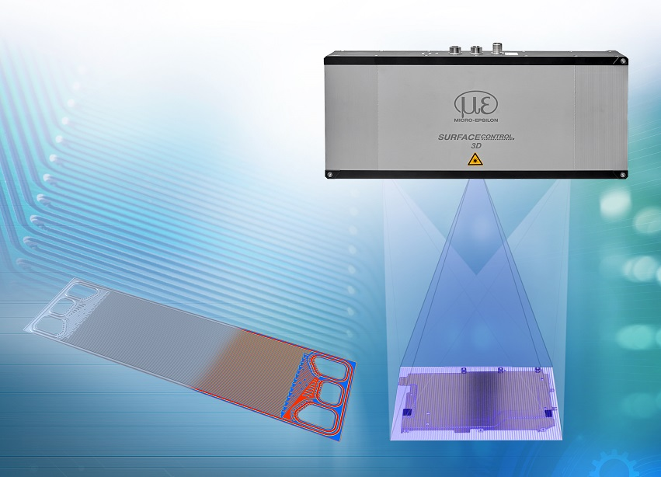
The surfaceCONTROL 3xx0-240.

Note to Editors:

About Micro-Epsilon
Manufacturing processes throughout all industries are evolving at a rapid pace, and the quality and tolerances expected from the end user are forever increasing. Thus, the need for smarter measurement solutions is continuously growing. Micro-Epsilon (www.micro-epsilon.co.uk) is renowned globally for being at the forefront of measurement technology.
For more than 50 years, we have continuously offered reliable, high performance, unique solutions particularly when high precision measurement or inspection is required. Our product range covers sensors for the measurement of distance and displacement, sensors for IR temperature measurement and colour detection, as well as turnkey systems for dimensional measurement and defect detection.
We understand that our customers are our business partners and aim to develop long term relationships with them. We work closely with our customers to fully understand their requirements; our salespeople are engineers and understand more than just the sensor performance. We are problem solvers.
We operate a fair working policy, which results in excellent customer service and support even post sale.
Our high performance products and way of working provide our customers with a genuine competitive advantage.

To download high resolution images for this article, please go to www.silverbulletpr.co.uk/press . Alternatively, you can request an image by contacting:

Issued by: Dean Palmer
Director
SilverBullet PR Ltd
19, Glen Crescent, Stamford,
Lincolnshire PE9 1SW
Tel: 01780 754 254
Mobile: 07703 023771
Email: dean@silverbulletpr.co.uk

Reader Enquiries/Advertising:
Glenn Wedgbrow,
Business Development Manager,
Micro-Epsilon UK Ltd
1, Shorelines Building,
Shore Road
Birkenhead
Cheshire CH41 1AU
Tel: +44 (0) 151 355 6070
Email: glenn.wedgbrow@micro-epsilon.co.uk

