Ref. ME460 2nd April 2024

Confocal measurement system enables faster, more accurate centring of Diamond-Anvil Cells at The University of Edinburgh
Research undertaken in the School of Chemistry at The University of Edinburgh is benefitting from the use of a confocal measurement system from Micro-Epsilon, which enables the optical centring of a Diamond-Anvil Cell (DAC) in X-ray diffraction experiments used to determine the structures of molecules and other compounds in the crystalline state. Compared to previous methods, the confocal measurement system is more accurate and significantly reduces the time required for centring.

The confocal measurement system comprises a confocal IFS2406-3 confocal chromatic sensor with a measuring range of 3 mm, and a confocal IFC2421 single channel controller. With resolution of 32 nm (static) and linearity of < ± 1.5 µm, the sensor is fixed into position using a JMA adjustable mounting adapter from Micro-Epsilon, which simplifies the alignment and any fine adjustments.

What is a DAC used for?
X-ray diffraction is the most widely used tool for studying the structures of materials at the atomic level. Its most famous application was in the determination of the structure of DNA, but it is used routinely in modern research in Chemistry, Physics, Biology and Geology. The University of Edinburgh is the UK’s leading centre for applying X-ray diffraction at high pressure, from 0.1 GPa (1000 atm) to 100 GPa (1 million atm) and beyond, to study the properties of materials. Pressures of this magnitude can be generated using a diamond anvil cell (DAC).

A DAC consists of two opposing diamonds with a small, sub-millimetre sized sample compressed between the polished culets (flat tips). The diamonds are arranged either side of a hole drilled within a piece of metal (usually tungsten, rhenium or steel) called a gasket (see Fig 1). This whole arrangement sits inside a clamp. The two halves of the clamp are carefully screwed together to create pressure inside the small cavity. A crystal is placed on one of the diamond faces. Pressure can be monitored using fluorescence of a reference material such as ruby, whose behaviour under pressure is known. The whole arrangement can sit in the palm of a hand.

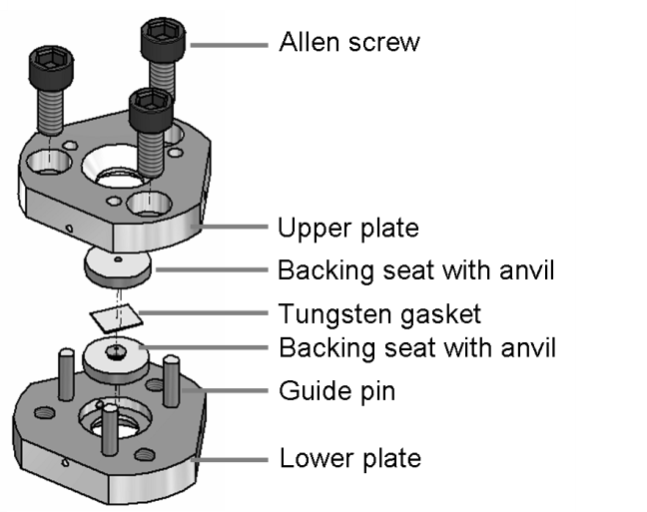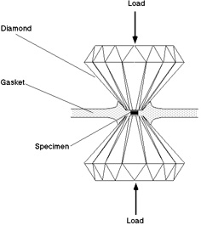

Fig 1. Schematic diagram showing a Merrill-Bassett diamond anvil cell used in high-pressure research (credit: Moggach, S. A., Allan, D. R., Parsons, S. & Warren, J. E. (2008). Incorporation of a new design of backing seat and anvil in a Merrill-Bassett diamond anvil cell. J. Appl. Cryst. 41, 249-251).

The highest reported pressure achieved in a DAC to date is in excess of 700 GPa, but the majority of DAC measurements are carried out at 0.1 to 100 GPa. The transparency of diamond in the visible, infrared and X-ray portions of the spectrum enables application of a variety of optical and X-ray techniques under in situ high-pressure conditions with this device. The study of the ways crystal structures adapt and transform at extreme pressures is a major focus of high-pressure studies. Significant changes in atomic bonding occur at high pressures, and materials also undergo major changes in mechanical properties – a famous example being the conversion of graphite to diamond that occurs at 12 GPa and 2000°C.

Simon Parsons, Professor of Crystallography, School of Chemistry at The University of Edinburgh, comments: “We study molecular materials to determine how the molecular structures of crystals change under high pressure. We use the X-ray diffraction method to determine the structure of the crystal and to understand how the inter-molecular interactions change as molecules are pushed together.”

Mounted on an X-ray diffractometer, the crystal is rotated through several hundred (approximately every 0.5 degrees) different orientations. The X-ray diffraction patterns captured at each point are combined to create a 3D diffraction pattern which is then used to determine the crystal structure. This method requires the crystal to be centred at all times so that it stays in the beam.

The centring challenge
As Simon Parsons explains: “The diamonds are transparent and you can see directly through the cell. The X-ray beam passes along the same path during data collections. The crystal can be centred using a microscope or video camera in the two directions that are perpendicular to the beam. However, the challenge is when you try to centre the crystal along the direction of the beam. Essentially, the crystal is obscured by the metal body of the cell and you cannot view it to centre it. This is where the Micro-Epsilon confocal chromatic sensor comes in.”

Prior to the confocal optical method, the DAC would be centred by ensuring that the image of the crystal is focused when viewed from both sides of the cell. While this is easy to perform, it can be inaccurate and also requires a clear view of the crystal in both directions, which is not possible for some samples. “We were struggling to get within 40-50 microns of the true centre in some cases. Another method that can be used is diffraction centring, which is accurate but can be very time consuming,” he adds.

At this point in his research studies, Simon Parsons started to look for an alternative method of centring the DAC with the X-ray diffractometer. He searched online for some kind of optical technology that could measure distance using a laser. He states: “I wanted to be able to measure the cell in one orientation, then rotate it through 180 degrees and move the cell so that the two readings are the same, which means it would be centred. I came across Micro-Epsilon’s website and its confocal chromatic sensors. I contacted one of the sales engineers, who came to Edinburgh to look at the laboratory set up. He recommended the IFS2406-3 confocal sensor and it has worked brilliantly since.”

He continues: “The sensor actually measures more precisely than we need. It’s capable of measuring to a resolution of 32 nm, but if we’re within 10 microns of the true centre in both directions, we consider it centred. In the laboratory set up, we move the cell so that it is perpendicular to the sensor, we take a reading, then we zero that reading. Next, we rotate it through 180 degrees and take another reading, then just move it halfway. We use the sensor every time we perform high-pressure data collections, often on a daily basis. The sensor has been very reliable and it has speeded up the time it takes to centre the DAC and diffractometer.”

“The confocal sensor is now our Stage One centring procedure, followed by a final check with diffraction centring,” says Parsons. “We usually find that no further adjustments are needed, but if they are, the confocal sensor makes any offsets easy to apply.”
High performance sensor
In terms of the size and performance of its product portfolio, Micro-Epsilon is a leader in the field of confocal measurement technology. The confocal measurement principle is designed for high accuracy, non-contact displacement, distance and position measurement against any surface: solid, transparent, polished mirrored surfaces, low reflective matt surfaces and even liquids.

The confocalDT 2421 controller is suitable for use with all confocal chromatic sensors from Micro-Epsilon. The controller is used for distance and thickness measurements of diffuse reflecting and specular surfaces.

The confocal IFS2406-3 sensor stands out due to its compact design and high precision. Quite often, confocal sensors are selected when laser triangulation or other optical sensors are not accurate or stable enough on the surface being measured. In addition, confocal sensors have an extremely small spot diameter, typically a few microns and measure in the vertical plane, so do not suffer from shadowing of the reflected light.

User-friendly technology
Simon Parsons comments: “The confocal sensor projects polychromatic light onto the target surface. It can be aligned using an optically centred 300 micron steel ball and then applied routinely to DAC experiments. The reflected light that comes back from the target surface is received by the sensor and transferred to the controller, a distance measurement is then performed to determine whether the target and the X-ray source are aligned. It’s a user-friendly system with high precision measurements that provides a simple and practical method for DAC centring.”

He concludes: “I had not worked with Micro-Epsilon before, but the advice and guidance they gave us was spot on. They demonstrated the sensor to us here and we could tell from the initial sensor set up that the confocal technology was going to work and provide us with what we needed. The technical support from Micro-Epsilon has also been excellent.”

For more information on the confocal IFS2406 series of confocal sensors and the confocalDT 2421 controller from Micro-Epsilon, please visit www.micro-epsilon.co.uk or call the Micro-Epsilon sales department on +44 (0)151 355 6070 or email mailto:info@micro-epsilon.co.uk

– ENDS – [1,410 words]

Photos and captions:

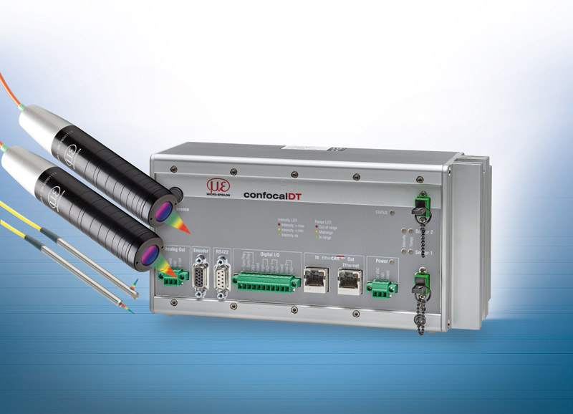
The confocalDT 2421 controller and IFS2406 series of confocal sensors from Micro-Epsilon.
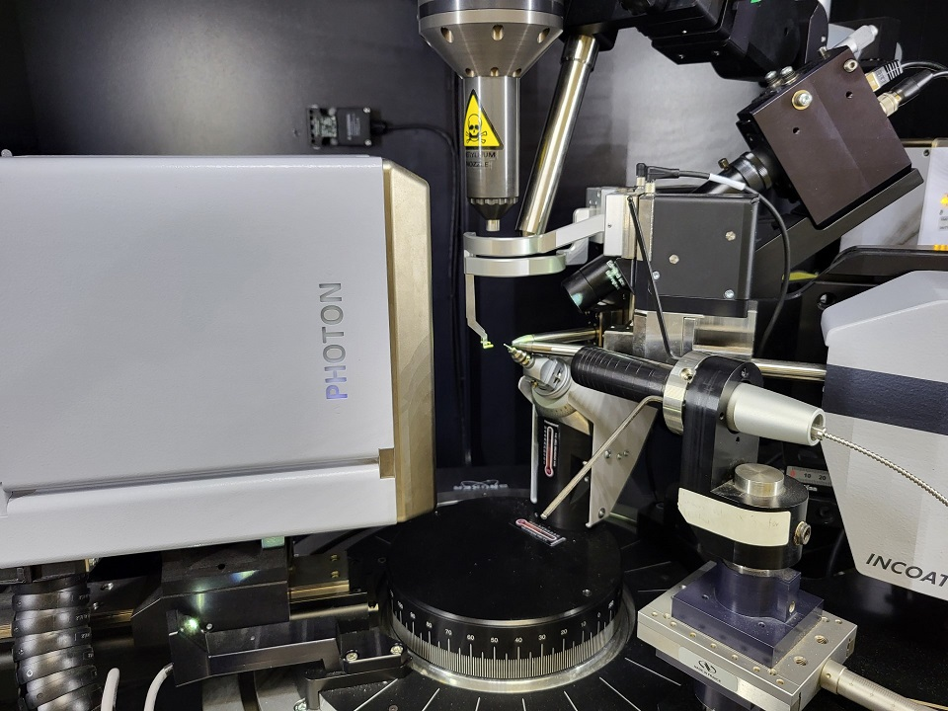
The IFS2406-3 confocal sensor is mounted at a distance of 75 mm from the target.

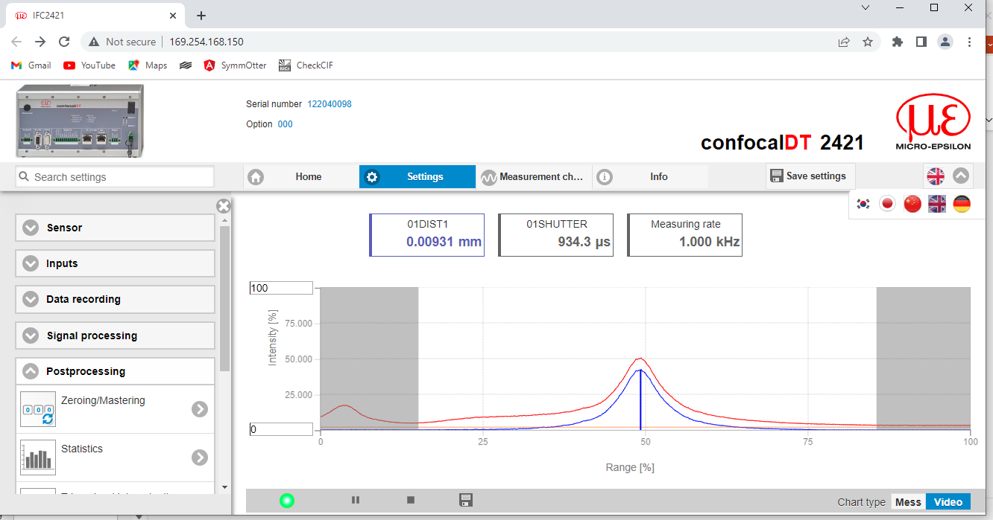
The confocal sensor performs a distance measurement to determine whether the DAC and the X-ray source are correctly aligned.
Note to Editors:

About Micro-Epsilon
Manufacturing processes throughout all industries are evolving at a rapid pace, and the quality and tolerances expected from the end user are forever increasing. Thus, the need for smarter measurement solutions is continuously growing. Micro-Epsilon (www.micro-epsilon.co.uk) is renowned globally for being at the forefront of measurement technology.
For more than 50 years, we have continuously offered reliable, high performance, unique solutions particularly when high precision measurement or inspection is required. Our product range covers sensors for the measurement of distance and displacement, sensors for IR temperature measurement and colour detection, as well as turnkey systems for dimensional measurement and defect detection.
We understand that our customers are our business partners and aim to develop long term relationships with them. We work closely with our customers to fully understand their requirements; our salespeople are engineers and understand more than just the sensor performance. We are problem solvers.
We operate a fair working policy, which results in excellent customer service and support even post sale.
Our high performance products and way of working provide our customers with a genuine competitive advantage.

To download high resolution images for this article, please go to www.silverbulletpr.co.uk/press . Alternatively, you can request an image by contacting:

Issued by: Dean Palmer
Director
SilverBullet PR Ltd
19, Glen Crescent, Stamford,
Lincolnshire PE9 1SW
Tel: 07703 023771
Email: dean@silverbulletpr.co.uk

Reader Enquiries/Advertising:
Glenn Wedgbrow,
Business Development Manager,
Micro-Epsilon UK Ltd
1, Shorelines Building,
Shore Road
Birkenhead
Cheshire CH41 1AU
Tel: +44 (0) 151 355 6070
Email: glenn.wedgbrow@micro-epsilon.co.uk

