11th Schaeffler Symposium, 2018

Schaeffler presents world firsts – technologies for the mobility of tomorrow

- Schaeffler presents new vehicle concepts for urban mobility
- Over 400 customers experience technology innovations at first hand
- Holistic approach to environmentally-friendly drive technologies

BADEN-BADEN, April 12, 2018. At the 11th Schaeffler Symposium, the automotive and industrial supplier will present a high number of technology innovations to over 400 customers. The range extends from components and system solutions for optimising powertrains based on internal combustion engines and the electrification of automotive drives for hybrid vehicles and electric vehicles, through to new vehicle concepts. With the “Schaeffler Mover” and a cargo variant of the “Bio-Hybrid”, Schaeffler will present specific vehicle concepts for future urban mobility. Thanks to its wide range of attractive technologies, Schaeffler is making a valuable contribution to shaping mobility for tomorrow.
“The challenges of mobility for tomorrow also lie in the variety of different mobility requirements,” explains Matthias Zink, CEO Automotive OEM at Schaeffler. “A decisive factor in the successful development of solutions is a holistic approach to the powertrain and the interaction between the electric machine, internal combustion engine, transmission and the corresponding infrastructure. Our customers benefit from Schaeffler’s comprehensive portfolio.”
A very wide range of products is therefore being presented to specialist visitors during the ‘Schaeffler Symposium’ and the combined technology show. This includes world firsts, such as dedicated hybrid transmissions – customised transmissions for hybrid vehicles – or the “Schaeffler Mover”, the world’s first technology platform for robo-taxis and urban transport vehicles. Thanks to electric wheel hub drives, 90-degree steering system, and a modular design, this compact, flexible and freely scalable platform is suitable for a range of different mobility solutions in urban areas.
Technologies for individual powertrains – internal combustion engines, hybrid vehicles and electric vehicles – are being presented in specialist presentations and in an exhibition divided according to the type of drive. In addition, multi-dimensional ‘Worlds of Experience’ provide an insight into the topics of urban mobility, digitalisation, and the energy chain and simulations demonstrate Schaeffler’s activities in these fields. There is also a presentation on the research activities carried out in Schaeffler’s worldwide network of cooperating universities (SHARE).
The Symposium has been taking place for 40 years. Every four years, the technology company provides its customers with comprehensive insights into its latest innovations. The event has developed into a congress that lasts for several days, in which specialist visitors are given a demonstration of Schaeffler’s products in around thirty specialist presentations and with the aid of a wide range of exhibits. The high-tech symposium in Baden-Baden marks the start of a series of events, which is continued in the second half of the year in North America, China and Japan. “We are now reaching all our customers’ experts worldwide with this series of events,” says Prof. Peter Pleus, also CEO Automotive OEM at Schaeffler. “The Symposium offers an opportunity for a direct exchange from developer to developer. This makes it interesting for both ourselves and our customers.”

Photos: Schaeffler
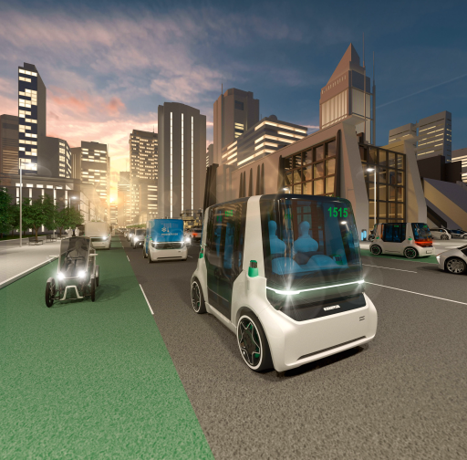
At the 11th Schaeffler Symposium, the automotive and industrial supplier will present a number of technology innovations to over 400 customers. The range extends from components and system solutions for optimising powertrains based on internal combustion engines and the electrification of automotive drives for hybrid vehicles and electric vehicles, through to new vehicle concepts.
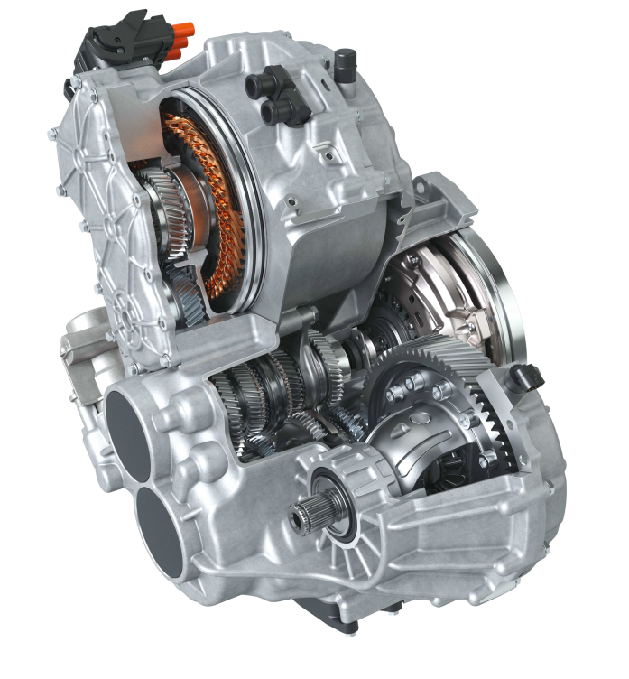
Smart hybrid transmissions (DH-ST 6+2): Schaeffler has developed a space-optimised transmission for plug-in hybrid vehicles. The dedicated hybrid transmission combines the benefits of an automated manual transmission with those of the electrified powertrain. At the same time, driving dynamics and ride comfort are enhanced while consumption and emissions are reduced.

About Schaeffler
The Schaeffler Group is a global automotive and industrial supplier. Top quality, outstanding technology, and exceptionally innovative spirit form the basis for the continued success of the company. By delivering high-precision components and systems in engine, transmission, and chassis applications, as well as rolling and plain bearing solutions for a large number of industrial applications, the Schaeffler Group is already shaping “Mobility for tomorrow” to a significant degree. The technology company generated sales of 14 billion euros in 2017. With more than 90,000 employees, Schaeffler is one of the world’s largest companies in family ownership. It has a worldwide network of manufacturing locations, research and development facilities, and sales companies at approximately 170 locations in more than 50 countries.
Follow us on Twitter @schaefflergroup to get all of our latest press releases and news.

Contact:
Jörg Walz, Vice President Communications and Marketing Automotive, Schaeffler Technologies AG & Co. KG, Herzogenaurach, phone: +49 9132 82-7557, e-mail: joerg.walz@schaeffler.com

Jakub Fukacz, Communications and Marketing Schaeffler Automotive, Schaeffler Technologies AG & Co. KG, Herzogenaurach, phone. +49 9132 82-8286, e-mail: jakub.fukacz@schaeffler.com

