|  |  |
| --- | --- |
|  | |
| Schaeffler subsidiary Compact Dynamics selected as exclusive FIA supplier from 2022 to 2024 | |
|  | |

* Compact Dynamics to supply hybrid system for FIA World Rally Championship (WRC)
* Schaeffler and Compact Dynamics benefit from longstanding and successful collaboration in innovative, high-performance electric drives

*Birmingham, UK* | *24. April 2020* | Compact Dynamics, a Starnberg, Germany-based wholly owned subsidiary of global automotive and industrial supplier Schaeffler, has been appointed by the FIA World Motor Sport Council as the exclusive supplier of the hybrid system to be used in the FIA World Rally Championship (WRC). The innovative hybrid technology will be used in the new Rally1 vehicle category for an initial period of three years, starting with the 2022 season. Compact Dynamics was selected following an extensive tendering process that drew a strong field of bids from the world’s leading suppliers. The company’s high-performance P3-topology hybrid system accommodates the motor-generator unit, control unit and battery in an extremely compact design envelope, thereby delivering maximum power density and meeting the FIA’s exacting requirements. The battery for the hybrid system is supplied by Compact Dynamics partner Kreisel Electric, based in Rainbach, Germany. Development work on the hybrid system for the FIA is already underway, and initial vehicle testing is planned for 2021.

“We are extremely proud of Compact Dynamics’s appointment as an exclusive FIA supplier,” commented Dr. Jochen Schröder, President of Schaeffler’s E-Mobility business division. “Compact Dynamics has been working with us since 2015 to develop the electric race-car drives that go with various other Schaeffler components in the highly successful systems we have been supplying for FIA Formula E vehicles. The know-how we gain from our involvement in motorsport feeds directly into the production-ready development of new technologies in areas such as electric axles, hybrid transmissions and electric motors for electric drive systems. Our involvement in the FIA World Rally Championship will further enhance this effect.”

Compact Dynamics Managing Director Oliver Blamberger shares this sentiment: “We are a specialist developer and supplier of innovative electric drive systems with key strengths in high-performance drives. Over the years, this has enabled us to carve out a niche in motorsport series such as FIA Formula 1, LeMans Prototype Class 1 and FIA Formula E. Our appointment by the FIA World Motor Sport Council is another milestone in this success story. We are delighted at this opportunity to prove the performance of our products at the highest level of rally car racing.”

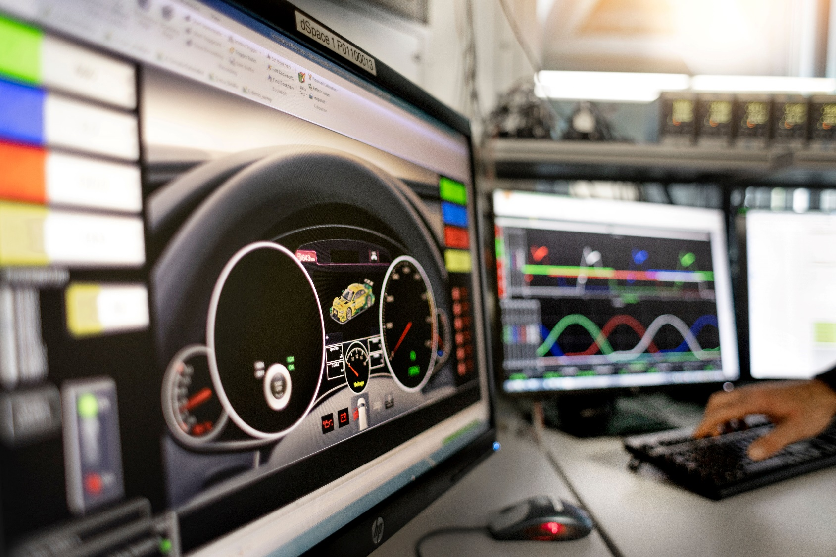

*Development work on the high-performance P3-topology hybrid system for the FIA is already underway.*

Photo: Schaeffler

|  |
| --- |
|  |
|  |

About Schaeffler

The Schaeffler Group is a leading global supplier to the automotive and industrial sectors. Its portfolio includes high-precision components and systems for engine, transmission and chassis applications as well as rolling and plain bearing solutions for a large number of industrial applications. The Schaeffler Group is already shaping “Mobility for tomorrow” to a significant degree with innovative and sustainable technologies for electric mobility, digitalization, and Industry 4.0. The technology company generated sales of approximately EUR 14.4 billion in 2019. With around 87,700 employees, Schaeffler is one of the world’s largest family companies and, with approximately 170 locations in over 50 countries, has a worldwide network of manufacturing locations, research and development facilities, and sales companies. With just on 2,400 patent applications in 2019, Schaeffler is Germany’s second most innovative company according to the DPMA (German Patent and Trademark Office).

|  |
| --- |
|  |
|  |

**Contact**

**Laura McKenzie**

UK Communications & Branding Manager

Schaeffler (UK) Ltd

Unit 308, Fort Dunlop

Fort Parkway

Birmingham

B24 9FD

 [**laura.mckenzie@schaeffler.com**](mailto:laura.mckenzie@schaeffler.com)

[](http://www.schaeffler.com/) [](https://www.facebook.com/SchaefflerGroup) [](https://twitter.com/schaefflergroup) [](https://www.instagram.com/schaefflergroup/) [](https://www.youtube.com/user/SchaefflerGlobal) [](http://www.linkedin.com/company/schaeffler)