|  |
| --- |
|  |
| Condition monitoring in logisticsOnline condition monitoring using SmartCheck prevents unplanned machine downtime at Schaeffler‘s European Distribution Centre |

Birmingham, UK | 08. July 2020 | By installing SmartCheck condition monitoring devices on 58 critical drives, Schaeffler’s European Distribution Centre has seen a range of benefits, including the prevention of unplanned downtime, reduced maintenance costs and increased machine availability.

Schaeffler’s European Distribution Centre (EDC Central) in Kitzingen, Germany, is one of Europe’s most modern logistics centres with several thousand shipping units rolling off the lines every day. Standard products can be delivered to customers within 24 to 48 hours after receipt of order.

Opened in June 2018, EDC Central covers a total area of 148,000 square metres and employs around 200 people. The site has two storage racks with a height of 38.5 metres, which provides space for 28,000 Euro pallets and 95,000 containers. Equipped with an in-floor, 2km long conveyor system and state-of-the-art conveying technology, the centre also provides 20 ramps for up to 85 trucks per day.

**Challenge for Schaeffler**

Inside the EDC Central are seven automated storage and retrieval systems, which continuously handle loads in various directions from storage racks with a height of around 38.5 metres. The bearings in the drives of these storage and retrieval systems are subjected to severe loads during operation. Any unplanned downtime of the storage and retrieval systems due to bearing damage can affect the entire supply chain. In the worst case scenario, this may result in delayed deliveries of customer orders. The logistics centre was therefore looking for a Predictive Maintenance solution.

**Schaeffler Solution**

The EDC Central relies on intelligent maintenance solutions developed in-house for monitoring the automated storage and retrieval systems. Of the approximately 3,000 drives at Kitzingen, 58 of the most critical are monitored using the Schaeffler SmartCheck condition monitoring solution.

51 of the SmartChecks are installed on spiral conveyors and lifting stations, where they monitor vibration, temperature and speed of the bearings. The SmartChecks are connected to the Schaeffler network, allowing local visualisation in the control room at Kitzingen.

Seven SmartChecks are installed on the drives of the storage and retrieval systems. After an operating period of around 18 months, one of the SmartChecks detected an irregular upward trend. The subsequent visual inspection carried out by local maintenance staff confirmed that grease had escaped from the track roller bearing. Due to the early detection of this irregularity, the site was able to schedule and perform the bearing replacement in good time and therefore prevent any unplanned downtime.

**Customer Benefits**

The online monitoring solution is an important tool for Kitzingen in eliminating unplanned downtime and malfunctions during operation. Other advantages include:

* Prevention of costs resulting from production downtime.
* Prevention of subsequent damage to the drive.
* Low purchasing costs for the monitoring system.
* Reduced maintenance costs.
* Increased machine availability.
* Enhanced reliability through a self-reporting system.

Oliver Massa, Intralogistics Portfolio Manager at Schaeffler summarises the benefits of the monitoring solution: "Bearing damage was detected at an early stage thanks to the SmartCheck. The team was able to carry out the four-hour maintenance work outside of our regular operating hours. Production was therefore safeguarded and subsequent damage to the drive was prevented. With predictive maintenance, we can save costs of up to 70,000 euros every year."

This holistic solution can also be applied and extended to other machines and equipment in almost every plant. In order to ensure optimum lubrication of the chain and roller conveyors, the EDC Central also uses the centrally controlled CONCEPT8 automatic lubrication system from Schaeffler with specially developed lubricating pinions for continuous and precise relubrication during operation.

For more information, please contact Schaeffler UK’s Communications & Branding Department on [info.uk@schaeffler.com](mailto:info.uk@schaeffler.com)

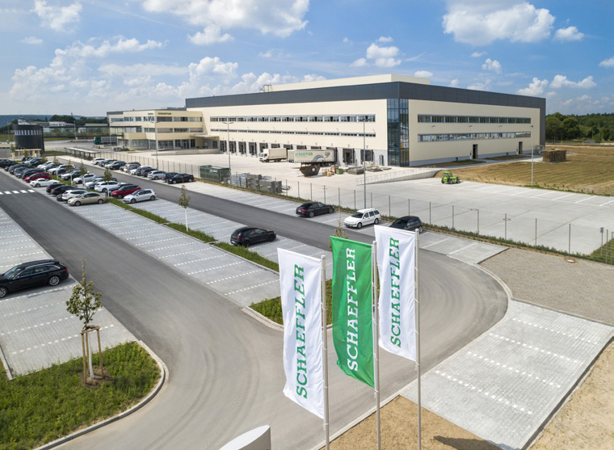

*Schaeffler’s European Distribution Centre in Kitzingen, Germany.*

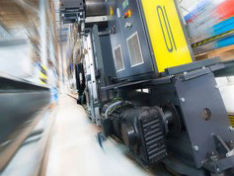

*One of the seven automated storage and retrieval systems that are monitored using Schaeffler SmartChecks.*

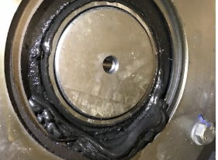

*Grease has escaped from a bearing in the drive of a storage and retrieval system.*

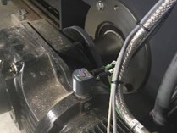

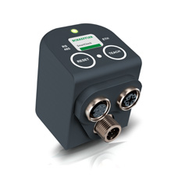

*Schaeffler SmartCheck installed on the drive of a storage and retrieval system.*

Photos: Schaeffler

|  |
| --- |
|  |
|  |

About Schaeffler

The Schaeffler Group is a leading global supplier to the automotive and industrial sectors. Its portfolio includes high-precision components and systems for engine, transmission and chassis applications as well as rolling and plain bearing solutions for a large number of industrial applications. The Schaeffler Group is already shaping “Mobility for tomorrow” to a significant degree with innovative and sustainable technologies for electric mobility, digitalization, and Industry 4.0. The technology company generated sales of approximately EUR 14.4 billion in 2019. With around 87,700 employees, Schaeffler is one of the world’s largest family companies and, with approximately 170 locations in over 50 countries, has a worldwide network of manufacturing locations, research and development facilities, and sales companies. With just on 2,400 patent applications in 2019, Schaeffler is Germany’s second most innovative company according to the DPMA (German Patent and Trademark Office).

|  |
| --- |
|  |
|  |

**Contact**

**Laura McKenzie**

UK Communications & Branding Manager

Schaeffler (UK) Ltd

Unit 308, Fort Dunlop

Fort Parkway

Birmingham

B24 9FD

 [**laura.mckenzie@schaeffler.com**](mailto:laura.mckenzie@schaeffler.com)

[](http://www.schaeffler.com/) [](https://www.facebook.com/SchaefflerGroup) [](https://twitter.com/schaefflergroup) [](https://www.instagram.com/schaefflergroup/) [](https://www.youtube.com/user/SchaefflerGlobal) [](http://www.linkedin.com/company/schaeffler)