|  |  |
| --- | --- |
|  | |
| Schaeffler demonstrates pioneering spirit and innovation, and is instrumental in shaping the fully-electric future of the DTM | |
|  | |

* Schaeffler is the new Series and Innovation Partner of the German Touring Car Masters (DTM)
* As preferred technology partner, Schaeffler is contributing to the electrification of the DTM with electric drive systems and steer-by-wire
* Matthias Zink: “Collaboration demonstrates pioneering spirit and innovation, and underlines our desire, as technology partner, to make progress that has an impact on the world.”
* New claim: “We pioneer motion”. As preferred technology partner, partnership underlines desire to make progress

Birmingham, UK | 11. November 2020 | At the final DTM race weekend of 2020, Schaeffler is showing what the future of the DTM will look like: it is green and electric. As the new Series and Innovation Partner of the DTM, Schaeffler and the umbrella organisation, ITR (Internationale Tourenwagen Rennen e.V.) are presenting a demonstration car at the Hockenheimring, which has four battery-powered Schaeffler drivetrains – one for each wheel – and is also equipped with Space Drive steer-by-wire technology. The prototype is driven by Formula E driver Daniel Abt and two-time DTM champion Timo Scheider, as well as Schaeffler Brand Ambassador, Sophia Flörsch.

“We are looking forward to the partnership,” said Matthias Zink, CEO Automotive Technologies at Schaeffler. “Our innovative e-drive technologies have been producing success in Formula E since 2014 and are now also used in production vehicles. The collaboration demonstrates pioneering spirit and innovation, and underlines our desire, as technology partner, to make progress that has an impact on the world.”

**Demonstration car generates almost 1,200 hp**

The demonstration car in action at the Hockenheimring generates almost 1,200 hp with 800 kW – that is virtually twice as much power as the current DTM cars (over 450 kW). The car accelerates from 0 to 100 km/h in 2.4 seconds, making it roughly 0.4 seconds faster than the current Schaeffler BMW M4 DTM. It also features Space Drive steer-by-wire technology, which has been successfully tried and tested in motorsport, as well as integrated vehicle dynamics control to control the four motors. In its role as a development platform for the electric DTM, outings are planned at DTM events in 2021. It is then possible that the DTM will be a fully-electric race series from 2023.

**“We pioneer motion”. Schaeffler loves partnerships, particularly when they nurture future technologies**

**The global automotive and industrial supplier has only recently launched a new image campaign, with the goal of positioning the corporate brand of Schaeffler and communicating the new claim “We pioneer motion”. At the heart of the campaign is the concept “Green makes the difference”, which symbolises that Schaeffler is a trailblazer when it comes to motion. Matthias Zink: “The partnership with the DTM is perfectly suited to Schaeffler. As a pioneer, we want to challenge the status quo and push the boundaries – and, in doing so, to make a difference.”**

You can find more information on the campaign at the [microsite “We pioneer motion”](https://www.we-pioneer-motion.com/de/).

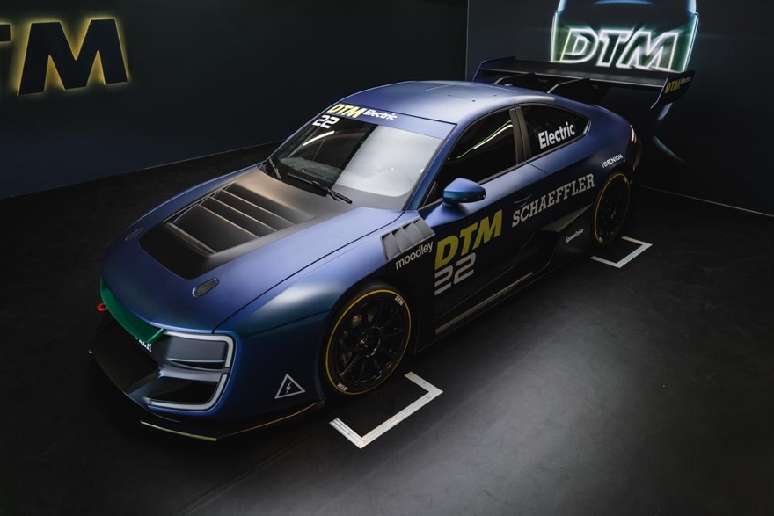

*The demonstration car generates just short of 1,200 hp with 880 kW.*

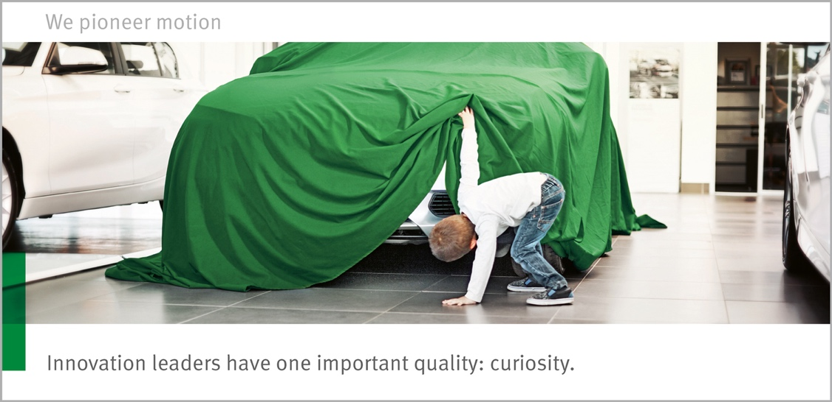

*The collaboration demonstrates Schaeffler's pioneering and innovative spirit.*

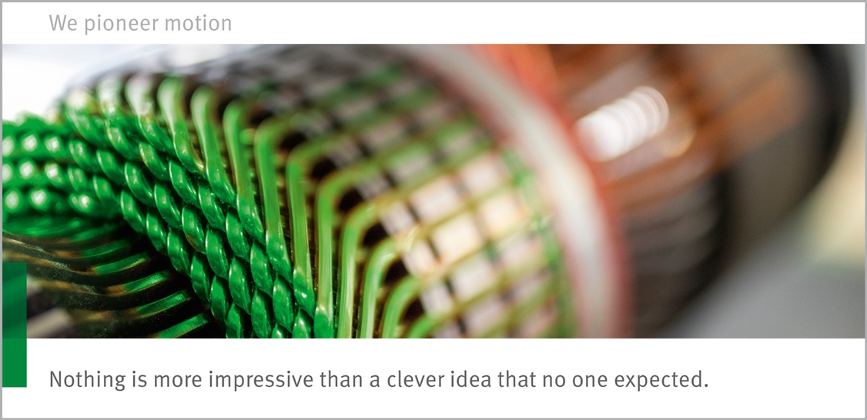

*Schaeffler is contributing to the electrification of the DTM with electric drive system.*

Images: Schaeffler

|  |
| --- |
|  |
|  |

Schaeffler Group – We pioneer motion

As a leading global supplier to the automotive and industrial sectors, the Schaeffler Group has been driving forward groundbreaking inventions and developments in the fields of motion and mobility for over 70 years. With innovative technologies, products, and services for CO₂-efficient drives, electric mobility, Industry 4.0, digitalization, and renewable energies, the company is a reliable partner for making motion and mobility more efficient, intelligent, and sustainable. The technology company manufactures high-precision components and systems for drive train and chassis applications as well as rolling and plain bearing solutions for a large number of industrial applications. The Schaeffler Group generated sales of approximately EUR 14.4 billion in 2019. With around 83,700 employees, Schaeffler is one of the world’s largest family companies. With almost 2,400 patent applications in 2019, Schaeffler is Germany’s second most innovative company according to the DPMA (German Patent and Trademark Office).

|  |
| --- |
|  |
|  |

**Contact**

**Laura McKenzie**

UK Communications & Branding Manager

Schaeffler (UK) Ltd

Unit 308, Fort Dunlop

Fort Parkway

Birmingham

B24 9FD

 [**laura.mckenzie@schaeffler.com**](mailto:laura.mckenzie@schaeffler.com)

[](http://www.schaeffler.com/) [](https://www.facebook.com/SchaefflerGroup) [](https://twitter.com/schaefflergroup) [](https://www.instagram.com/schaefflergroup/) [](https://www.youtube.com/user/SchaefflerGlobal) [](http://www.linkedin.com/company/schaeffler)