|  |
| --- |
|  |
| 70 years old but with an entire future ahead: The cage-guided needle roller bearing from Schaeffler |
|  |

* In 1950, the idea of a cage-guided needle roller bearing conceived by

Dr.-Ing. E.h. Georg Schaeffler was filed as a patent application, which revolutionised bearing technology

* Georg F. W. Schaeffler: “One of the most important innovations in our company's history as an automotive and industrial supplier”
* The cage-guided needle roller bearing also plays an exceptional role in topics of future importance, such as collaborative robotics and electromobility
* More than 100 billion Schaeffler needle roller bearings have already been sold

Birmingham, UK | 09. December 2020 | 70 years ago, Dr.-Ing. E.h. Georg Schaeffler revolutionised bearing technology. The idea: to improve guidance of the needles in the needle roller bearing by using a cage. The first practical tests involving cage-guided needle roller bearings began in February 1950. The results were convincing – the components exhibited extremely low wear and friction. The application for a patent in September 1950 laid the foundation for the product's success. In February 1951, just one year after construction of the first prototype, the first volume production orders were obtained from automotive manufacturers, and use in industrial applications was to follow. “With this invention, my father, Georg Schaeffler, laid the foundation for the rapid growth of our company. The cage-guided needle roller bearing is one of the most important innovations in our company's history as an automotive and industrial supplier,” says Georg F. W. Schaeffler, Family Shareholder and Chairman of the Supervisory Board. “The development of this very product is, in itself, an impressive example of what sets us apart: we have utilised all synergies in the cage-guided needle roller bearing, which will allow us to serve all relevant target markets with this innovative product and generate real customer benefits – in both the automotive and the industrial sector.”

**Higher speeds with less friction**

With the invention Dr.-Ing. E.h. Georg Schaeffler eliminated the serious disadvantages associated with the full complement needle roller bearings that had previously been used as standard – the long needle rollers tended to move in a transverse direction during rotation of the bearing (skewing), which would then cause the bearing to jam. Furthermore, a substantial amount of sliding friction was generated between the counter-rotating needle rollers. The development of the new needle cage overcame these disadvantages and permitted considerably higher speeds and less friction. This allowed engineers to substitute other bearing designs for cage-guided needle roller bearings and significantly improve the performance of their applications.

In particular, needle roller bearings made an invaluable contribution to the development of small, high-performance, and affordable vehicles. “Without reliable needle roller bearings, modern automotive drives would still be inconceivable today,” says Matthias Zink, CEO Automotive Technologies at Schaeffler. The use of needle roller bearings in mechanical and plant engineering, construction and agricultural machinery, and in conveyor technology, was also being gradually introduced.

**Role in future markets**

Needle roller bearings will continue to play a key role in the future. In e-mobility, needle roller bearings are vital for the function of numerous electrified transmissions. Needle roller and cage assemblies facilitate bearing arrangements with a minimal design envelope, since their section height only corresponds to the diameter of the needle rollers. In addition, they have a high load carrying capacity and are inexpensive compared with other bearing designs. KZK needle roller bearings (crank pin cages) are used, for example, in e-axles with a coaxial design. One application example is the Schaeffler e-axle drive, which has been produced for the Audi e-tron since 2018.

In industry too, where lightweight robots are increasingly in demand, the use of needle bearings permits light and compact joint designs by means of downsizing. The needle bearings provide minimal variability and the highest level of safety. The most recent example is the angular contact needle roller bearing XZU from Schaeffler, which is used both as an articulated arm bearing in lightweight robots and cobots, and as the main bearing arrangement in the new RTWH precision gearbox, a ready-to-install reduction gear unit for robot joints.

**Technological development**

What originally started life as an ingenious idea by Dr.-Ing. E.h. Georg Schaeffler, has been continuously developed by Schaeffler engineers over the course of 70 years, both in terms of performance and the variety of available types. Compared to a machined needle roller bearing from the 1950s, the operating life for bearings with the same dimensions has increased 15-fold, and the static load carrying capacity has tripled. The power density, which has been enormously improved thanks to the needle roller and cage assembly, offers considerable downsizing potential for applications that are easier on energy and resources.

There has also been a steady increase in the variety of types. Today, the Schaeffler needle roller bearing portfolio comprises more than 15,000 variants to fulfill a wide variety of requirements. Since the patent application was filed 70 years ago, Schaeffler has sold a total of more than 100 billion needle roller bearings. The length of the wires used in the production of 60 billion needle roller bearings annually would be sufficient to wind around the earth's equator 18 times. Almost 170 million needle rollers are produced from this wire every day.

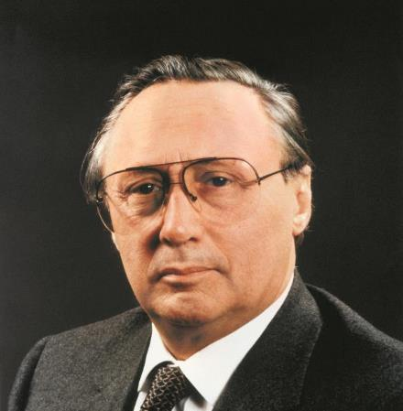

*With the idea of the needle cage, Dr.-Ing. E.h. Georg Schaeffler revolutionised bearing technology.*

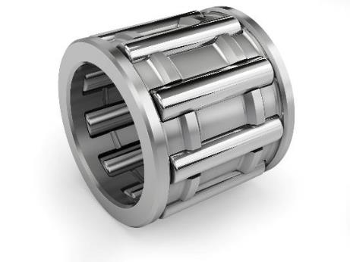

*Replica of the first cage-guided needle roller bearing from Schaeffler.*

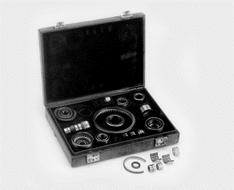

*Brothers Dr. Wilhelm and Dr.-Ing E.h. Georg Schaeffler set out to see the customer armed with a sample case of various needle roller bearings.*

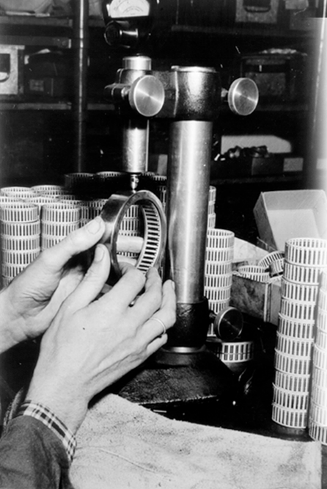

*Insight into needle roller bearing production in 1950.*

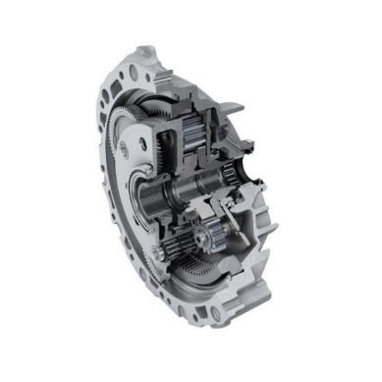

*Example of an automotive application for needle bearings: The Schaeffler e-axle drive, which has been produced for the Audi e-tron since 2018.*

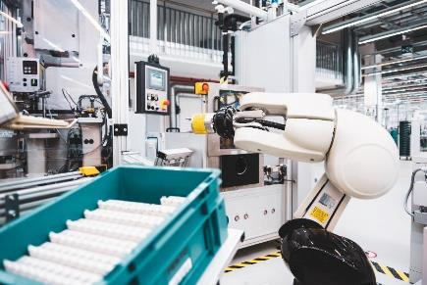

*Needle roller bearings also play a major role in topics of future importance such as lightweight robots. Here, they ensure the necessary rigidity while requiring little space.*

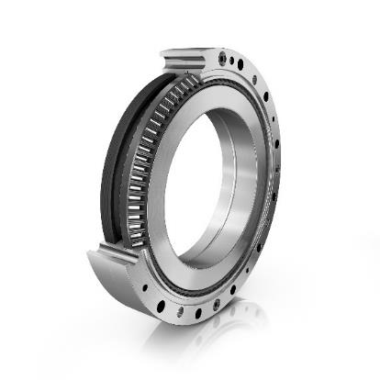

*The angular contact needle roller bearing XZU from Schaeffler is used in lightweight robots and collaborative robots.*

Photos: Schaeffler

|  |
| --- |
|  |
|  |

Schaeffler Group – We pioneer motion

As a leading global supplier to the automotive and industrial sectors, the Schaeffler Group has been driving forward groundbreaking inventions and developments in the fields of motion and mobility for over 70 years. With innovative technologies, products, and services for CO₂-efficient drives, electric mobility, Industry 4.0, digitalization, and renewable energies, the company is a reliable partner for making motion and mobility more efficient, intelligent, and sustainable. The technology company manufactures high-precision components and systems for drive train and chassis applications as well as rolling and plain bearing solutions for a large number of industrial applications. The Schaeffler Group generated sales of approximately EUR 14.4 billion in 2019. With around 83,700 employees, Schaeffler is one of the world’s largest family companies. With almost 2,400 patent applications in 2019, Schaeffler is Germany’s second most innovative company according to the DPMA (German Patent and Trademark Office).

|  |
| --- |
|  |
|  |

**Contact**

**Laura McKenzie**

UK Communications & Branding Manager

Schaeffler (UK) Ltd

Unit 308, Fort Dunlop

Fort Parkway

Birmingham

B24 9FD

 [**laura.mckenzie@schaeffler.com**](mailto:laura.mckenzie@schaeffler.com)

[](http://www.schaeffler.com/) [](https://www.facebook.com/SchaefflerGroup) [](https://twitter.com/schaefflergroup) [](https://www.instagram.com/schaefflergroup/) [](https://www.youtube.com/user/SchaefflerGlobal) [](http://www.linkedin.com/company/schaeffler)