|  |
| --- |
|  |
| For Automatic and Individually Adjustable LubricationSchaeffler adds the CONCEPT1 and CONCEPT4 to its range of lubricators |
|  |

* CONCEPT1 and CONCEPT4 lubricators ensure automatic, individually adjustable lubrication
* Maintenance outlay and costs reduced by up to 30 per cent
* Eco-friendly and flexible: all lubricators and cartridges can be refilled multiple times, even with lubricants from outside the Arcanol range

Birmingham, UK | 17. December 2020 | Manual lubrication frequently takes place too late and with too much lubricant. An automatic lubricant supply prevents over-lubrication and under-lubrication and also saves time and extends the bearings’ operating life. Maintenance outlay and maintenance costs can be reduced by up to 30 per cent compared to manual lubrication, and problem-free production is ensured in the long term.

Schaeffler has now expanded its CONCEPT range through the addition of further automatic lubricators. In addition to the existing lubricators – the CONCEPT2 with two lubricant supply line outlets and the CONCEPT8 with eight lubricant supply line outlets – the range is now completed by the CONCEPT1, launched in the UK in November 2020 and CONCEPT4 lubricators. The CONCEPT1 is designed for automatic relubrication of one lubrication point, while the CONCEPT4 can independently supply up to four lubrication points.

Another new development is that the CONCEPT1 lubricator itself and the replacement cartridges for the CONCEPT4 can be filled up to three times in just a few steps, even with greases from outside Schaeffler’s proprietary Arcanol range. This reduces waste, helps protect the environment, and saves maintenance costs.

**CONCEPT1 with independent gas-powered drive**

Thanks to its ease of installation and application, the CONCEPT1 is primarily suitable as a starting point in the field of automatic relubrication. It is available in 60 cm3 and 125 cm3 sizes and is powered via electrochemical reaction by a gas-producing dry cell, which means that an external power supply is not needed.

The CONCEPT1 is suitable for use in a wide range of applications, including electric motors, pumps, and belt conveyors. Due to its compact dimensions, it can be mounted in virtually any lubrication point. Furthermore, the CONCEPT1 is also certified for operation in explosion-proof areas (according to ATEX).

**CONCEPT4 for demanding industrial applications**

The CONCEPT4 is suitable for minimum-quantity lubrication, dispensing just 0.15 cm3 per actuation impulse. It was intentionally designed without an integrated timer for the lubricant dosage and without a display with control buttons, which makes it particularly robust in application. The CONCEPT4 is regulated solely via an external control unit and is thus aimed exclusively at customers who have an existing PLC infrastructure.

Unlike the CONCEPT1, the CONCEPT4 utilises special lubricant cartridges (as do the CONCEPT2 and CONCEPT8). The CONCEPT4 lubricator, which utilises cartridges with a standard size of 400 cm3 and has four outlets for lubricant supply lines, can also create particularly high delivery pressures of up to 70 bar. This ensures that lubricant reaches even hard-to-access points that require long lubricant supply lines, such as those found in electric motors, fans, pumps, gearboxes, compressors, and machine tools, for example.

An overview of Schaeffler’s entire range of lubricators can be found at the following link: [www.schaeffler.de/lubricators](http://www.schaeffler.de/lubricators)

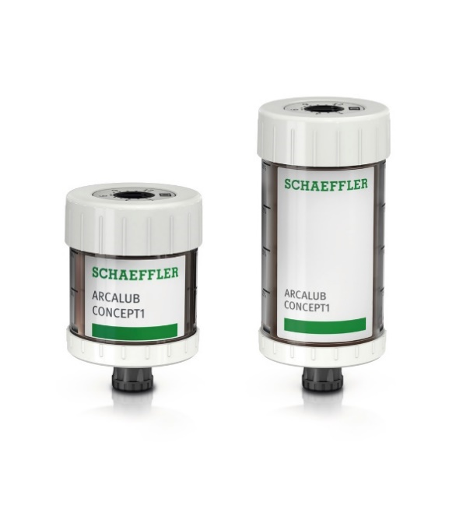

The CONCEPT1, which is designed for single-point lubrication, is primarily suitable as a starting point in the field of automatic relubrication thanks to its ease of installation and application. It is available in 60 cm3 and 125 cm3 sizes and is powered via electrochemical reaction by a gas-producing dry cell.

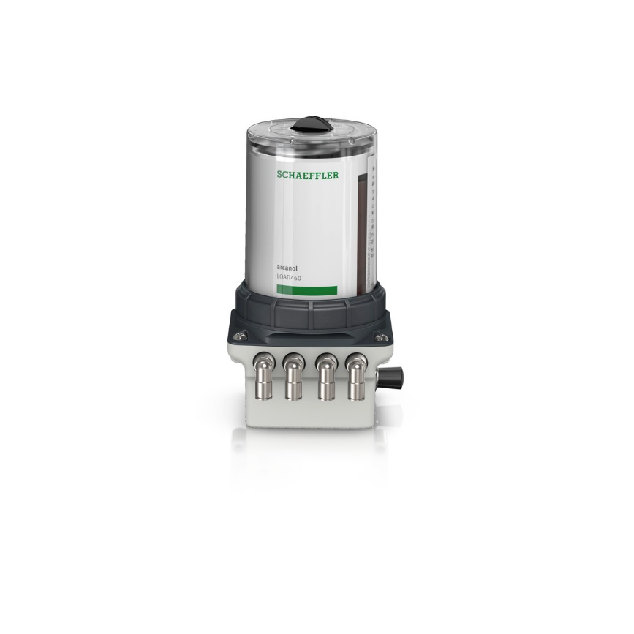

The CONCEPT4 features an especially robust design and is equipped with four outlets for lubricant supply lines. The CONCEPT4 utilises cartridges with a standard size of 400 cm³. It is regulated solely via an external control unit.

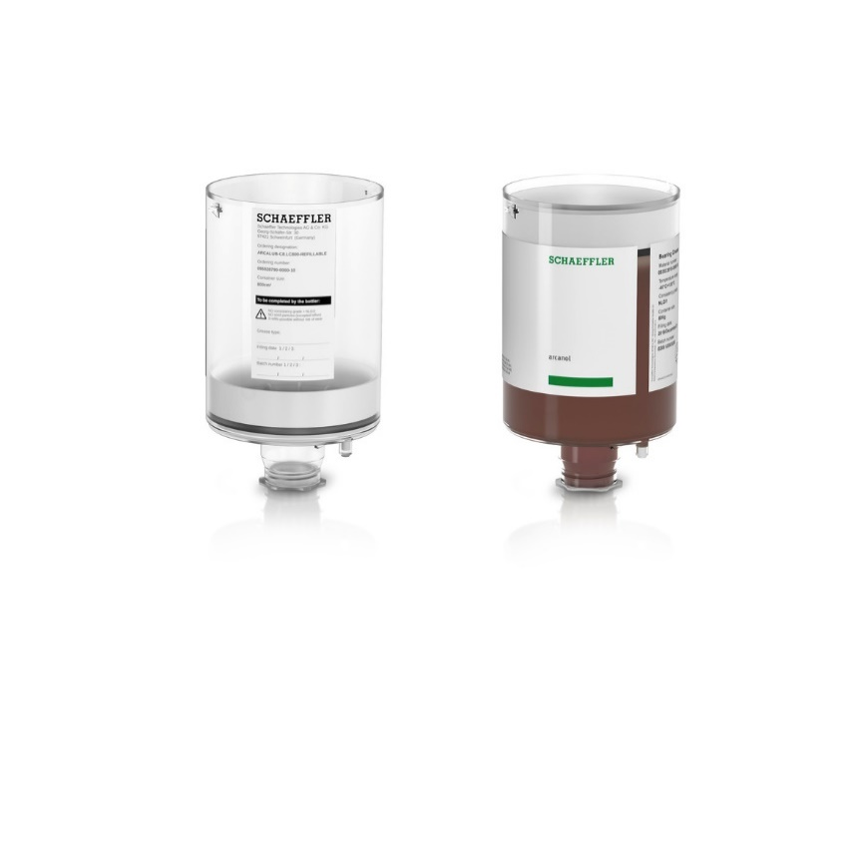

The cartridges for the CONCEPT2, CONCEPT4, and CONCEPT8 lubricators are available in two versions: empty or pre-filled with lubricant. These devices can therefore also be operated with greases from outside Schaeffler’s proprietary Arcanol series and refilled up to three times (shown here: CONCEPT8 cartridge and empty cartridge).

Images: Schaeffler

|  |
| --- |
|  |
|  |

Schaeffler Group – We pioneer motion

As a leading global supplier to the automotive and industrial sectors, the Schaeffler Group has been driving forward groundbreaking inventions and developments in the fields of motion and mobility for over 70 years. With innovative technologies, products, and services for CO₂-efficient drives, electric mobility, Industry 4.0, digitalization, and renewable energies, the company is a reliable partner for making motion and mobility more efficient, intelligent, and sustainable. The technology company manufactures high-precision components and systems for drive train and chassis applications as well as rolling and plain bearing solutions for a large number of industrial applications. The Schaeffler Group generated sales of approximately EUR 14.4 billion in 2019. With around 83,700 employees, Schaeffler is one of the world’s largest family companies. With almost 2,400 patent applications in 2019, Schaeffler is Germany’s second most innovative company according to the DPMA (German Patent and Trademark Office).

|  |
| --- |
|  |
|  |

**Contact**

**Laura McKenzie**

UK Communications & Branding Manager

Schaeffler (UK) Ltd

Unit 308, Fort Dunlop

Fort Parkway

Birmingham

B24 9FD

 [**laura.mckenzie@schaeffler.com**](mailto:laura.mckenzie@schaeffler.com)

[](http://www.schaeffler.com/) [](https://www.facebook.com/SchaefflerGroup) [](https://twitter.com/schaefflergroup) [](https://www.instagram.com/schaefflergroup/) [](https://www.youtube.com/user/SchaefflerGlobal) [](http://www.linkedin.com/company/schaeffler)