|  |  |
| --- | --- |
|  | |
| Industry 4.0: Linear motion technologyLinear actuators offer higher power density and improved energy efficiency over hydraulic and pneumatic systems | |
|  | |

* P.ACT range of electromechanical linear actuators from Schaeffler offers improved energy balance compared to hydraulic and pneumatic systems
* Flexible, modular configuration options to suit a wide range of industrial applications
* Compact design envelope with very high power density

Birmingham, UK | 05. January 2021 | Global industrial and automotive supplier Schaeffler has launched the new P.ACT series of electromechanical linear actuators to the UK market.

With potential applications ranging from production machinery, drive technology and industrial automation, to logistics, raw materials and mobile machinery, P.ACT linear actuators offer high power density and significantly improved energy efficiency compared to hydraulic and pneumatic systems.

P.ACT linear actuators are protected by a rigid, robust, hexagonal-shaped, aluminium housing (up to class IP65S). They can be flexibly configured via a modular design platform, which enables them to be individually optimised for specific applications together with other Schaeffler components. Integrated T-slots along the entire length of the actuator enable flexible fixing options for the actuator and its accessories.

**Options to suit every application**P.ACT linear actuators can be used as both ‘force’ actuators and precise positioning systems. A basic actuator version or a driven version are available in two sizes (ACT15 and ACT25). Options include an integrated high performance linear measuring system, additional position switches for flexibly setting the switching point, servo motors, and controller with Ethernet and/or digital I/O.

Their unique combination of high performance and high energy efficiency in such a compact design envelope, allow the P.ACT series to be used in new application areas such as commercial and off-road vehicles. The high performance PWG planetary screw drive and ZKLF spindle bearing supports from Schaeffler ensure reliable operation even in the most challenging conditions.

Richmond Averill, Linear Product Specialist at Schaeffler UK commented: "Due to their modular flexibility, high performance and improved energy balance, P.ACT linear actuators will attract much interest from UK customers from a variety of industry sectors. In terms of their mechanical performance, the actuators are approximately 20% more effective compared to hydraulic systems and 50 per cent more effective than pneumatic systems, which will provide customers with a clear competitive advantage.”

For more information on P.ACT linear actuators, please contact Schaeffler UK’s Communications & Branding Department on [info.uk@schaeffler.com](mailto:info.uk@schaeffler.com)

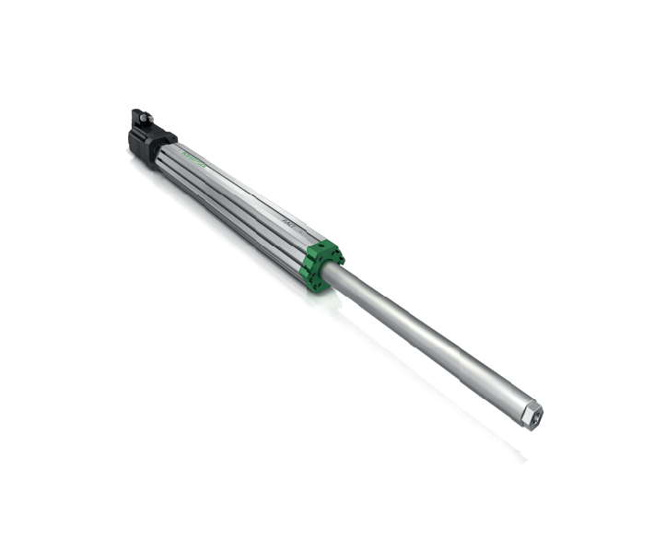

*The P.ACT range of electromechanical linear actuators from Schaeffler.*

Photos: Schaeffler

|  |
| --- |
|  |
|  |

Schaeffler Group – We pioneer motion

As a leading global supplier to the automotive and industrial sectors, the Schaeffler Group has been driving forward groundbreaking inventions and developments in the fields of motion and mobility for over 70 years. With innovative technologies, products, and services for CO₂-efficient drives, electric mobility, Industry 4.0, digitalization, and renewable energies, the company is a reliable partner for making motion and mobility more efficient, intelligent, and sustainable. The technology company manufactures high-precision components and systems for drive train and chassis applications as well as rolling and plain bearing solutions for a large number of industrial applications. The Schaeffler Group generated sales of approximately EUR 14.4 billion in 2019. With around 83,700 employees, Schaeffler is one of the world’s largest family companies. With almost 2,400 patent applications in 2019, Schaeffler is Germany’s second most innovative company according to the DPMA (German Patent and Trademark Office).

|  |
| --- |
|  |
|  |

**Contact**

**Laura McKenzie**

UK Communications & Branding Manager

Schaeffler (UK) Ltd

Unit 308, Fort Dunlop

Fort Parkway

Birmingham

B24 9FD

 [**laura.mckenzie@schaeffler.com**](mailto:laura.mckenzie@schaeffler.com)

[](http://www.schaeffler.com/) [](https://www.facebook.com/SchaefflerGroup) [](https://twitter.com/schaefflergroup) [](https://www.instagram.com/schaefflergroup/) [](https://www.youtube.com/user/SchaefflerGlobal) [](http://www.linkedin.com/company/schaeffler)