|  |
| --- |
|  |
| **Schaeffler to build state-of-the-art laboratory complex at Herzogenaurach campus** |
|  |

* Automotive and industrial supplier investing in state-of-the-art, sustainable R&D infrastructure as part of its Roadmap 2025
* New 15,000 sqm central laboratory complex will consolidate and integrate 15 laboratories representing Schaeffler’s core competencies and key technologies
* Complex to be built and operated as a green building in accordance with latest sustainability standards
* Investment will strengthen Schaeffler’s competitiveness and its Herzogenaurach campus

Birmingham, UK | 23. February 2021 | Schaeffler is investing around 80 million euros in a new central laboratory complex in Herzogenaurach as part of the company's Roadmap 2025 strategy announced last year. The investment is aimed at securing the Schaeffler Group’s competitiveness and ability to realise future opportunities, as well as strengthening the position of its Herzogenaurach campus as a centre of technological excellence. The complex, currently in the detailed planning phase, is scheduled for completion in 2023.

Schaeffler’s headquarters in Herzogenaurach will soon be home to a cross-divisional central laboratory complex that will span around 15,000 square metres of gross floor space and house 15 laboratories and more than 360 employees. The new laboratory facility will centralise and consolidate the Schaeffler Group’s core competencies and capabilities in key areas of technology, including measurement, testing and calibration systems, materials research and design, electrochemistry, and optimisation of product lifespan, strength, and reliability. It will also house a new electronics laboratory. The company’s aims in consolidating all these activities under one roof include improving the transfer of knowledge and technology between its divisions and enhancing performance through shared use of resources.

“The idea of the new central laboratory complex is to make key technologies available on an integrated, cross-divisional basis so that we can, for example, develop products for sustainable and carbon-neutral mobility and energy ecosystems,” explained Uwe Wagner, Schaeffler AG’s Chief Research & Development Officer. “To develop solutions for megatrends such as carbon neutrality, next-generation mobility, and automation, we also need to boost our ability to rapidly develop our core competencies across a wide range of disciplines, from materials and surface technology to electrochemistry, electronics, and digitalisation. The new central laboratory complex will provide the ideal springboard for this.”

Schaeffler also intends to make the new complex accessible to external customers. Its plans therefore include a laboratory and presentation area for digitalisation and the use of artificial intelligence.

“Our excellence in manufacturing means we are also ideally positioned to offer our customers optimal solutions in key future areas of technology, such as electric mobility, robotics, and hydrogen,” explained Chief Operating Officer Andreas Schick. “These are growth areas where, right from the basic research stage, we have to consider the end product or application, as well as commercial-scale production in order to stay ahead of our global competitors. Our digital simulation technologies, in particular, are integral to this.”

Apart from its extensive R&D capabilities, the central laboratory complex in Herzogenaurach will set new standards in laboratory climate control and vibration elimination, making it ideal for high-resolution measurement systems and other highly sensitive technologies. The building, which is scheduled for occupation at the start of 2024, will be built to the latest sustainability standards and operated as a green building in accordance with the DNGB (German Sustainability Council) Gold Standard.

The new facility is an important part of the Roadmap 2025 strategy, which was announced last November and details how the Schaeffler Group will sustainably strengthen its future readiness and competitive position. “The central laboratory complex will secure high-tech jobs in key growth areas,” said Klaus Rosenfeld, CEO of Schaeffler AG. “It will also add value to Herzogenaurach and the surrounding region in the eyes of customers and employees and underscores our commitment to Germany as a business location.”

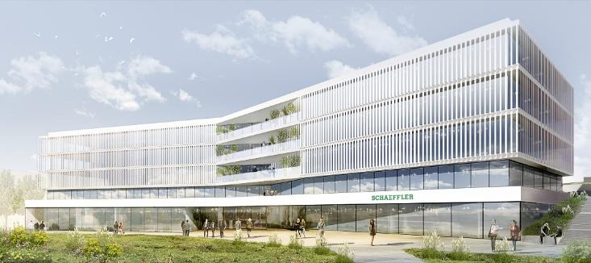

Schaeffler to build state-of-the-art laboratory complex at Herzogenaurach campus

Picture: Schaeffler

|  |
| --- |
|  |
|  |

Schaeffler Group – We pioneer motion

As a leading global supplier to the automotive and industrial sectors, the Schaeffler Group has been driving forward groundbreaking developments in the fields of motion and mobility for more than 70 years. With innovative technologies, products and services for CO₂-efficient drives, electric mobility, Industry 4.0, digitalization, and renewable energies, the company is a reliable partner for making motion and mobility more efficient, intelligent and sustainable. The technology company manufactures high-precision components and systems for drive train and chassis applications as well as rolling and plain bearing solutions for a large number of industrial applications. The Schaeffler Group generated sales of approximately EUR 14.4 billion in 2019. With around 83,700 employees, Schaeffler is one of the world’s largest family companies. With almost 2,400 patent applications in 2019, Schaeffler is Germany’s second most innovative company according to the DPMA (German Patent and Trademarks Office).

|  |
| --- |
|  |
|  |

**Contact**

**Laura McKenzie**

UK Communications & Branding Manager

Schaeffler (UK) Ltd

Unit 308, Fort Dunlop

Fort Parkway

Birmingham

B24 9FD

 [**laura.mckenzie@schaeffler.com**](mailto:laura.mckenzie@schaeffler.com)

[](http://www.schaeffler.com/) [](https://www.facebook.com/SchaefflerGroup) [](https://twitter.com/schaefflergroup) [](https://www.instagram.com/schaefflergroup/) [](https://www.youtube.com/user/SchaefflerGlobal) [](http://www.linkedin.com/company/schaeffler)