|  |
| --- |
|  |
| **Schaeffler becomes an anchor partner for STARTUP AUTOBAHN** |
|  |

* Schaeffler joins STARTUP AUTOBAHN and establishes a partner network to develop market-ready innovations more rapidly
* This network includes more than 30 partners and 30,000 startups
* Uwe Wagner: “STARTUP AUTOBAHN is perfect for Schaeffler and is an important milestone in our innovation strategy.”

Birmingham, UK | 12. March 2021 | Schaeffler is a new “anchor partner” to the Stuttgart-based STARTUP AUTOBAHN innovation platform. This platform brings established companies and startups together with the objective of developing new technologies and bringing them to market readiness more rapidly. As an anchor partner, Schaeffler is establishing a network together with various startups that spans the company’s innovation clusters: “Hydrogen and Energy Transition”, “Electric and Automated Mobility”, “Robotics and IoT”, “Bearing Technologies”, “Material and Surface Science”, and “Artificial Intelligence”.

“As a global automotive and industrial supplier, we want to pioneer motion to advance how the world moves. STARTUP AUTOBAHN is perfect for Schaeffler and is an important milestone in our innovation strategy. Our strategic cooperation with startups enables us to identify growth markets, enhance our core business together with strong partners, and offer innovative, sustainable future technologies,” explains Uwe Wagner, Chief Technology Officer at Schaeffler.

**The network includes 30,000 qualified startups**

STARTUP AUTOBAHN, which was founded in 2016 and now includes more than 30 partners, offers a network of 30,000 startups. Since the platform was established, more than 320 pilot projects have been developed. In addition to its headquarters in Stuttgart, the network also has locations in China, India and Singapore. “We are extremely happy to welcome Schaeffler as the newest anchor partner to our platform. As a leading global supplier to the automotive and industrial sectors, Schaeffler brings over seven decades of expertise in motion and mobility to the table. It is clear that their diverse product and system portfolio will enable valuable opportunities to startups. In collaboration with startups, OEM’s and other partners new ideas and technologies can be developed to the next level for implementation into new services, products and processes. We are looking forward to getting started,” explains Sascha Karimpour, Managing Director at Plug & Play Germany and a co-initiator of STARTUP AUTOBAHN.

Managers and experts from Schaeffler’s specialist departments select the appropriate startups based on the innovation clusters. Pilot projects are then collaboratively developed and, in the next stage, presented to a wide audience at the twice-annual Expo Day event. The subsequent objective is to work together in the continued development of these pilot projects to achieve market readiness. The partner network’s broad spectrum is a particularly attractive aspect: “It provides a place to meet existing customers and a large number of suppliers as well as new partners and exciting companies that have the technologies relevant to us. We see the further digitalisation of our products and production processes in particular as a source of major opportunities for innovation – for both the automotive and industrial sectors,” explains Prof. Dr.-Ing. Tim Hosenfeldt, Senior Vice President of Research and Innovation and Corporate Technology.

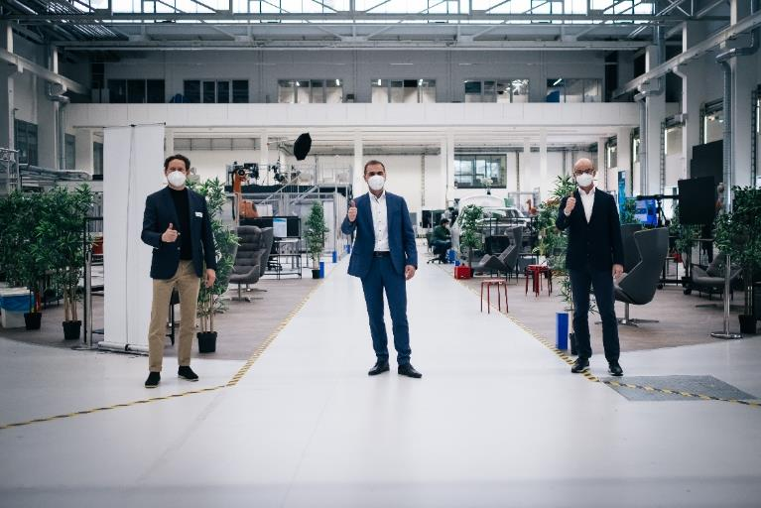 Uwe Wagner (center), Chief Technology Officer at Schaeffler, Sascha Karimpour (left), Managing Director at Plug & Play Germany, and Prof. Dr.-Ing. Tim Hosenfeldt (right), Senior Vice President of Research and Innovation and Corporate Technology at Schaeffler, are looking forward to the anchor partnership.

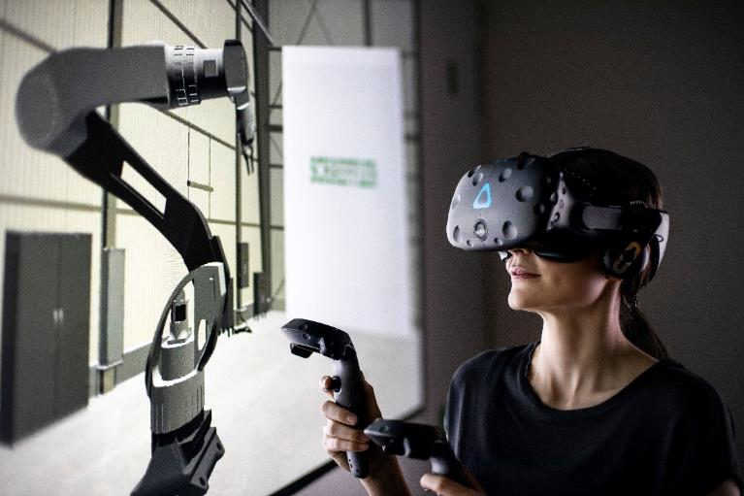

Schaeffler sees major opportunities above all in the digitalisation of its products and production processes.

Images: Schaeffler

|  |
| --- |
|  |
|  |

Schaeffler Group – We pioneer motion

As a leading global supplier to the automotive and industrial sectors, the Schaeffler Group has been driving forward groundbreaking inventions and developments in the fields of motion and mobility for over 70 years. With innovative technologies, products, and services for CO₂-efficient drives, electric mobility, Industry 4.0, digitalization, and renewable energies, the company is a reliable partner for making motion and mobility more efficient, intelligent, and sustainable. The technology company manufactures high-precision components and systems for powertrain and chassis applications as well as rolling and plain bearing solutions for a large number of industrial applications. The Schaeffler Group generated sales of approximately EUR 12.6 billion in 2020. With around 83,300 employees, the Schaeffler Group is one of the world’s largest family companies. With more than 1,900 patent applications in 2020, Schaeffler is Germany’s second most innovative company according to the DPMA (German Patent and Trademark Office).

|  |
| --- |
|  |
|  |

**Contact**

**Laura McKenzie**

UK Communications & Branding Manager

Schaeffler (UK) Ltd

Unit 308, Fort Dunlop

Fort Parkway

Birmingham

B24 9FD

 [**laura.mckenzie@schaeffler.com**](mailto:laura.mckenzie@schaeffler.com)

[](http://www.schaeffler.com/) [](https://www.facebook.com/SchaefflerGroup) [](https://twitter.com/schaefflergroup) [](https://www.instagram.com/schaefflergroup/) [](https://www.youtube.com/user/SchaefflerGlobal) [](http://www.linkedin.com/company/schaeffler)