|  |
| --- |
|  |
| |  | | --- | | Schaeffler and Flender introduce innovative and eco-friendly packing system for large size bearings | |  |  * Schaeffler and Flender develop innovative “SMART Box”, a reusable transport box for large size bearings * The modular design of the box ensures improved handling and reduced storage space * “SMART Box” provides an innovative solution for environmental and climate protection |
|  |

* Schaeffler and Flender develop innovative “SMART Box”, a reusable transport box for large size bearings
* The modular design of the box ensures improved handling and reduced storage space
* “SMART Box” provides an innovative solution for environmental and climate protection

Birmingham, UK | 26. March 2021 | Automotive and industrial supplier Schaeffler and drive manufacturer Flender have joined forces to create a new, innovative and eco-friendly reusable packaging system.

The so-called “SMART Box” (Schaeffler Modular Adaptable Returnable Transport Box) replaces previous disposable transport boxes and is currently already used at several locations of the Industrial division for bearings with an outer diameter of 350 to 750 mm. Together, the two companies are making a significant contribution towards conserving resources and avoiding waste.

“The subject of sustainability has been firmly rooted in Schaeffler's DNA for many years and represents one of our four corporate values. Thanks to the new packaging system, not only is the handling of the boxes improved, but storage space and costs are also significantly reduced,” says Dr. Stefan Spindler, CEO Industrial at Schaeffler. “The replacement of up to 25,000 disposable transport boxes each year could be achieved for deliveries to Flender alone.”

“For Flender, the close cooperation with customers and suppliers is a key part of achieving complete climate neutrality. For this reason, it is also important for us to focus our attention on potential savings within the supply chain. We are delighted to have a partner in Schaeffler who also thinks along these lines. With the introduction of SMART Boxes for one gearbox platform, we are already reducing the amount of wood used as disposable packaging material by more than 100 tonnes per year,” says Flender Group CEO Andreas Evertz.

**Innovative design**   
During the development of the new packaging system, considerable importance was placed on ensuring its usability for different bearing designs. Schaeffler is currently working on a design of the box for bearings with an outer diameter of up to 2400 mm. A GPS tracking system, which facilitates tracking of the boxes in transit, is also currently being tested. The size of the boxes is uniform and adapted to the footprint of a euro pallet with a total of up to five frames stacked per pallet. Thus, one complete unit of the new packaging system replaces a multitude of individual boxes across several pallets.

**Sustainable solutions**In contrast to the materials used in the previous disposable boxes, the new SMART Box results in a CO2 reduction of more than 50 per cent. This calculation already includes the return transportation of empty packaging. This reduction in CO2 particularly stems from the avoidance of wood waste resulting from the increased number of transport cycles of the new SMART Box. Thanks to the abrasion-resistant melamine resin coating on both sides, the SMART Boxes are much more robust than uncoated wooden transport boxes and can be used for up to 20 transport runs.

For the Schaeffler Group, sustainable corporate success means taking on ecological and social responsibility – in production and towards its customers and suppliers. With the new SMART Boxes, Schaeffler is meeting the demands of the future and supporting its customers in environmental and climate protection.

Additional information can be found in the new Schaeffler Sustainability Report at <https://www.schaeffler-sustainability-report.com/2020/>

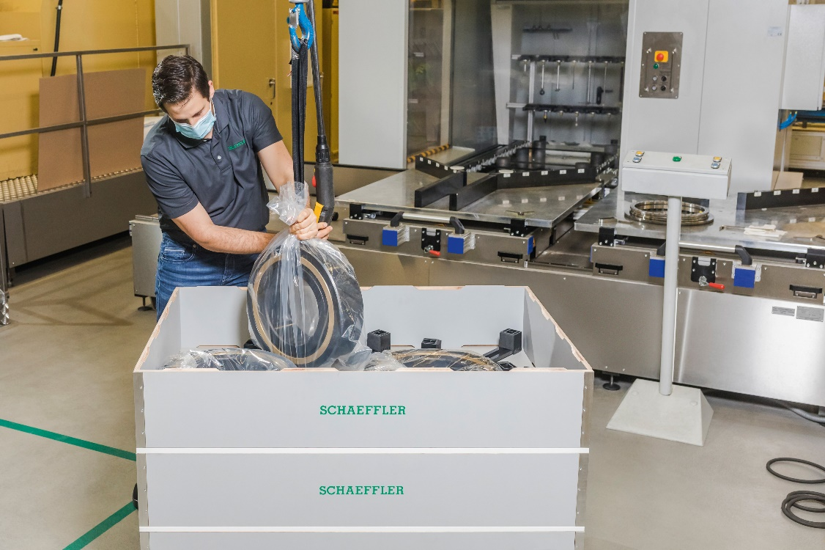

The new “SMART Box” (Schaeffler Modular Adaptable Returnable Transport Box) is an innovative reusable packaging system for large size bearings.

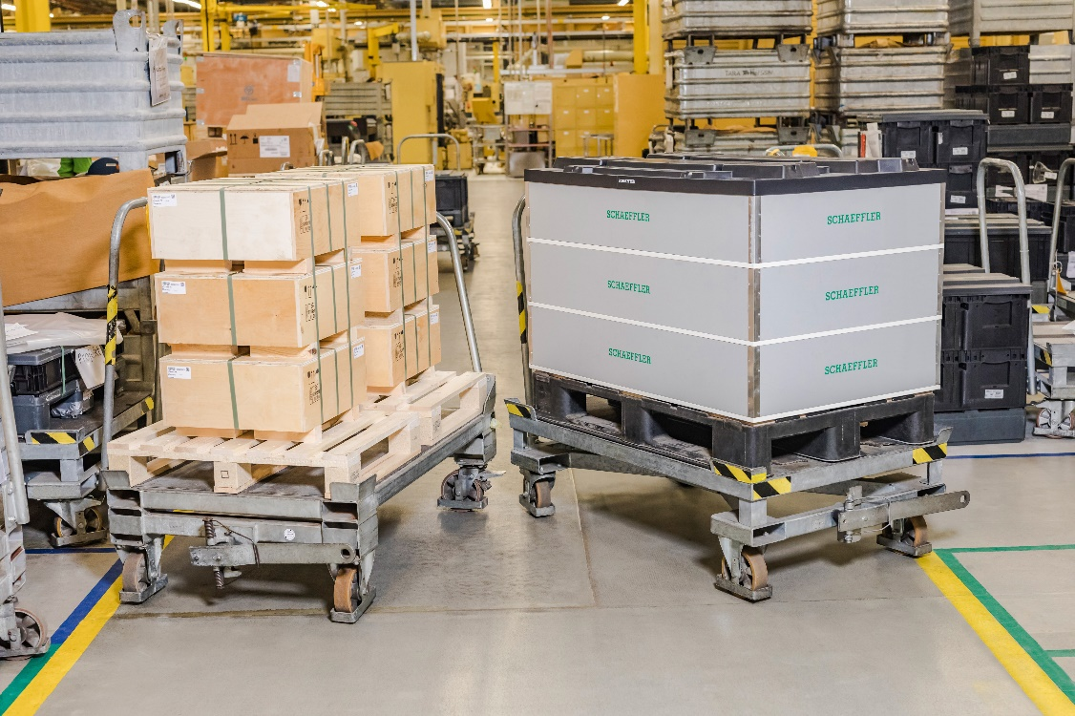 One complete unit of the new packaging system (right) replaces a multitude of individual boxes across several pallets. A total of up to five frames can be stacked per pallet with up to three bearings stacked per frame.

Images: Schaeffler

|  |
| --- |
|  |
|  |

**Schaeffler Group – We pioneer motion**

As a leading global supplier to the automotive and industrial sectors, the Schaeffler Group has been driving forward groundbreaking inventions and developments in the fields of motion and mobility for over 70 years. With innovative technologies, products, and services for CO₂-efficient drives, electric mobility, Industry 4.0, digitalization, and renewable energies, the company is a reliable partner for making motion and mobility more efficient, intelligent, and sustainable. The technology company manufactures high-precision components and systems for powertrain and chassis applications as well as rolling and plain bearing solutions for a large number of industrial applications. The Schaeffler Group generated sales of approximately EUR 12.6 billion in 2020. With around 83,300 employees, Schaeffler is one of the world’s largest family companies. With more than 1,900 patent applications in 2020, Schaeffler is Germany’s second most innovative company according to the DPMA (German Patent and Trademark Office).

|  |
| --- |
|  |
|  |

**Contact**

**Laura McKenzie**

UK Communications & Branding Manager

Schaeffler (UK) Ltd

Unit 308, Fort Dunlop

Fort Parkway

Birmingham

B24 9FD

 [**laura.mckenzie@schaeffler.com**](mailto:laura.mckenzie@schaeffler.com)

[](http://www.schaeffler.com/) [](https://www.facebook.com/SchaefflerGroup) [](https://twitter.com/schaefflergroup) [](https://www.instagram.com/schaefflergroup/) [](https://www.youtube.com/user/SchaefflerGlobal) [](http://www.linkedin.com/company/schaeffler)