|  |
| --- |
|  |
| |  | | --- | | Schaeffler showcases innovations for robotics and services | |  |  * Schaeffler and Flender develop innovative “SMART Box”, a reusable transport box for large size bearings * The modular design of the box ensures improved handling and reduced storage space * “SMART Box” provides an innovative solution for environmental and climate protection |
|  |

* Increasing automation and autonomous production offer considerable growth potential for Schaeffler
* Schaeffler is presenting itself as a partner for lightweight robotics at the “Hannover Messe Digital Edition”
* Condition monitoring solution OPTIME developed further and wins award for its design

Birmingham, UK | 13. April 2021 | Increasing automation and the goal of autonomous production offer considerable growth potential for Schaeffler, especially with respect to robotics solutions and service solutions based on digital technologies. For this year’s “Hannover Messe Digital Edition” Schaeffler is bringing its innovations in the fields of robotics and services to life virtually.

“We want to occupy a key position in the rapidly growing markets of condition monitoring and robotics,” says Dr. Stefan Spindler, CEO Industrial of Schaeffler AG. “Through strategic initiatives and close collaboration, we offer our customers innovations for the production of the future.”

**Expertise generates added value**As an integrated automotive and industrial supplier, Schaeffler has considerable opportunities to create synergies. Wide-ranging technology expertise and process experience from the Automotive Technologies division of Schaeffler come together in the development of robotics innovations. Digital services by Schaeffler are based on their expertise in the field of rolling bearing design and application, among others. “Our industrial business is of particular importance to the Schaeffler Group's strategic development,” explains Klaus Rosenfeld, CEO of Schaeffler AG. “In the medium-term, we want to grow faster with the Industrial division than global industrial production under our own steam.”

**New potential areas of application for lightweight robots and cobots**With a modular portfolio of innovative bearing supports, robot gearboxes and drive motors, Schaeffler has positioned itself as a partner for lightweight robotics. These system components play a crucial part in the performance of compact robots and hold the potential for great advances in development. With the increasing power density and precision of these components, lightweight robots and cobots can be used in areas of application that require higher speeds, precision and cleanliness levels, as well as increased load-bearing capacity. Schaeffler offers the components separately or as matched systems which meet customers’ requirements for maximum compactness, dynamics and performance.

**IoT solution OPTIME reduces downtime**OPTIME is a user-friendly, wireless IoT solution that makes the condition monitoring of machines in production processes efficient and cost-effective. Installation and commissioning are so easy that several hundred units can be integrated without issue in one day. The latest update enables two more IoT-capable hardware solutions by Schaeffler to be connected: ProLink and SmartCheck. This makes condition monitoring for a very wide range of machines and often even entire plants a possibility. Status information for all systems is clearly visualised in the OPTIME app.

Schaeffler was awarded the 2021 Red Dot Design Award in two categories for OPTIME’s outstanding product design, functional configuration, and high level of innovation.

**

For this year’s “Hannover Messe Digital Edition” Schaeffler is bringing its innovations in the fields of robotics and services to life virtually.

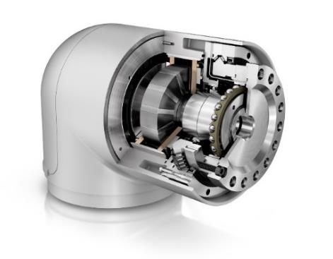

Only with innovative and high-performance system components can even more compact robots with greater working ranges and higher load-bearing capacity be developed. For the joints, Schaeffler offers a system assembly consisting of the DuraWave RTWH strain wave gear with the XZU angular contact needle roller bearing and the UPRS-series motor.

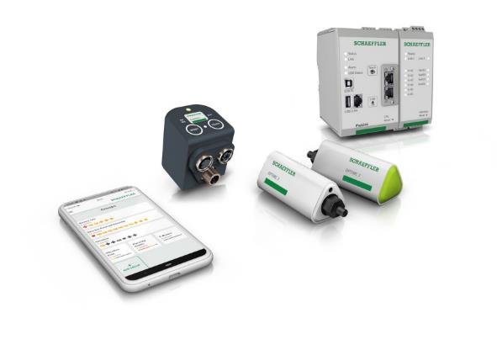

Schaeffler OPTIME: with the latest update, three IoT-capable hardware solutions can now be connected, making condition monitoring for a wide range of machines and often even entire plants possible. Status reports for all systems are clearly visualised in the OPTIME app.

Images: Schaeffler

|  |
| --- |
|  |
|  |

**Schaeffler Group – We pioneer motion**

As a leading global supplier to the automotive and industrial sectors, the Schaeffler Group has been driving forward groundbreaking inventions and developments in the fields of motion and mobility for over 70 years. With innovative technologies, products, and services for CO₂-efficient drives, electric mobility, Industry 4.0, digitalization, and renewable energies, the company is a reliable partner for making motion and mobility more efficient, intelligent, and sustainable. The technology company manufactures high-precision components and systems for powertrain and chassis applications as well as rolling and plain bearing solutions for a large number of industrial applications. The Schaeffler Group generated sales of approximately EUR 12.6 billion in 2020. With around 83,300 employees, Schaeffler is one of the world’s largest family companies. With more than 1,900 patent applications in 2020, Schaeffler is Germany’s second most innovative company according to the DPMA (German Patent and Trademark Office).

|  |
| --- |
|  |
|  |

**Contact**

**Laura McKenzie**

UK Communications & Branding Manager

Schaeffler (UK) Ltd

Unit 308, Fort Dunlop

Fort Parkway

Birmingham

B24 9FD

 [**laura.mckenzie@schaeffler.com**](mailto:laura.mckenzie@schaeffler.com)

[](http://www.schaeffler.com/) [](https://www.facebook.com/SchaefflerGroup) [](https://twitter.com/schaefflergroup) [](https://www.instagram.com/schaefflergroup/) [](https://www.youtube.com/user/SchaefflerGlobal) [](http://www.linkedin.com/company/schaeffler)