|  |
| --- |
|  |
| |  | | --- | | Schaeffler receives Red Dot Design Award in two categories with OPTIME | |  |  * Schaeffler and Flender develop innovative “SMART Box”, a reusable transport box for large size bearings * The modular design of the box ensures improved handling and reduced storage space * “SMART Box” provides an innovative solution for environmental and climate protection |
|  |

* Condition monitoring solution OPTIME wins in the “Smart Product” and “Industrial Design” categories
* Award confirms Schaeffler's innovative strength in the development of leading Industry 4.0 products
* Wireless IoT solution OPTIME makes the condition monitoring of machines in production processes efficient and cost-effective

Birmingham, UK | 15. April 2021 | The innovative condition monitoring solution OPTIME is a winner of this year’s Red Dot Design Award in two categories. A jury composed of designers, professors and journalists from various specialist fields awarded OPTIME in the categories of “Smart Product” and “Industrial Design”, thus confirming the outstanding product design, functional configuration and high level of innovation demonstrated by the digital service solution from Schaeffler.

“Our passion for technology and innovation is a key part of our DNA,” says Dr. Stefan Spindler, CEO Industrial of Schaeffler AG. “OPTIME receiving the award proves that we can successfully expand our portfolio with digital services that prioritise the benefit to the customer.”

**Customers benefit from solution-focused development**With this award, Schaeffler joins the list of winners of the Red Dot Design Award, which includes leading companies worldwide. “Receiving the Red Dot Design Award for OPTIME has made everyone involved in this project very proud,” says Rauli Hantikainen, Head of the Industry 4.0 Strategic Business Field. “For the development of OPTIME, we established an ecosystem of partners who were each in possession of the leading technologies and skills in their respective fields. At the same time, we collaborated closely with our pilot customers, as the guiding principle of agile product development has always been to achieve the maximum benefit for our customers.”

Schaeffler worked together with LINK Design from Finland, as a member of the partner network, on the product design of the OPTIME sensors and the user experience of the OPTIME app.

“While we are advancing our digitalisation agenda, it is fantastic to see that with the Red Dot Design Award, we are gaining recognition in the market,” says Denis Wiegel, Head of Sales Management and Marketing Industrial. “OPTIME is proof of our transformation and shows that we at Schaeffler not only think outside the box but that we also develop ground-breaking innovations – in a diverse, agile team that works on equal footing with internal and external partners. This is just the beginning.”

**Efficient, cost-effective production processes**With OPTIME, Schaeffler is consistently pursuing its aspiration to actively help shape digital transformation. Digital services that generate added value for customers through Schaeffler's expertise play a central role in this. OPTIME is a wireless IoT solution that makes the condition monitoring of machines in production processes efficient and cost-effective. Installation and commissioning are so easy that several hundred units can be integrated without issue in one day. Schaeffler has summarised the advantages provided by OPTIME under the guiding principle “Plug. Play. Predict.”

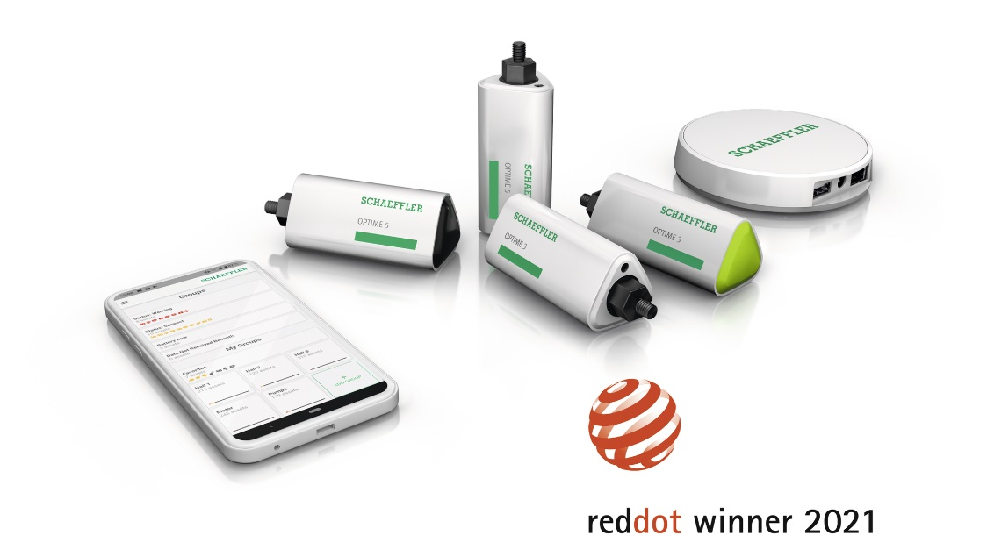

The innovative condition monitoring solution OPTIME from Schaeffler is a winner of this year’s Red Dot Design Award in two categories. The jury awarded the IoT solution in the “Smart Product” and “Industrial Design” categories, thus confirming its outstanding product design, functional configuration, and high level of innovation.

Image: Schaeffler

|  |
| --- |
|  |
|  |

**Schaeffler Group – We pioneer motion**

As a leading global supplier to the automotive and industrial sectors, the Schaeffler Group has been driving forward groundbreaking inventions and developments in the fields of motion and mobility for over 70 years. With innovative technologies, products, and services for CO₂-efficient drives, electric mobility, Industry 4.0, digitalization, and renewable energies, the company is a reliable partner for making motion and mobility more efficient, intelligent, and sustainable. The technology company manufactures high-precision components and systems for powertrain and chassis applications as well as rolling and plain bearing solutions for a large number of industrial applications. The Schaeffler Group generated sales of approximately EUR 12.6 billion in 2020. With around 83,300 employees, Schaeffler is one of the world’s largest family companies. With more than 1,900 patent applications in 2020, Schaeffler is Germany’s second most innovative company according to the DPMA (German Patent and Trademark Office).

|  |
| --- |
|  |
|  |

**Contact**

**Laura McKenzie**

UK Communications & Branding Manager

Schaeffler (UK) Ltd

Unit 308, Fort Dunlop

Fort Parkway

Birmingham

B24 9FD

 [**laura.mckenzie@schaeffler.com**](mailto:laura.mckenzie@schaeffler.com)

[](http://www.schaeffler.com/) [](https://www.facebook.com/SchaefflerGroup) [](https://twitter.com/schaefflergroup) [](https://www.instagram.com/schaefflergroup/) [](https://www.youtube.com/user/SchaefflerGlobal) [](http://www.linkedin.com/company/schaeffler)