|  |
| --- |
|  |
| Schaeffler is one of the 50 Sustainability & Climate Leaders of the United Nations |
|  |

* United Nations names Schaeffler Group one of its 50 Sustainability & Climate Leaders worldwide
* Nomination for clearly defined sustainability strategy and consistent sustainability management
* Video documentary shows company-wide activities and technologies in favour of sustainability and climate protection

Birmingham, UK | 16. April 2021 | The Schaeffler Group has been selected as one of the 50 Sustainability & Climate Leaders worldwide on the occasion of the 75th anniversary of the United Nations (UN). The common objective of this initiative is the achievement of the 17 goals for sustainable development set by the United Nations.

“For us, the appointment of the Schaeffler Group by the UN as one of the Sustainability & Climate Leaders is not just recognition of the work we have done to date, but both an incentive and an obligation to continue implementing our sustainability strategy with the utmost consistency,” said Klaus Rosenfeld, Chief Executive Officer of Schaeffler AG. “As part of this impressive initiative, we will do everything in our power to realise our sustainability and climate targets and thus make our contribution to achieving the 17 sustainability goals of the United Nations.”

A prerequisite for the admission into the 50 Sustainability & Climate Leaders is a clearly defined sustainability strategy and corresponding corporate objectives. As a corporate value, sustainability has been firmly anchored in the Schaeffler Group's activities for many years and is an integral component of the corporate strategy. “Sustainable corporate success to us means assuming ecological and social responsibility – in production, through the use of our products, and with the involvement of our suppliers,” said Corinna Schittenhelm, member of the Board of Managing Directors of Schaeffler AG with responsibility for HR and sustainability.

Schaeffler was convincing in the selection process and now represents the automotive and industrial supplier sector in the DACH region (Germany, Austria, Switzerland). For the Schaeffler Group, it is not only the ecological footprint of its own production facilities that plays a major role. The development and production of technologies for the optimal use of renewable energies is also an important contribution to climate protection. Schaeffler’s components, systems, and service solutions make specific contributions to sustainable changes in a wide range of industries – for example, in the electrification of the powertrain for vehicles or in the manufacturing of large-sized bearings for wind turbines.

A good initial overview of the Schaeffler’s sustainability activities is provided by a documentary that will be officially broadcast today by media partner Bloomberg and published on [https://www.50climateleaders.com](https://www.50climateleaders.com/schaeffler-innovative-solutions-that-enable-sustainable-mobility-and-motion/) as part of the initiative.

Since 2020, selected targets have been integrated into the variable remuneration of managers. Furthermore, Schaeffler is continuously developing its employees with comprehensive training programs and measures for retraining and further qualification. Further details and background information on sustainability at Schaeffler can be found in the recently published sustainability report. This report provides information on key figures and objectives, illustrating the development of the Schaeffler Group towards greater sustainability. The report is available in digital format and the content can be accessed via an interactive microsite: [www.schaeffler-sustainability-report.com](https://www.schaeffler-sustainability-report.com/2020/)

You can find press photos of Klaus Rosenfeld and Corinna Schittenhelm here: [www.schaeffler.com/en/executive-board](http://www.schaeffler.com/en/executive-board)

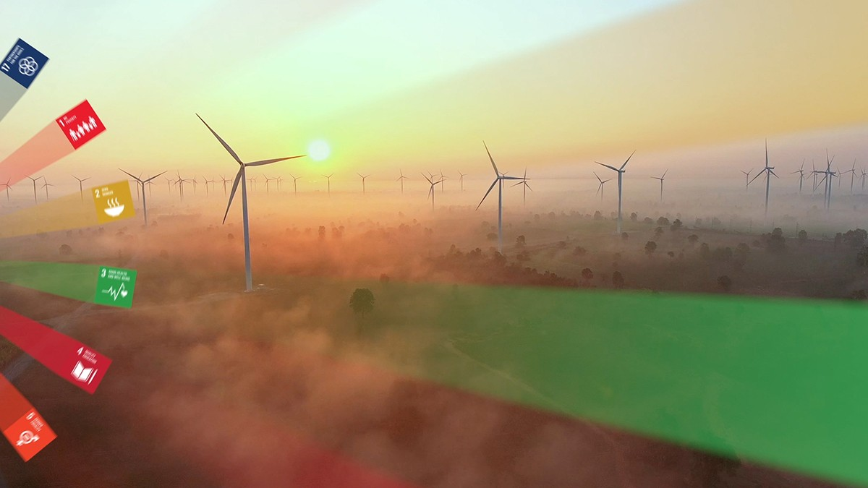

The Schaeffler Group has been selected as one of the 50 Sustainability & Climate Leaders of the United Nations (UN). The common objective of this initiative is the achievement of the 17 goals for sustainable development set by the United Nations.

Image: Schaeffler

|  |
| --- |
|  |
|  |

Schaeffler Group – We pioneer motion

As a leading global supplier to the automotive and industrial sectors, the Schaeffler Group has been driving forward groundbreaking inventions and developments in the fields of motion and mobility for over 70 years. With innovative technologies, products, and services for CO₂-efficient drives, electric mobility, Industry 4.0, digitalization, and renewable energies, the company is a reliable partner for making motion and mobility more efficient, intelligent, and sustainable. The technology company manufactures high-precision components and systems for powertrain and chassis applications as well as rolling and plain bearing solutions for a large number of industrial applications. The Schaeffler Group generated sales of approximately EUR 12.6 billion in 2020. With around 83,300 employees, Schaeffler is one of the world’s largest family companies. With more than 1,900 patent applications in 2020, Schaeffler is Germany’s second most innovative company according to the DPMA (German Patent and Trademark Office).

|  |
| --- |
|  |
|  |

**Contact**

**Laura McKenzie**

UK Communications & Branding Manager

Schaeffler (UK) Ltd

Unit 308, Fort Dunlop

Fort Parkway

Birmingham

B24 9FD

 [**laura.mckenzie@schaeffler.com**](mailto:laura.mckenzie@schaeffler.com)

[](http://www.schaeffler.com/) [](https://www.facebook.com/SchaefflerGroup) [](https://twitter.com/schaefflergroup) [](https://www.instagram.com/schaefflergroup/) [](https://www.youtube.com/user/SchaefflerGlobal) [](http://www.linkedin.com/company/schaeffler)