|  |
| --- |
|  |
| Jens Schüler appointed as new CEO of Automotive Aftermarket division |
|  |

* Michael Söding will retire at the end of the year after 20 years at Schaeffler
* Söding successfully established and developed the Automotive Aftermarket division into a global market leader
* Jens Schüler brings many years of international experience in the fields of strategy, sales and marketing, and digitalisation

Birmingham, UK | 23. April 2021 | During an extraordinary meeting, the Supervisory Board of Schaeffler AG has agreed the appointment of Jens Schüler (46) as the new CEO of the Automotive Aftermarket division with effect from January 1, 2022. He is successor to Michael Söding (59) who is retiring at the end of the year at his own request after working for Schaeffler for 20 years. The Automotive Aftermarket division posted revenues of 1.64 billion euros in 2020. The division employs around 1,700 employees.

Michael Söding studied industrial engineering and began his career at a renowned tyre manufacturer in 1989. After various positions in the aftermarket sector, he joined the Schaeffler Group in 2002 where he initially assumed management functions in the fields of sales and marketing. From 2009 to 2017, he was responsible for Schaeffler’s replacement parts business at a global level. With the establishment of Automotive Aftermarket as the company’s third division with an Executive Board function in 2018, Mr. Söding was appointed as a member of Schaeffler AG’s Executive Board. He is a member of important national and international associations, for example, he is the Chairman of the sector association AAMPACT and co-founder of various sector initiatives such as TecAlliance GmbH and Caruso GmbH.

Michael Söding says: “Schaeffler Automotive Aftermarket has risen to become a global market leader and makes a very successful contribution to the results of Schaeffler AG. The unprecedented need for a transformation to data-based business models, digitalisation and an enhanced customer experience means that now is an ideal time for passing the baton to the next generation.”

With the appointment of Jens Schüler, a successor will assume the role of CEO Automotive Aftermarket who has many years of experience in the fields of strategy, sales and marketing, and digitalisation and who brings many years of international experience.

Jens Schüler joined Schaeffler directly after completing his studies in economics in 2003. He began his career as assistant to the President and CEO of Schaeffler Automotive Aftermarket. In the following years, his focus in the aftermarket business included strategic planning, before he assumed leadership positions in the Americas region, initially as President Automotive Aftermarket North America in 2011 and then as President Automotive Aftermarket – Schaeffler Americas from 2014. Since 2018, Mr. Schüler has been in charge of Global Sales and Marketing in the Automotive Aftermarket division.

“Michael Söding is an acknowledged and very well-connected industry expert who has played a formative role in shaping the Automotive Aftermarket division during his 20 years of work at Schaeffler and has developed the division into an important pillar for the Schaeffler Group. He deserves special thanks for this achievement. As much as we regret his decision to begin his well-earned retirement, we wish him all the best for the future. I am therefore very pleased that we are able to appoint Mr. Schüler as a very well-qualified successor from our own ranks and have been able to decide on a successor to lead the Automotive Aftermarket division at an early stage. I wish him every success with the challenges that lie ahead,” said Georg F. W. Schaeffler, family shareholder and Chairman of the Supervisory Board of Schaeffler AG.

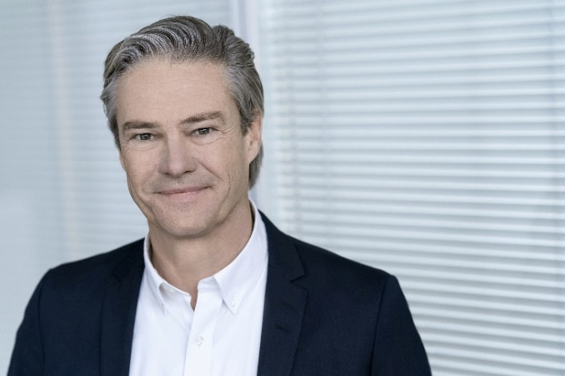

Michael Söding

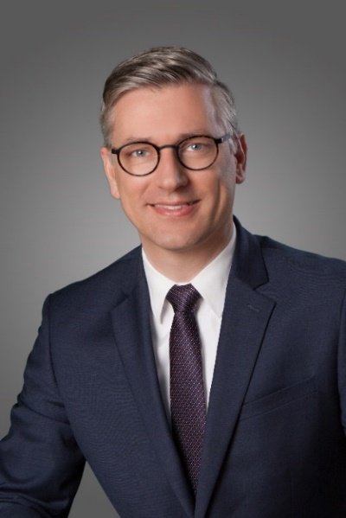

Jens Schüler

Photos: Schaeffler AG

|  |
| --- |
|  |
|  |

Schaeffler Group – We pioneer motion

As a leading global supplier to the automotive and industrial sectors, the Schaeffler Group has been driving forward groundbreaking inventions and developments in the fields of motion and mobility for over 70 years. With innovative technologies, products, and services for CO₂-efficient drives, electric mobility, Industry 4.0, digitalization, and renewable energies, the company is a reliable partner for making motion and mobility more efficient, intelligent, and sustainable. The technology company manufactures high-precision components and systems for powertrain and chassis applications as well as rolling and plain bearing solutions for a large number of industrial applications. The Schaeffler Group generated sales of approximately EUR 12.6 billion in 2020. With around 83,300 employees, the Schaeffler Group is one of the world’s largest family companies. With more than 1,900 patent applications in 2020, Schaeffler is Germany’s second most innovative company according to the DPMA (German Patent and Trademark Office).

|  |
| --- |
|  |
|  |

**Contact**

**Laura McKenzie**

UK Communications & Branding Manager

Schaeffler (UK) Ltd

Unit 308, Fort Dunlop

Fort Parkway

Birmingham

B24 9FD

 [**laura.mckenzie@schaeffler.com**](mailto:laura.mckenzie@schaeffler.com)

[](http://www.schaeffler.com/) [](https://www.facebook.com/SchaefflerGroup) [](https://twitter.com/schaefflergroup) [](https://www.instagram.com/schaefflergroup/) [](https://www.youtube.com/user/SchaefflerGlobal) [](http://www.linkedin.com/company/schaeffler)