|  |
| --- |
|  |
| Viktor Molnar appointed President Chassis Systems business division of the Schaeffler Group |
|  |

* Schaeffler strengthens Chassis Systems business division for a sustainable and successful future
* Viktor Molnar will drive the expansion of chassis mechatronics
* Two prominent volume-production nominations acquired for intelligent mechatronic rear axle steering system

Birmingham, UK | 12 May, 2021 | Viktor Molnar (45) will assume the management of the Chassis Systems business division at Schaeffler on June 1, 2021. In this role, the native Hungarian will report to Matthias Zink, CEO of the Automotive Technologies division of Schaeffler AG, who has been managing the business division on a provisional basis for the interim period. In keeping with the claim “We pioneer motion”, the automotive and industrial supplier is continuing its transformation and, in addition to the electrification of the powertrain, is also ramping up activities in the field of chassis systems. The advancing automation of driving functions is placing greater demands on new chassis solutions. Working from a high level of production expertise, Schaeffler offers a wide range of products for innovative chassis applications ranging from components to mechatronic systems. Two prominent volume-production nominations in the area of the intelligent mechatronic rear axle steering system (iRWS) are testament to the decisive role played by Schaeffler in shaping the transformation to innovative chassis applications.

Viktor Molnar was previously employed at Robert Bosch GmbH, where he held various managerial positions in Hungary, China, and Germany. During his employment, which spanned over 20 years, he was most recently responsible for the Body Electronics business unit. In this role, he oversaw the global development and marketing of complex, software-intensive control units such as body computers and gateways. Additional areas of responsibility also included the high-performance computer in the drive and body domains (Vehicle Computer for Body and Motion). Viktor Molnar studied mechanical engineering at the Budapest University of Technology and Economics.

“We are delighted that, in Viktor Molnar, we have successfully acquired a proven expert in the fields of electronics and mechatronics,” says Matthias Zink. “With his outstanding specialist knowledge and many years of experience, he is optimally qualified to lead the Chassis Systems business division successfully into the future. Schaeffler sees potential for growth in this area which is equally as great as for electric mobility.”

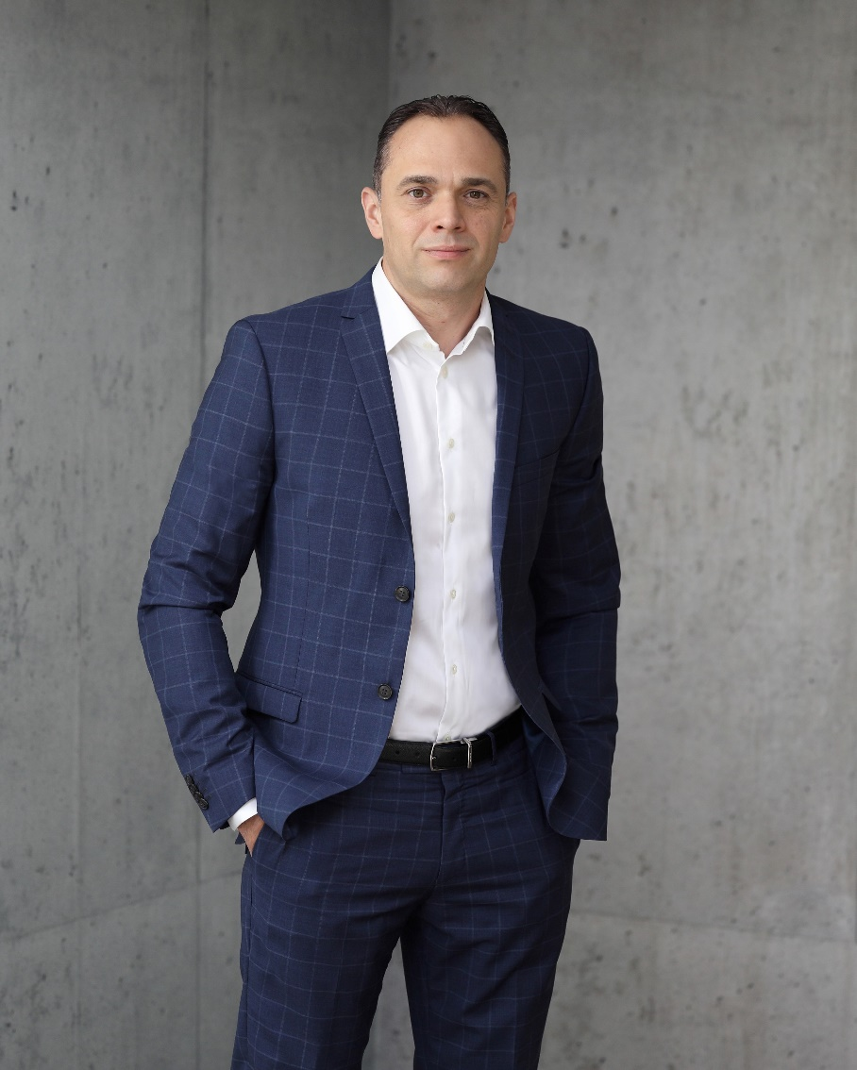

Viktor Molnar will head the Chassis Systems business division with effect from June 1, 2021.

|  |
| --- |
|  |

Schaeffler Group – We pioneer motion

As a leading global supplier to the automotive and industrial sectors, the Schaeffler Group has been driving forward groundbreaking inventions and developments in the fields of motion and mobility for over 70 years. With innovative technologies, products, and services for CO₂-efficient drives, electric mobility, Industry 4.0, digitalization, and renewable energies, the company is a reliable partner for making motion and mobility more efficient, intelligent, and sustainable. The technology company manufactures high-precision components and systems for powertrain and chassis applications as well as rolling and plain bearing solutions for a large number of industrial applications. The Schaeffler Group generated sales of approximately EUR 12.6 billion in 2020. With around 83,900 employees, Schaeffler is one of the world’s largest family companies. With more than 1,900 patent applications in 2020, Schaeffler is Germany’s second most innovative company according to the DPMA (German Patent and Trademark Office).

|  |
| --- |
|  |
|  |

**Contact**

**Laura McKenzie**

UK Communications & Branding Manager

Schaeffler (UK) Ltd

Unit 308, Fort Dunlop

Fort Parkway

Birmingham

B24 9FD

 [**laura.mckenzie@schaeffler.com**](mailto:laura.mckenzie@schaeffler.com)

[](http://www.schaeffler.com/) [](https://www.facebook.com/SchaefflerGroup) [](https://twitter.com/schaefflergroup) [](https://www.instagram.com/schaefflergroup/) [](https://www.youtube.com/user/SchaefflerGlobal) [](http://www.linkedin.com/company/schaeffler)