|  |
| --- |
|  |
| Schaeffler and Siemens to cooperate on intelligent diagnostics for drive systems |
|  |

* Together with Siemens Large Drives Applications, Schaeffler is advancing the digitisation of industry with a focus on customer benefits
* Digital service for automated bearing diagnostics from Schaeffler is now integrated into Siemens' IIoT platform Sidrive IQ
* Bearing condition’s analysis results as part of overall motor health status support informed operation and maintenance decisions to reduce unplanned downtime.

Birmingham, UK | 17 May, 2021 | Electric motors drive our core industrial processes, and the rolling bearing is their central mechanical component. The bearings experience all of the loads and stresses that occur in the electric motor. Therefore, bearing diagnostics provide a crucial indicator of the overall condition and reliability of a motor. In addition to developing a portfolio of condition monitoring solutions for operators, the automotive and industrial supplier Schaeffler is also working with OEM customers such as Siemens on joint offerings to increase the availability of machinery and equipment.

“This partnership between Schaeffler and Siemens is based on a solid foundation of product knowledge and specific expertise. Both companies are playing an instrumental role in driving digitalisation forward in the industry while keeping their entire focus on customer value,” adds Dr. Stefan Spindler, CEO Industrial of Schaeffler AG.

**Services seamlessly integrated in one platform**   
The collaboration between Siemens and Schaeffler combines Sidrive IQ – the digital platform for drive systems and solutions from Siemens – with Schaeffler’s decades of experience and expertise in designing, manufacturing, and servicing bearings. Sidrive IQ integrates a number of functionalities into one seamless solution and augments drive systems with AI-based analytics and digital content. For the customer, this means the ability to make better decisions when it comes to operation, maintenance, and maintenance measures for drive systems.

**New dimensions of collaboration in the industrial IoT**   
The integration of Schaeffler’s analysis service for automated bearing diagnostics in Sidrive IQ makes it possible to determine the bearing condition with greater certainty and precision. “This cooperation and automated exchange of algorithm-based diagnostic data is one of the first of its kind in the industrial IoT. It’s a great example of a new dimension of cooperation among established technology companies,” says Hermann Kleinod, CEO of Siemens Large Drives Applications.

With the help of well-founded insights and specific information, operators can quickly determine whether the drive system can continue to operate or whether, in the event of impending damage, the bearing needs to be replaced immediately or can wait for the next maintenance interval. This reduces maintenance effort and cost, and most importantly, unplanned and costly downtimes can be prevented.

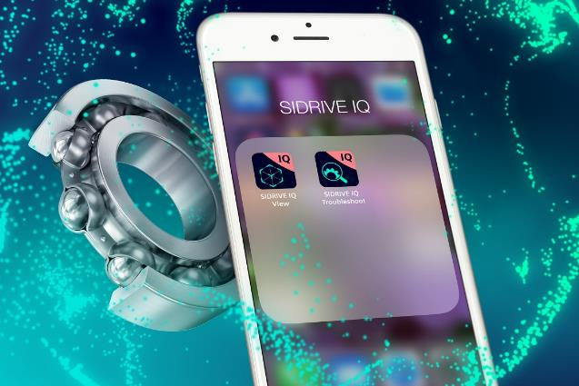

The collaboration between Siemens and Schaeffler combines Siemens' IIoT platform Sidrive IQ with Schaeffler’s decades of experience and expertise in designing, manufacturing, and servicing bearings. (Picture: Siemens)



Bearing diagnostics provide a crucial indicator of the overall condition and reliability of an electric motor. Operators can thus reduce maintenance effort and costs, and most importantly, avoid unplanned and costly downtime. (Picture: Schaeffler)

Pictures: Schaeffler, Siemens

|  |
| --- |
|  |

Schaeffler Group – We pioneer motion

As a leading global supplier to the automotive and industrial sectors, the Schaeffler Group has been driving forward groundbreaking inventions and developments in the fields of motion and mobility for over 70 years. With innovative technologies, products, and services for CO₂-efficient drives, electric mobility, Industry 4.0, digitalization, and renewable energies, the company is a reliable partner for making motion and mobility more efficient, intelligent, and sustainable. The technology company manufactures high-precision components and systems for powertrain and chassis applications as well as rolling and plain bearing solutions for a large number of industrial applications. The Schaeffler Group generated sales of approximately EUR 12.6 billion in 2020. With around 83,900 employees, Schaeffler is one of the world’s largest family companies. With more than 1,900 patent applications in 2020, Schaeffler is Germany’s second most innovative company according to the DPMA (German Patent and Trademark Office).

**Siemens AG** (Berlin and Munich) is a global technology powerhouse that has stood for engineering excellence, innovation, quality, reliability and internationality for more than 170 years. Active around the world, the company focuses on intelligent infrastructure for buildings and distributed energy systems and on automation and digitalization in the process and manufacturing industries. Siemens brings together the digital and physical worlds to benefit customers and society. Through Mobility, a leading supplier of intelligent mobility solutions for rail and road transport, Siemens is helping to shape the world market for passenger and freight services. Via its majority stake in the publicly listed company Siemens Healthineers, Siemens is also a world-leading supplier of medical technology and digital health services. In addition, Siemens holds a minority stake in Siemens Energy, a global leader in the transmission and generation of electrical power that has been listed on the stock exchange since September 28, 2020.

In fiscal 2020, which ended on September 30, 2020, the Siemens Group generated revenue of €55.3 billion and net income of €4.2 billion. As of September 30, 2020, the company had around 293,000 employees worldwide. Further information is available on the Internet at www.siemens.com.

**Siemens Large Drives Applications** (LDA) engineers and produces heavy-duty electrical drive systems for the medium- and high-voltage ranges: electrical motors, converters, and generators. LDA is one of Siemens’ Portfolio Companies. These units are agile, flexible, and decentralized and offer fast decision-making and reaction times. This allows them to be more competitive in their respective markets with a greater focus on their customers in different industries.

|  |
| --- |
|  |
|  |

**Contact**

**Laura McKenzie**

UK Communications & Branding Manager

Schaeffler (UK) Ltd

Unit 308, Fort Dunlop

Fort Parkway

Birmingham

B24 9FD

 [**laura.mckenzie@schaeffler.com**](mailto:laura.mckenzie@schaeffler.com)

[](http://www.schaeffler.com/) [](https://www.facebook.com/SchaefflerGroup) [](https://twitter.com/schaefflergroup) [](https://www.instagram.com/schaefflergroup/) [](https://www.youtube.com/user/SchaefflerGlobal) [](http://www.linkedin.com/company/schaeffler)