|  |
| --- |
|  |
| Online Customer Platform OptimisedSchaeffler combines e-commerce, knowledge base and product catalogue in a single platform |
|  |

* Research, compare, and order: Schaeffler has optimised its medias online platform with new functions and a new, responsive design
* The platform is structured as a three-tier user model and covers different customer requirements
* The content is adapted to the specific countries and available in eleven languages

Birmingham, UK | 20 May, 2021 | The integrated automotive and industrial supplier Schaeffler has optimised its medias online platform (<https://medias.schaeffler.com>) in order to provide users with even faster and more efficiently with comprehensive information. In addition to information on rolling and plain bearings, linear systems as well as mechatronic, digital and service solutions, medias now also gives Schaeffler customers and interested parties access to selection assistants, configuration tools, and the ordering process itself.

As part of the enhancement of its user-friendliness, the platform has also been given a simplified navigation and a new and responsive design, as well as new content and functions. The three-tier user model structure, which comprises medias, medias Plus, and medias Business, also covers different customer requirements. The content has been adapted for the specific country in each case and is available in eleven different languages.

**Get started quickly without registration****: medias**  
All product information, solutions, and services from Schaeffler’s Industrial division can be found here, and new content is being added constantly. Alongside established engineering tools, several new options are also now available, including the linear configurator which allows the design of linear guidance systems based on the customers’ requirements. All changes and extensions that are made are visually illustrated immediately during configuration.

**For greater performance at no cost: medias Plus**  
Medias Plus is also available free of charge following a brief registration process. Users can save favourites using a wish list and can directly request a quotation from Schaeffler sales partners. What is more, linear configurations can also be stored and retrieved at any time, and users will shortly receive access to white papers and product training videos.

**For Schaeffler sales partners and direct customers: medias Business**  
Medias Business is aimed at existing Schaeffler customers, and it provides unrestricted access to the full range of consultation tools and product information and includes an even larger range of product variants. In addition to the simple and direct ordering process, medias Business also includes numerous extras that facilitate commercial processes, such as information about scale prices, real-time availability, and an overview of open orders.

The content available in medias is being successively expanded. Medias is thus increasingly becoming a central knowledge platform.

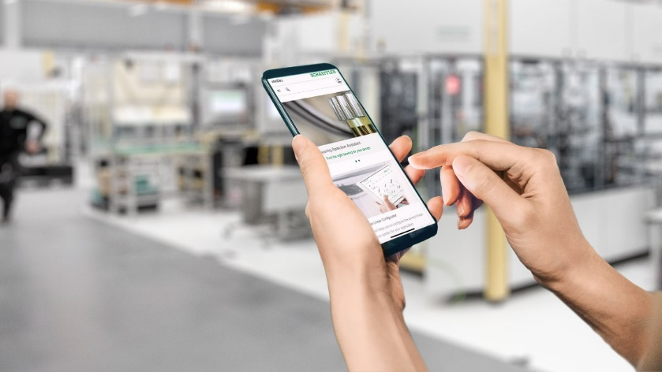

Schaeffler has optimised its medias online product catalogue with new content and functions as well as a responsive new design.

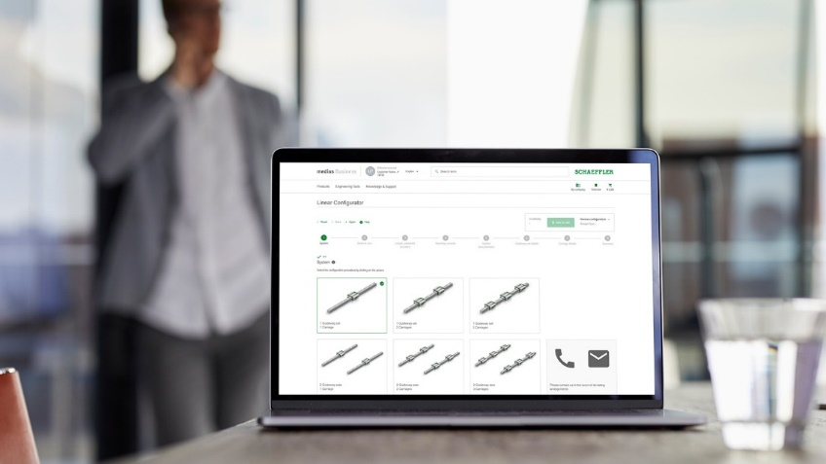

In addition to comprehensive information about bearings and bearing-related topics, selection assistants and configuration tools such as the linear configurator shown here, customers also have access to the ordering system itself in the medias online platform.

Images: Schaeffler

|  |
| --- |
|  |
|  |

**Schaeffler Group – We pioneer motion**

As a leading global supplier to the automotive and industrial sectors, the Schaeffler Group has been driving forward groundbreaking inventions and developments in the fields of motion and mobility for over 70 years. With innovative technologies, products, and services for CO₂-efficient drives, electric mobility, Industry 4.0, digitalization, and renewable energies, the company is a reliable partner for making motion and mobility more efficient, intelligent, and sustainable. The technology company manufactures high-precision components and systems for powertrain and chassis applications as well as rolling and plain bearing solutions for a large number of industrial applications. The Schaeffler Group generated sales of approximately EUR 12.6 billion in 2020. With around 83,900 employees, Schaeffler is one of the world’s largest family companies. With more than 1,900 patent applications in 2020, Schaeffler is Germany’s second most innovative company according to the DPMA (German Patent and Trademark Office).

|  |
| --- |
|  |
|  |

**Contact**

**Laura McKenzie**

UK Communications & Branding Manager

Schaeffler (UK) Ltd

Unit 308, Fort Dunlop

Fort Parkway

Birmingham

B24 9FD

 [**laura.mckenzie@schaeffler.com**](mailto:laura.mckenzie@schaeffler.com)

[](http://www.schaeffler.com/) [](https://www.facebook.com/SchaefflerGroup) [](https://twitter.com/schaefflergroup) [](https://www.instagram.com/schaefflergroup/) [](https://www.youtube.com/user/SchaefflerGlobal) [](http://www.linkedin.com/company/schaeffler)