|  |
| --- |
|  |
| Space Drive: Steer-by-wire revolutionises DTM |
|  |

* Audi, BMW, Mercedes-AMG: Steer-by-wire technology Space Drive installed in three DTM race cars
* Matthias Zink: “Using the technology under extreme conditions proves its maturity and brings the development a step closer to large-scale production.”
* Steering without a steering column: Space Drive is a key technology for autonomous driving

Birmingham, UK | 21 June, 2021 | The DTM 2021 season opener will be in Monza, Italy. Leading automotive and industrial supplier Schaeffler is the official “Series and Innovation Partner” to the racing series and will bring the steer-by-wire technology, Space Drive, to the starting grid in three DTM cars from different German car makers: in the Audi R8 LMS GT3 driven by Schaeffler brand ambassador Sophia Flörsch, in Gary Paffett’s Mercedes-AMG and in Timo Glock’s BMW M6 GT3.

In Space Drive technology there is no mechanical steering column and the steering commands are transmitted purely digitally via cable. “As a series partner to the DTM, Schaeffler is demonstrating innovative strength and pioneering spirit,” says Matthias Zink, CEO Automotive Technologies at Schaeffler. “Using the technology under extreme conditions proves its maturity and brings the development a step closer to large-scale production. Space Drive is a thoroughly tried and tested key technology for autonomous driving with more than a billion kilometres driven on public roads.” Roland Arnold, CEO of Schaeffler Paravan Technologie GmbH & Co. KG, says: “Motorsport has always been seen as a development accelerator. In this environment, the Space Drive system is subjected to extreme stresses, making it an ideal test environment for generating important functionalities for the ongoing development of Space Drive 3 for large-scale production.”

**Preferred technology partner for chassis systems**

Autonomous driving is an important component of Schaeffler’s Roadmap 2025. In its “Vision Chassis 2035” the company has developed a basic scenario for the level of automation of cars and light commercial vehicles. Accordingly, Schaeffler predicts that by 2035, around 30 per cent of all new cars and light commercial vehicles produced worldwide will be at least partially automated, while half of them will offer the capability for highly automated driving. “The increasing automation of driving functions on the road to autonomous vehicles also imposes more rigorous requirements on chassis applications in respect of reliability and safety,” says Viktor Molnar, President Chassis Systems business division at Schaeffler. “We are continuing to ramp up our activities at component and system level and are well on track to becoming a preferred technology partner for intelligent drive and chassis solutions.”

**Two partnerships for the first time**

As well as the use of Space Drive, Schaeffler is celebrating another premiere. This season, the automotive and industrial supplier will be partnering with two teams for the first time: Marco Wittmann will be driving for Walkenhorst Motorsport and Sophia Flörsch for Abt Sportsline. At the same time, Schaeffler is also actively promoting technological developments for the future of the DTM and is in the process of developing the electric drive system for its electrification, which is set to become a reality in 2023 with the DTM Electric, where Space Drive technology will also be used. The DTM’s programme of supporting events for 2021 will include appearances by the highly innovative DTM Electric demonstrator car.

You can find a press photo of Matthias Zink here: [www.schaeffler.com/en/executive-board](http://www.schaeffler.com/en/executive-board)

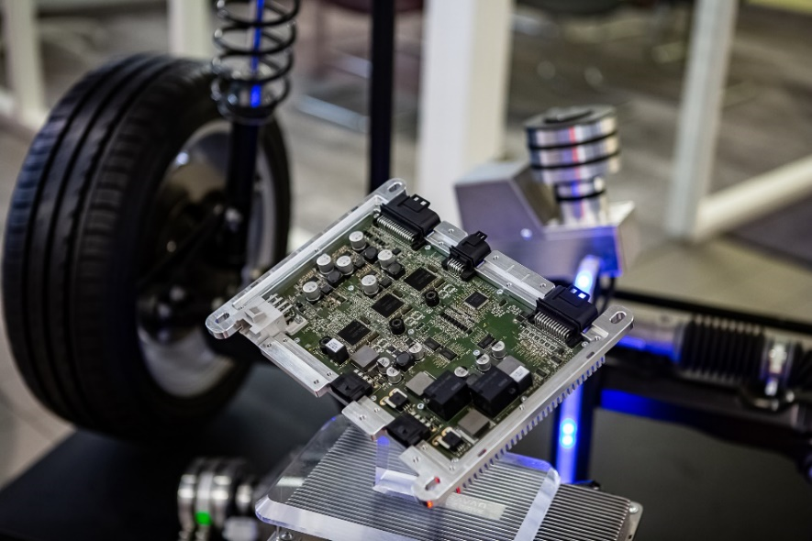

The Space Drive system is a key technology for autonomous driving and has already proven its effectiveness in more than a billion kilometres driven.



Sophia Flörsch is a Schaeffler brand ambassador and will be chasing points in an Audi R8 LMS GT3 with Space Drive.



Gary Paffett with his Mercedes-AMG fitted with Space Drive.

Timo Glock will also use Space Drive to steer his BMW M6 GT3.

Images: Schaeffler

|  |
| --- |
|  |
|  |

Schaeffler Group – We pioneer motion

As a leading global supplier to the automotive and industrial sectors, the Schaeffler Group has been driving forward groundbreaking inventions and developments in the fields of motion and mobility for over 70 years. With innovative technologies, products, and services for CO₂-efficient drives, electric mobility, Industry 4.0, digitalization, and renewable energies, the company is a reliable partner for making motion and mobility more efficient, intelligent, and sustainable. The technology company manufactures high-precision components and systems for drive train and chassis applications as well as rolling and plain bearing solutions for a large number of industrial applications. The Schaeffler Group generated sales of approximately EUR 12.6 billion in 2020. With around 83,900 employees, Schaeffler is one of the world’s largest family companies. With more than 1,900 patent applications in 2020, Schaeffler is Germany’s second most innovative company according to the DPMA (German Patent and Trademark Office).

|  |
| --- |
|  |
|  |

**Contact**

**Laura McKenzie**

UK Communications & Branding Manager

Schaeffler (UK) Ltd

Unit 308, Fort Dunlop

Fort Parkway

Birmingham

B24 9FD

 [**laura.mckenzie@schaeffler.com**](mailto:laura.mckenzie@schaeffler.com)

[](http://www.schaeffler.com/) [](https://www.facebook.com/SchaefflerGroup) [](https://twitter.com/schaefflergroup) [](https://www.instagram.com/schaefflergroup/) [](https://www.youtube.com/user/SchaefflerGlobal) [](http://www.linkedin.com/company/schaeffler)